

**CS4001NI Programming**

**60% Individual Coursework**

**2025 Spring**

**Student Name: Sichu Maharjan**

**London Met ID: 24046892**

**College ID: NP01CP4A240151**

**Assignment Due Date: Friday, May 16, 2025**

**Assignment Submission Date: Friday, May 16, 2025**

*I confirm that I understand my coursework needs to be submitted online via MySecondTeacher under the relevant module page before the deadline in order for my assignment to be accepted and marked. I am*

*fully aware that late submissions will be treated as non-submission and a marks of zero will be awarded.*

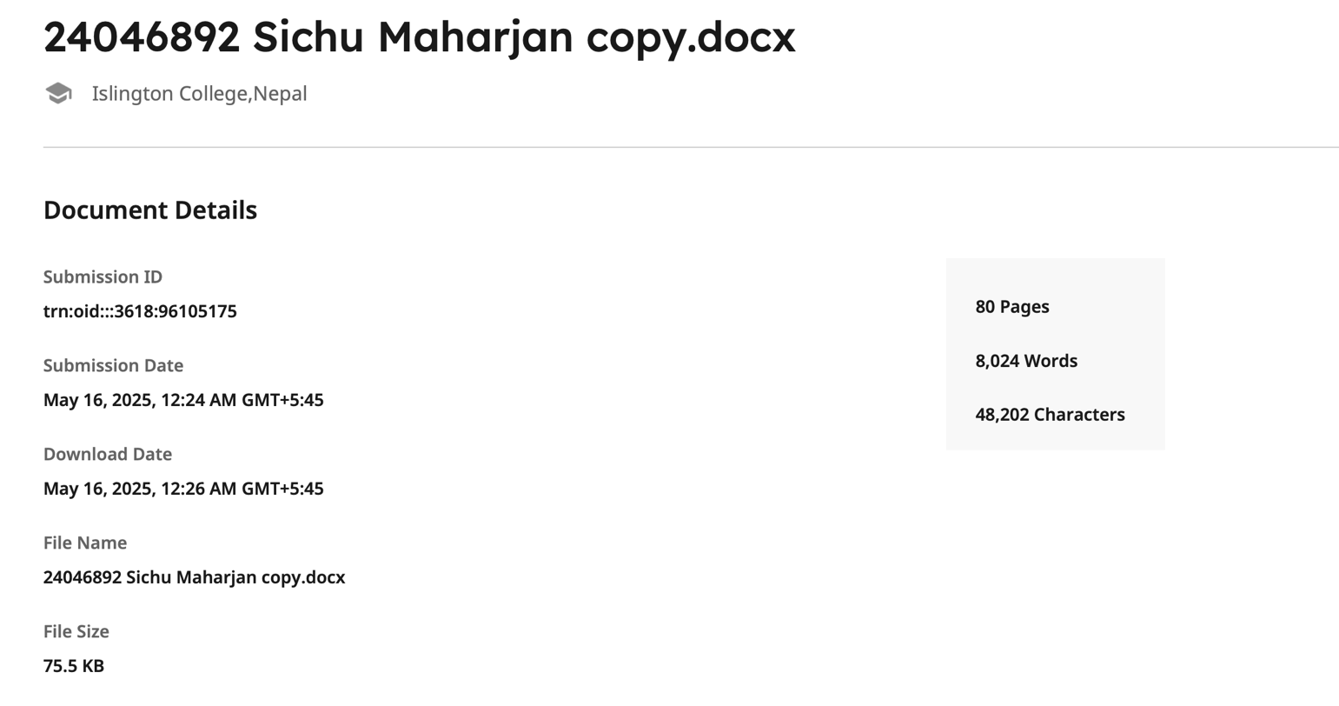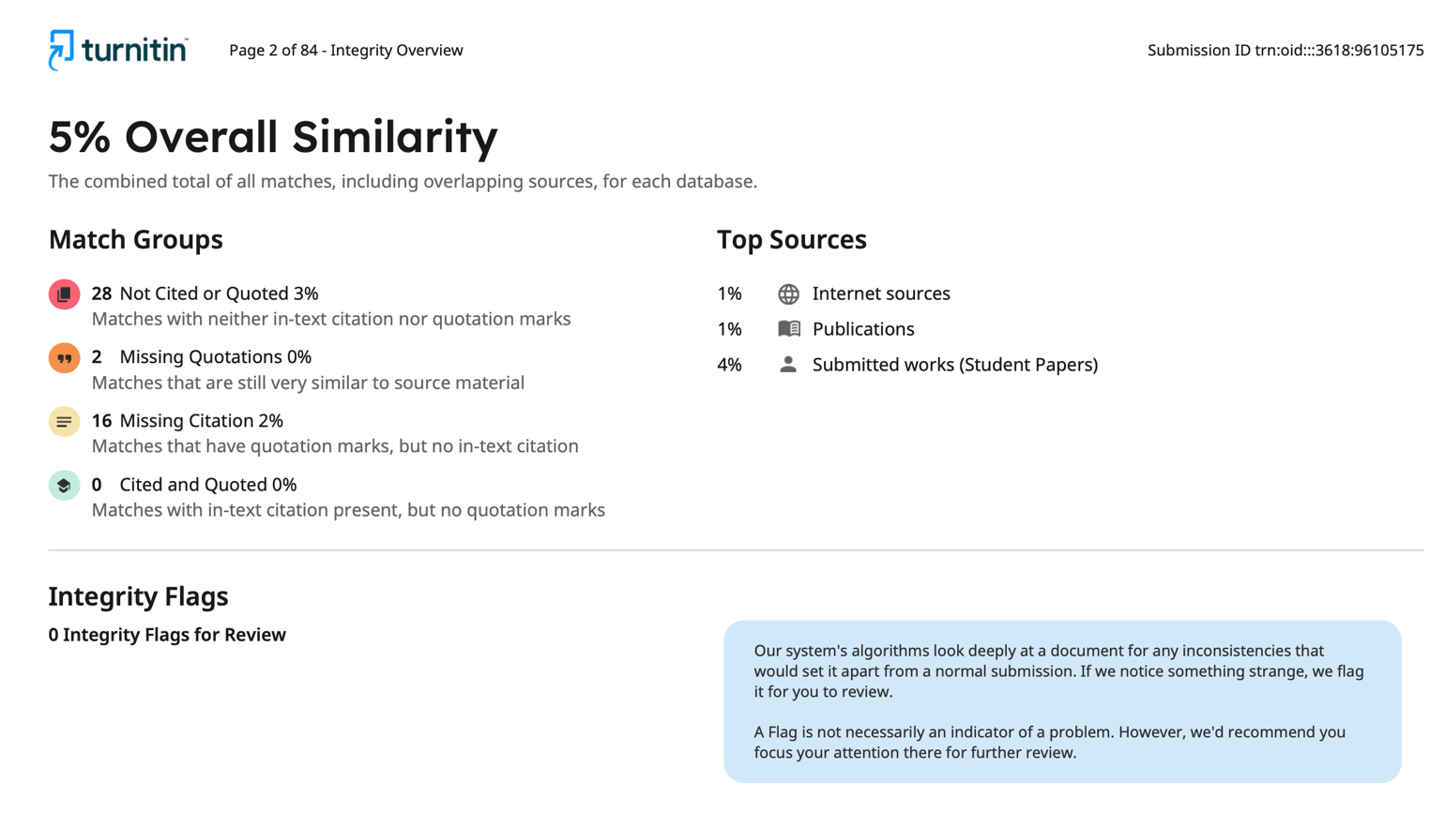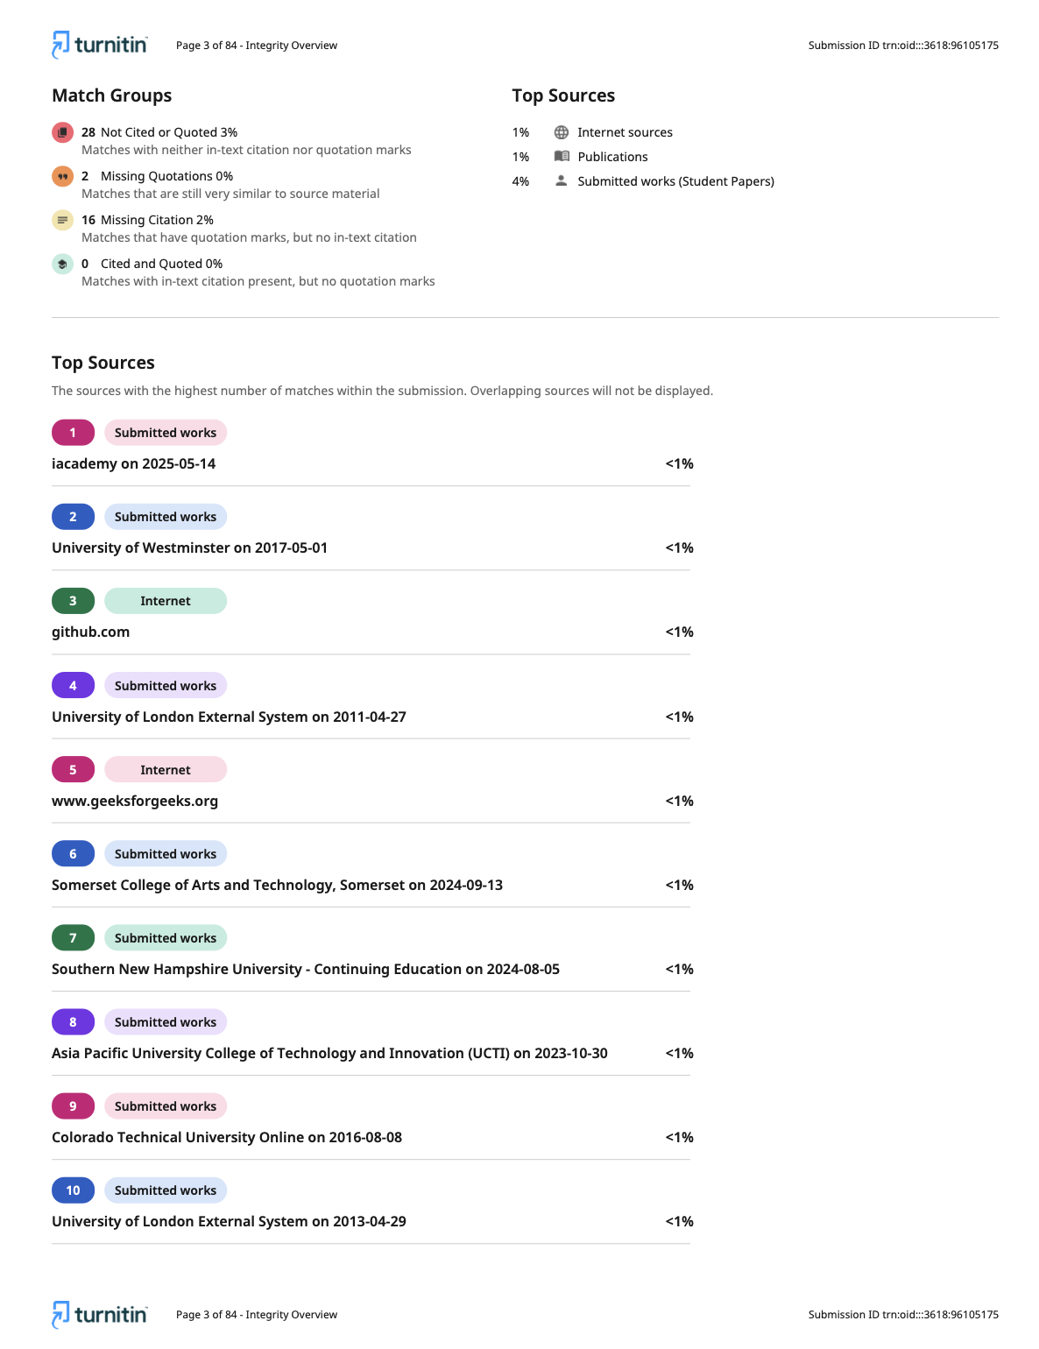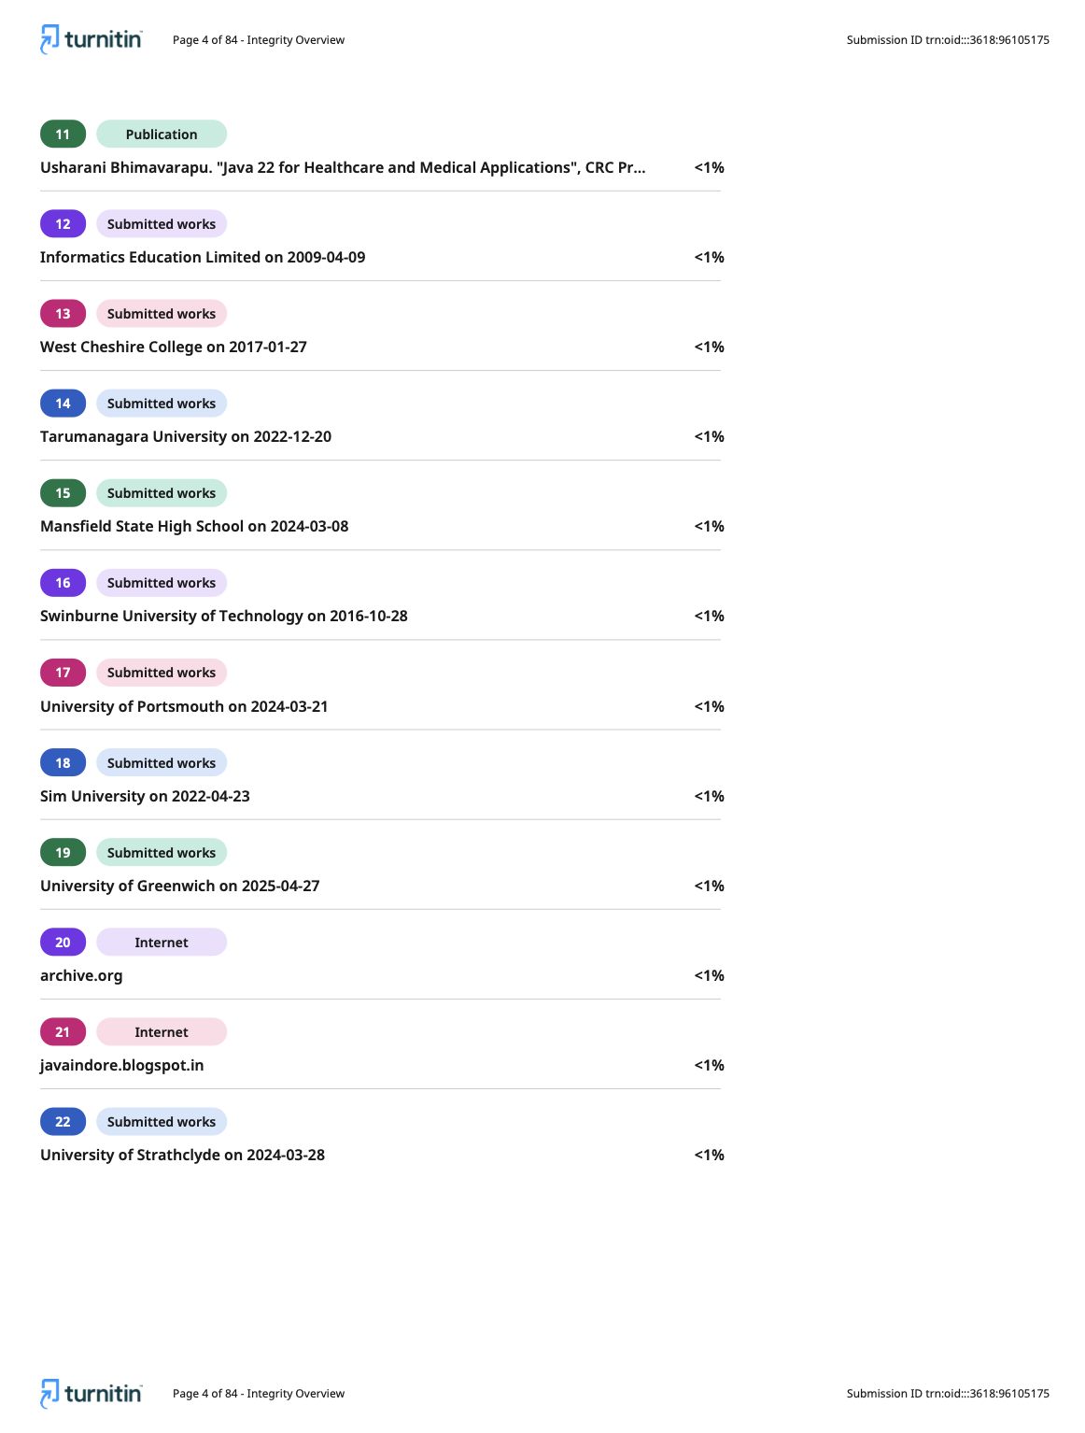

Table of Contents

Introduction 1

Introduction to the coursework: 1

Aim and Objectives: 2

Programming language used: Java 2

Tools used: 4

1. BlueJ 4

2. Draw.io 4

3. Figma 4

GUI wireframe 5

Class Diagram 7

Pseudocode 11

GymMember 11

Regular Member 14

Premium member 18

GymGUI 21

Method Description 53

Methods in GymMember class 53

Methods in RegularMember class 56

Methods in PremiumMember class 59

Method in GymGUI class 62

Testing 63

Test-1 63

Test-2 64

Test-3 69

Test-4 76

Test-5 84

Error Detection and Correction 91

Syntax Error 91

Runtime error 92

Logical error 93

Conclusion 94

Bibliography 95

Appendix (Code Listing) 96

List of tables

Table 1: test-1: compile and run the program 63

Table 2: test-2.1: add regular member 64

Table 3: test-2.2: add premium member 66

Table 4: test-3.1: increase mark attendance 69

Table 5: test-3.2: update plan 72

Table 6: test-4.1: calculate discount 76

Table 7: test-4.2: pay due 79

Table 8: test-4.3: revert member 81

Table 9: test-5.1: save to file 84

Table 10: test-5.2: read from file 89

# Introduction

## Introduction to the coursework:

As a part of first year coursework for programming module, this system is developed. This system is developed considering the scenario of a gym. This system allows the gym to maintain a record for their members which involves their name, contact information as well as their eligibility to use the facilities of the gym. This system not only works to store information but also to track the frequency of members attending the gym as well as counting their loyalty points. Not only that, but this system tracks also whether the member has paid the fee for using the gym or not and if it is paid in full or not.

This system has differentiated between regular members of the gym and premium members who have paid extra to use other facilities of the gym. This coursework required me to use all the Java components which has only been studied and practice but not used for a real-world scenario system. This system combines various components like class, encapsulation, inheritance, abstraction, etc. Different components are used in various places to ensure an easy and functional system.

In this the GymMember class is an abstract class which define the variable, which is used by the child class, RegularMember and PremiumMember. These classes extends the GymMember class and has functions of their own too. These functions are carried out by the help of a GUI named GymGUI class where an user interface is created to help the user navigate through different functions and methods. The buttons present in the GUI triggers different methods to be executed. In this way, this gym system takes life and becomes a fully functioning system.

The regular member frame contains buttons like add regular member, mark attendance, activate/deactivate/revert membership, upgrade plan, save, read from file and many more. As the title of the button suggests, it does these things. Similarly, the premium member frame contains similar button in addition to discount, and pay button.

## Aim and Objectives:

This system was created with the primary goal of developing a working system for a gym. This website has various goals and objectives to be achieved for being a fully functioning system.

**Aim:**

The aim is to develop a functioning gym system which can do series of operations ranging from adding members, marking attendance, updating plans, calculating payment, calculating discount, and many more.

**Objectives:**

1. To create a user-friendly GUI interface.
2. To develop a system which manages different plans for the member and allowing them to upgrade to new plan or to deactivate their membership.
3. To track the information (id, name, location, contact information) of members
4. To implement the payment tracking to ensure members have paid full amount, neither less nor more than the requirement.
5. To make sure some variables values cannot be changed.
6. To give members accurate discounts.

## Programming language used: Java

Java is an object-oriented programming language developed by James Gosling in the year 1995. Java is a widely used OOP language and software platform which runs on many devices worldwide(Anon., 2021). The syntax of Java is based on C and C++ languages. Java is used to develop various mobile application, desktop application, business system, scientific application, database connection and many more.

**Features:**

1. Java has open source and rich API (Application programming Interface) tools available for programmers to use.
2. Java code is portable as it works on different platforms known as platform independent.
3. Java is both complied and interpreted language.
4. Java supports running many small tasks simultaneously. (College, n.d.)

**Concepts:**

1. **Inhritance**: this allows reusability of code. In Java, variables and method used in one class can be used in another class with the concept of inheritance. It is achieved by using the keyword extends. (College, n.d.)
2. **Encapsulation**: the process of wrapping variable and methods into a single unit is called encapsulation. In this coursework encapsulation is achieved by using getter/setter methods. This ensures data security. (College, n.d.)
3. **Abstraction**: this is the process of hiding how the function works and only showing that the function works to the user. It makes sure that all the unnecessary information are hidden from the user. (College, n.d.)
4. **Polymorphism**: polymorphism is a concept which allows same name methods. These methods can do two different things but will have the same name. according to the situation, the required methods are triggered. It is of two types, overloading an overriding

## Tools used:

## BlueJ

BlueJ is a free windows-based platform for JDK (Java Development Kit) started in 1995. BlueJ was developed to help teach and learn OOP (Object-Oriented Programming). It can be freely download from its website. BlueJ is easy to use and has simple interface. It even makes debugging easier as it shows the error line. BlueJ runs on any platform whether it is windows, Mac or Linux (Anon., 2022). BlueJ has several features which ensures user has an easy time using it. It colour codes block of statements to make it easier to read and spot missing brackets. BlueJ allows the user to interact with objects within the program, pass them as parameters, call methods, etc. (Anon., n.d.) (Anon., n.d.)

## Draw.io

It is a free website which allows the user to design variety of stuffs. It lets user create class diagram, flowchart, ER diagram, advanced drawing, anything. It contains variety of diagrammatic tools which assists users to create any visual diagrams of anything. It also allows user to save the created diagram in google drive, one drive or the device itself. There is no need to sign up on this website for basic use. It supports exporting to multiple formats such as PDF, PNG, JPEG, etc. (Anon., n.d.)

In this coursework, draw.io is used to create the class diagram. It already contained the template for the class diagram. It was used to create the class diagrams of the four classes made in this system.

## Figma

Figma is a design tool which is mainly used for UI/UX design, and wireframing websites or any other applications. It runs in your browser so there is no need for installing it. Developers, students and many people use figma for creating wireframes. It also allows user to collaborate with people to make different designs. (Anon., n.d.)

It was used to create the wireframe of the GUI. Different tools of figma was used inorder to create the wireframe of the GUI. Frame, shapes, text, color and many more tools were used to create the wireframe.

# GUI wireframe

Wireframe is a simple visual layout that is made to give the developer some sort of idea on how to arrange stuffs. It might not contains any design, it may be of simple kind just pin pointing where the components should be set.In this coursework, the wireframe is made for the GUI part. This wireframe gives a general idea for arranging various components of the GUI such as label, button, combo box and many more.

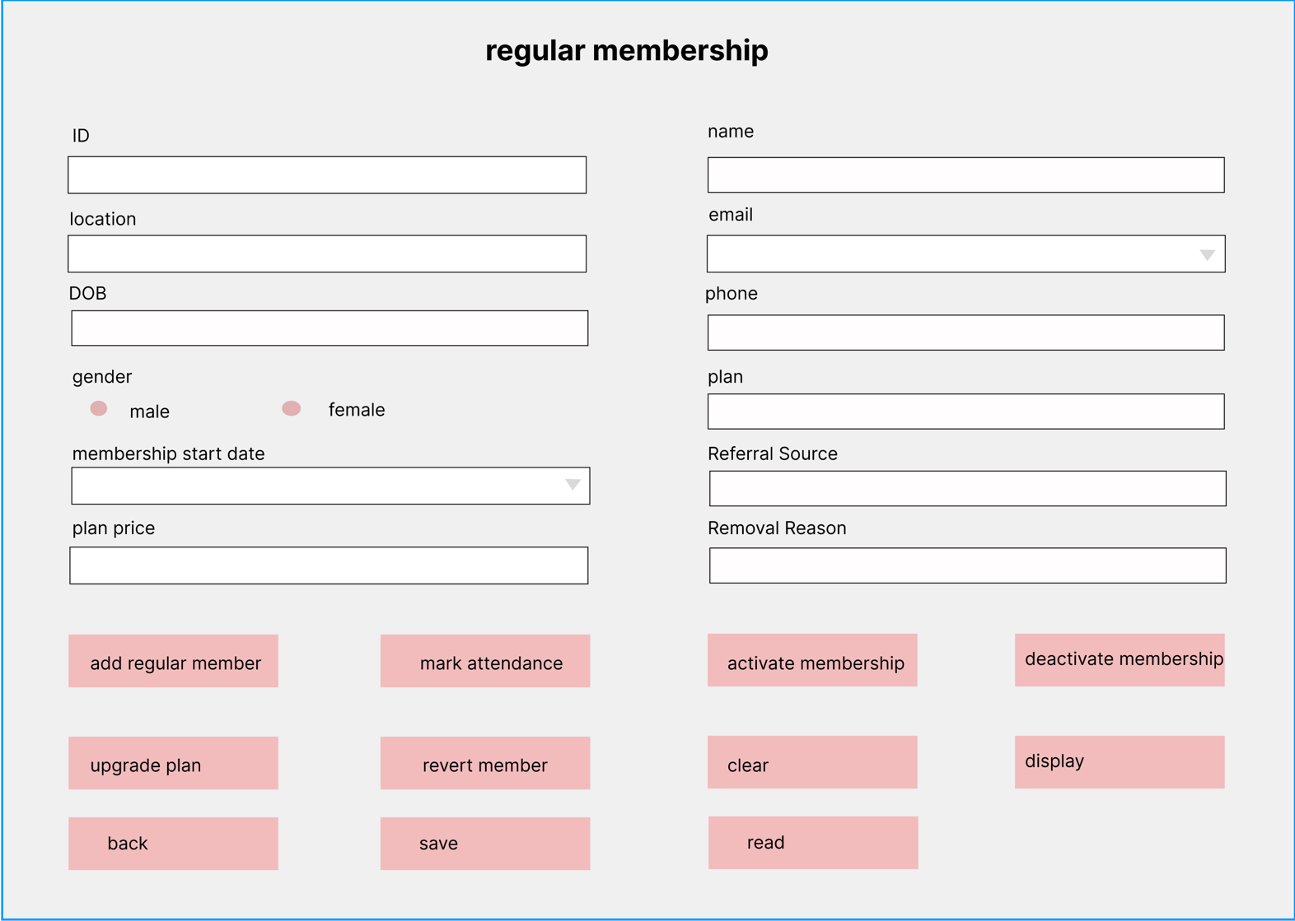

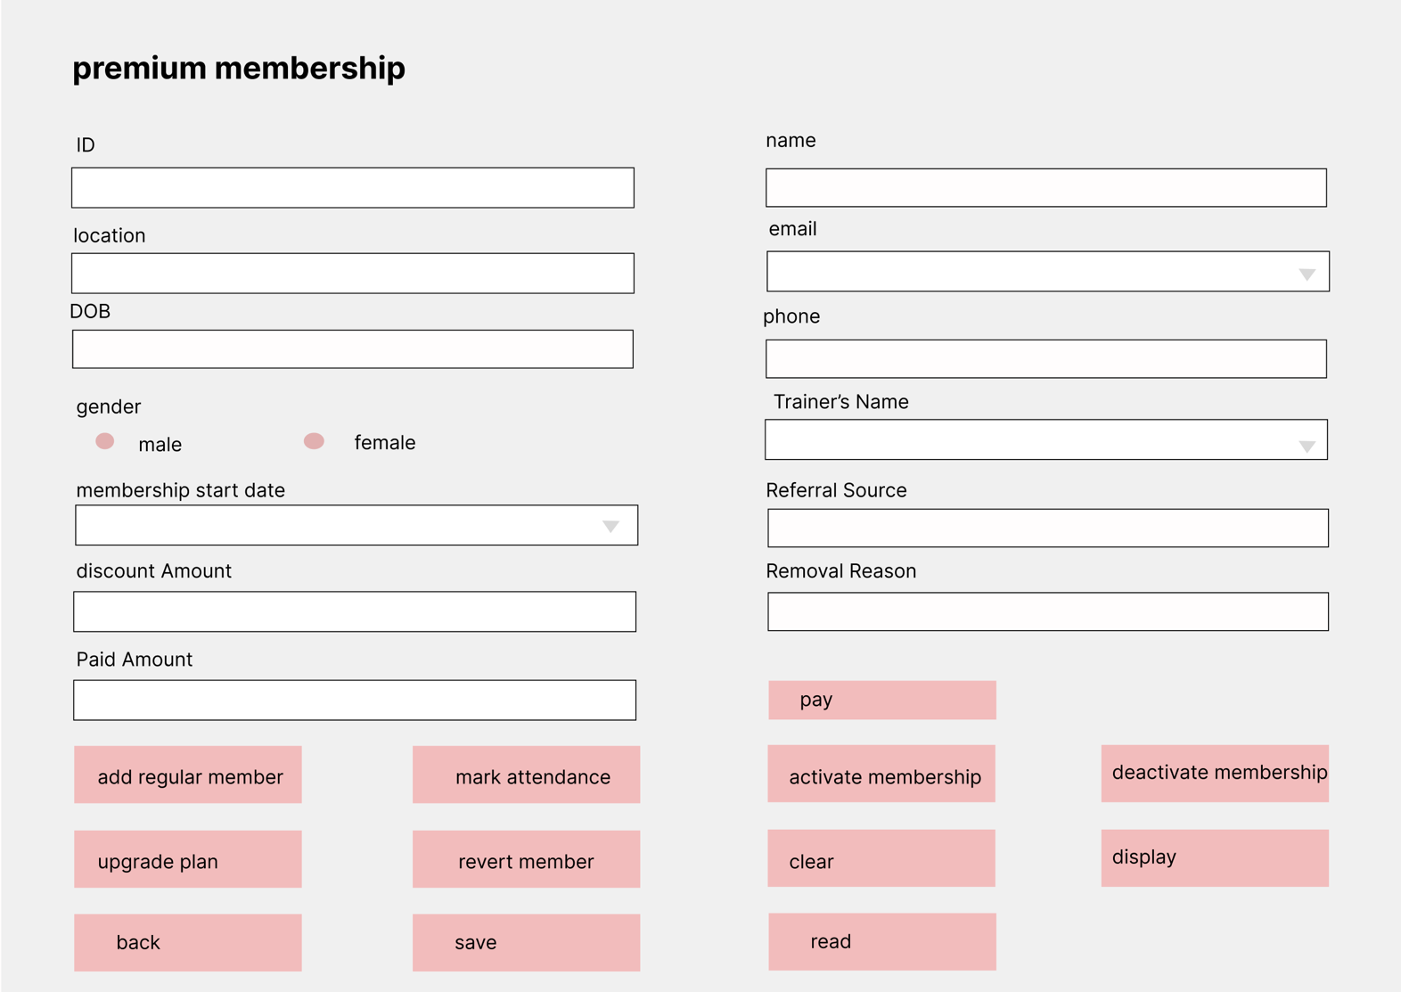

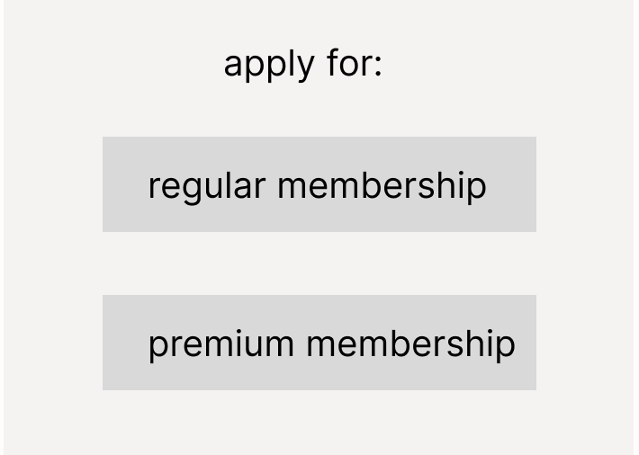

# Class Diagram

Class diagram is a structured diagram that describes the class structure which includes its attributes and methods. Class diagram is the visual representation of a class in object-oriented programming. It contains class name, attributes with datatype and access modifier and methods with return type and access modifiers.

Attribute: access modifier variable_name : datatype

Methods: access modifier method_name : return_type

|  |  |
| --- | --- |
| symbol | meaning |
| + | Public access modifier |
| - | Private access modifier |
| # | Protected access modifier |
| <<constructor>> | Constructor |
| <<abstract>> | Abstract |

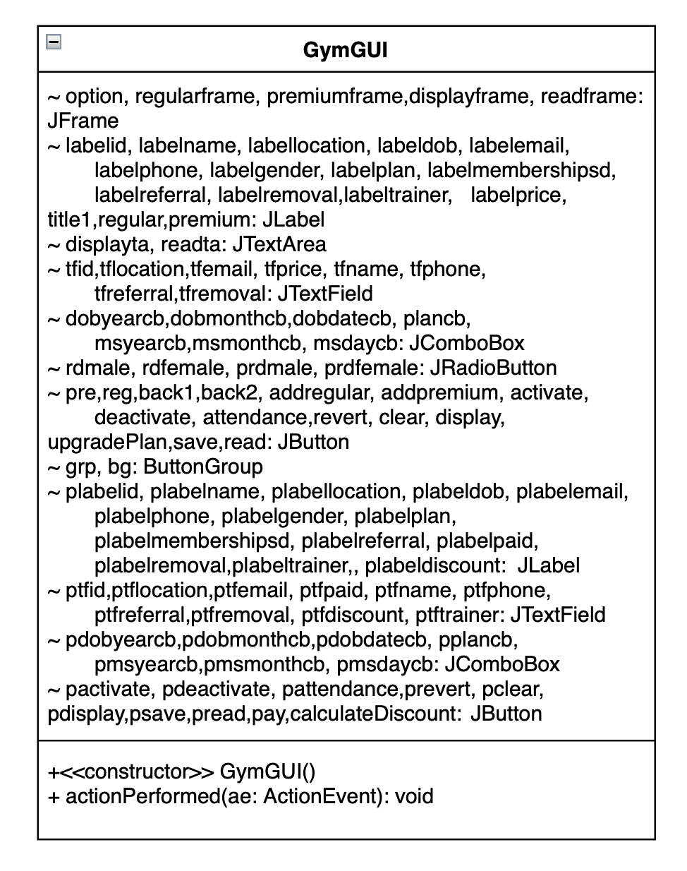

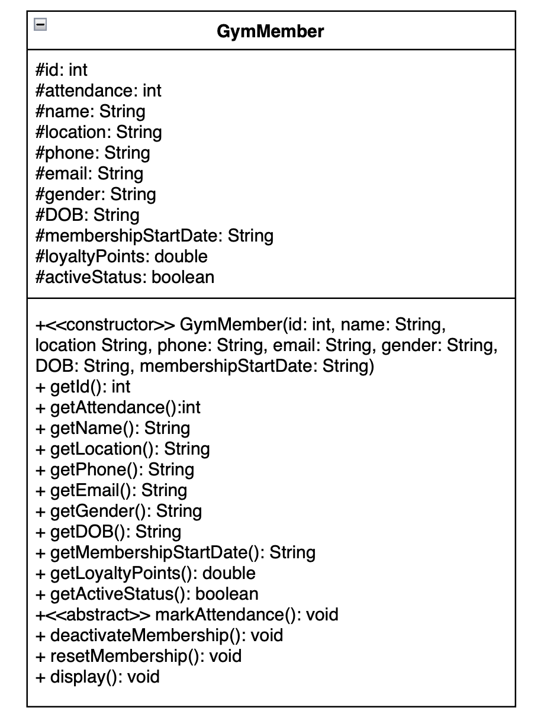

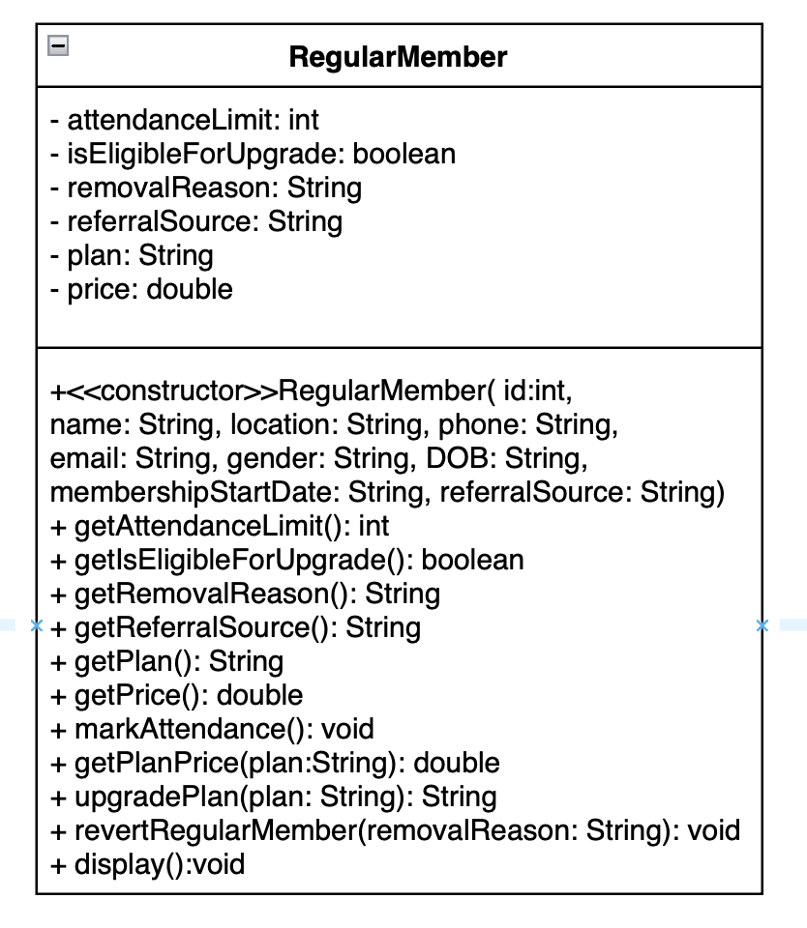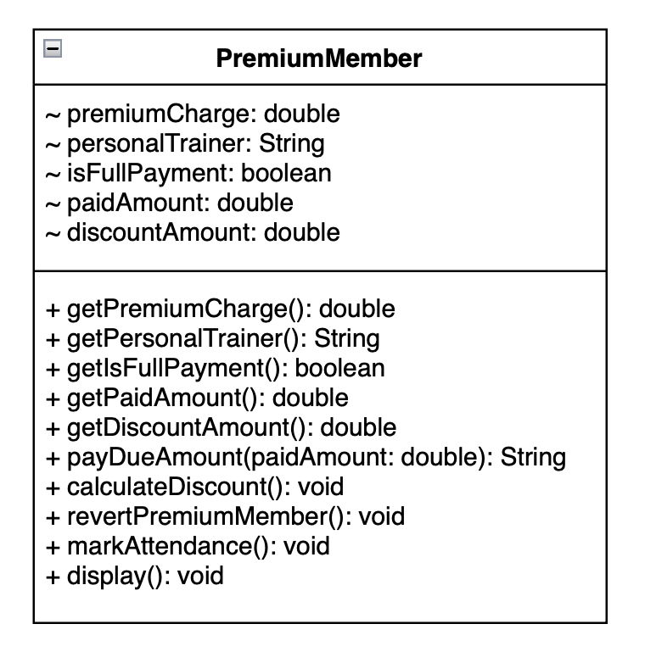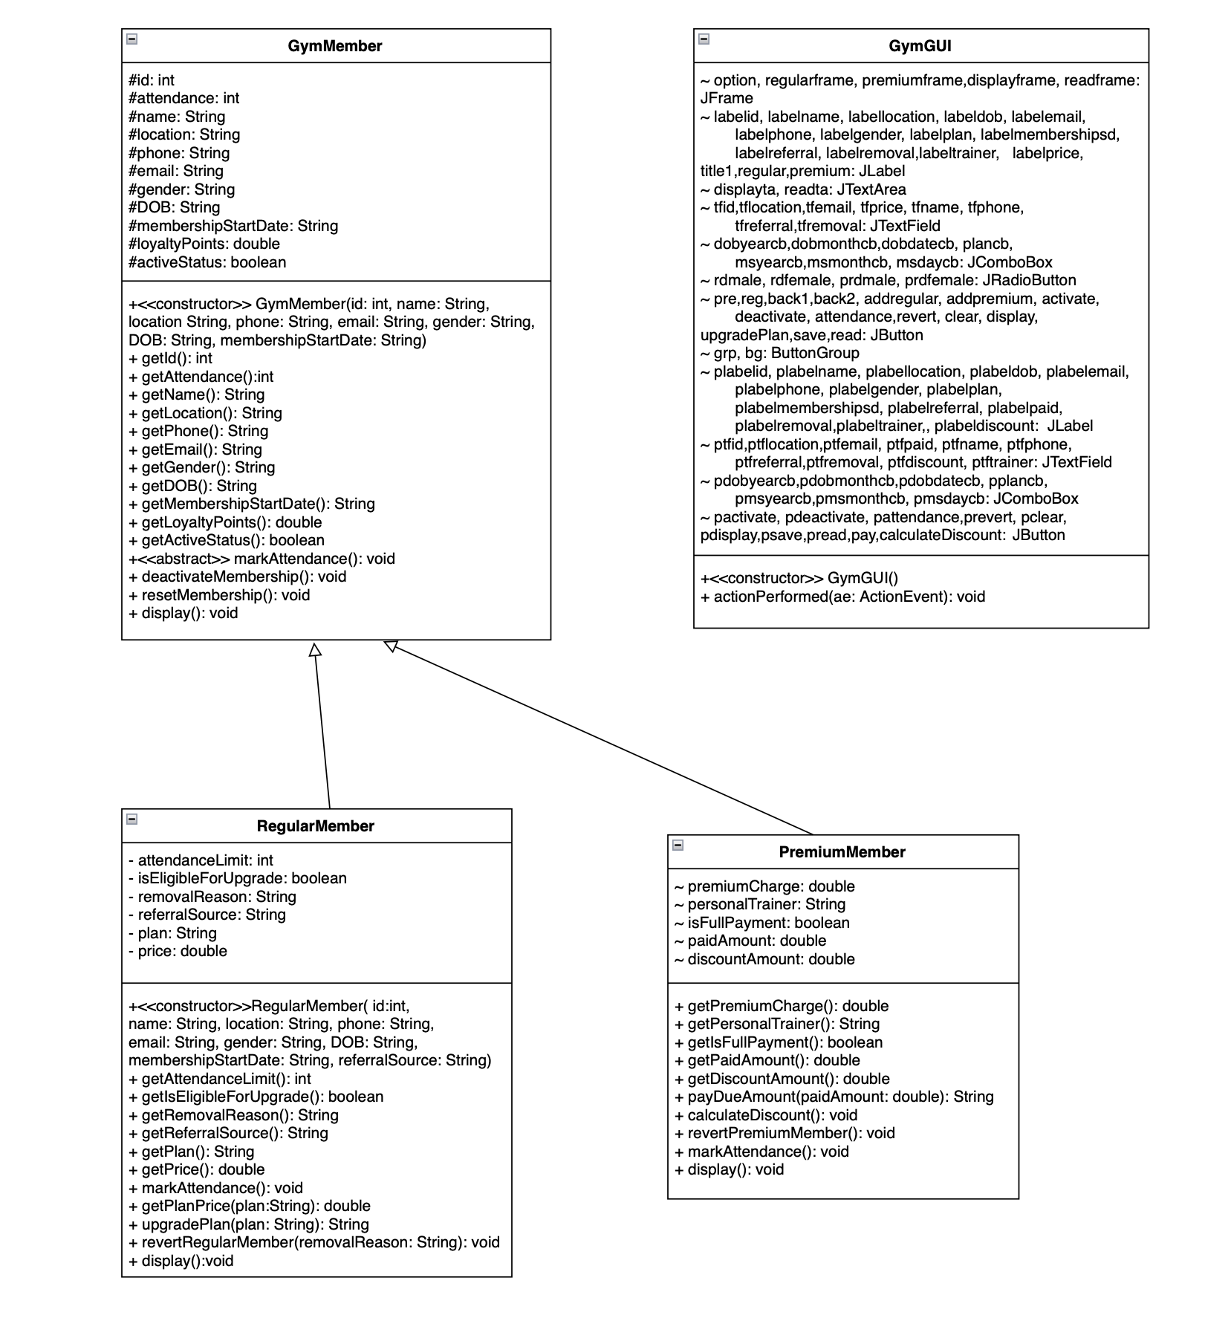

# Pseudocode

Pseudocode is a plain language translation of algorithm. It contains the programs core logic without any actual code. It is written before an actual code. It does. Not use technical terms and uses simple words like create, set, generate, assign and many more. It uses ident to show the hierarchy. It avoids actual syntax rules of programming. It shows how the things are done but not the whole process of it.

## GymMember

**CLASS** GymMember

**DECLARE** INSTANCE VARIABLE id AS protected Integer

**DECLARE** INSTANCE VARIABLE attendance AS protected Integer

**DECLARE** INSTANCE VARIABLE name AS protected String

**DECLARE** INSTANCE VARIABLE location AS protected String

**DECLARE** INSTANCE VARIABLE phone AS protected String

**DECLARE** INSTANCE VARIABLE email AS protected String

**DECLARE** INSTANCE VARIABLE gender AS protected String

**DECLARE** INSTANCE VARIABLE DOB AS protected String

**DECLARE** INSTANCE VARIABLE membershipStartDate AS protected String

**DECLARE** INSTANCE VARIABLE loyaltyPoints AS protected Double

**DECLARE** INSTANCE VARIABLE activeStatus AS protected Boolean

**CREATE** CONSTRUCTOR GymMember (id AS Integer , name AS String, location AS String, phone AS String, email AS String, gender AS String, DOB AS String, membershipStartDate AS String)

**SET** INSTANCE VARIABLE id AS id;

**SET** INSTANCE VARIABLE name AS name;

**SET** INSTANCE VARIABLE location AS location;

**SET** INSTANCE VARIABLE phone AS phone;

**SET** INSTANCE VARIABLE email AS email;

**SET** INSTANCE VARIABLE gender AS gender;

**SET** INSTANCE VARIABLE DOB AS DOB;

**SET** INSTANCE VARIABLE membershipStartDate AS membershipStartDate;

**SET** INSTANCE VARIABLE attendance AS 0;

**SET** INSTANCE VARIABLE loyaltyPoints AS 0;

**SET** INSTANCE VARIABLE activeStatus AS false;

**END** CONSTRUCTOR

**DEFINE** abstract METHOD markAttendance();

**END** METHOD

**DEFINE** METHOD activateMembership()

**SET** activeStatus AS true;

**END** METHOD

**DEFINE** METHOD deactivateMembership()

**IF**(activeStatus)

**SET** activeStatus AS false;

**ELSE**

OUTPUT("It seems like active status is already inactive");

**END** METHOD

**DEFINE** METHOD resetMembership()

**SET** activeStatus AS false;

**SET** attendance AS 0;

**SET** loyaltyPoints AS 0;

**END** METHOD

**DEFINE** METHOD display()

**OUTPUT**("Id: "+id);

**OUTPUT**("Name: "+name);

**OUTPUT**("Location: "+location);

**OUTPUT**("Phone: "+phone);

**OUTPUT**("Email: "+email);

**OUTPUT**("Gender: "+gender);

**OUTPUT**("DOB: "+DOB);

**OUTPUT**("Membership Start Date: "+membershipStartDate);

**OUTPUT**("Attendance: "+attendance);

**OUTPUT**("Loyalty points: "+loyaltyPoints);

**OUTPUT**("Active Status: "+(activeStatus?"active":"inactive"));

**END** METHOD

**END** GymMember

## Regular Member

**CLASS** RegularMember **EXTENDS** GymMember

{

**DECLARE** INSTANCE VARIABLE attendanceLimit AS private Integter

**DECLARE** INSTANCE VARIABLE isEligibleForUpgrade AS private boolean

**DECLARE** INSTANCE VARIABLE removalReason AS private String

**DECLARE** INSTANCE VARIABLE referralSource AS private String

**DECLARE** INSTANCE VARIABLE plan AS private String

**DECLARE** INSTANCE VARIABLE price AS private double

**CREATE** CONSTRUCTOR RegularMember (id AS Integer , name AS String, location AS String, phone AS String, email AS String, gender AS String, DOB AS String, membershipStartDate AS String, referralSource AS String)

**CALL** GymMember CONSTRUCTOR WITH id, name, location, phone, email, gender, DOB, membershipStartDate

**SET** INSTANCE VARIABLE isEligibleForUpgrade AS false

**SET** INSTANCE VARIABLE attendanceLimit AS 30

**SET** INSTANCE VARIABLE plan AS "basic"

**SET** INSTANCE VARIABLE price AS 6500

**SET** INSTANCE VARIABLE removalReason AS ""

**SET** INSTANCE VARIABLE referralSource AS referralSource

**END CONSTRUCTOR**

@Override

**DEFINE** METHOD markAttendance()

**SET** attendance++

**SET** loyaltyPoints += 5

**IF** (getAttendance() >= attendanceLimit)

**SET** isEligibleForUpgrade AS true

**END IF**

**END METHOD**

**DEFINE** METHOD getPlanPrice(String plan) AS double

**DECLARE** double x

**SWITCH**(plan)

case "basic":

**RETURN** 6500

case "standard":

**RETURN** 12500

case "deluxe":

**RETURN** 18500

default:

**RETURN** -1

**END SWITCH**

**END METHOD**

**DEFINE** METHOD upgradePlan(String plan) AS String

**IF** (isEligibleForUpgrade != true)

**RETURN** "the member is not eligible for upgrade"

**ELSE**

**IF**(INSTANCE VARIABLE plan == plan

**RETURN** "the member has chosen the same plan"

**ELSE**

**IF**(getPlanPrice(plan) == -1)

**RETURN** "the member has entered invalid plan"

**ELSE**

**SET** INSTANCE VARIABLE plan AS plan

**SET** INSTANCE VARIABLE price AS getPlanPrice(plan)

**RETURN** ("plan upgraded to "+plan+" price = "+price)

**END IF**

**END IF**

**END IF**

**END METHOD**

**DEFINE** METHOD revertRegularMember(String removalReason)

**CALL** PARENT CLASS METHOD resetMembership()

**SET** INSTANCE VARIABLE isEligibleForUpgrade AS false

**SET** INSTANCE VARIABLE plan AS "basic"

**SET** INSTANCE VARIABLE price AS 6500

**SET** INSTANCE VARIABLE removalReason AS removalReason

**END METHOD**

@Override

**DEFINE** METHOD void display()

**CALL** PARENT CLASS METHOD display()

**OUTPUT** ("plan: "+plan)

**OUTPUT** ("price: "+price)

**IF** (removalReason != "")

**OUTPUT** ("removal reason: "+removalReason)

**END IF**

**END METHOD**

**END CLASS**

## Premium member

**CLASS** PremiumMember EXTENDS GymMember

{

**DECLARE** INSTANCE VARIABLE premiumCharge AS double

**DECLARE** INSTANCE VARIABLE personalTrainer AS String

**DECLARE** INSTANCE VARIABLE isFullPayment AS boolean

**DECLARE** INSTANCE VARIABLE paidAmount AS double

**DECLARE** INSTANCE VARIABLE discountAmount AS double

**CREATE** CONSTRUCTOR PremiumMember (id AS Integer , name AS String, location AS String, phone AS String, email AS String, gender AS String, DOB AS String, membershipStartDate AS String, personalTrainer AS String)

**CALL** PARENT CLASS CONSTRUCTOR (id, name, location, phone, email, gender, DOB, membershipStartDate)

**SET** INSTANCE VARIABLE premiumCharge=50000

**SET** INSTANCE VARIABLE paidAmount=0

**SET** INSTANCE VARIABLE isFullPayment=false

**SET** INSTANCE VARIABLE discountAmount=0

**SET** INSTANCE VARIABLE personalTrainer=personalTrainer

**END CONSTRUCTOR**

**DECLARE** METHOD payDueAmount (double paidAmount) AS String

**IF** (INSTANCE VARIABLE paidAmount==premiumCharge)

INSTANCE VARIABLE isFullPayment=true

**END IF**

**IF** (INSTANCE VARIABLE isFullPayment)

**OUTPUT** ("full payment has been done")

**RETURN** "the member has already paid full amount"

**ELSE**

**SET** INSTANCE VARIABLE paidAmount += paidAmount

**IF** (INSTANCE VARIABLE paidAmount > premiumCharge)

**SET** INSTANCE VARIABLE paidAmount -= paidAmount

**OUTPUT** ("the member has paid more than premiumCharge.")

**RETURN** "please pay the correct amount"

**ELSE**

**OUTPUT** ("payment was successful")

**RETURN** "remaining Amount="+(premiumCharge-INSTANCE VARIABLE paidAmount)

**END IF**

**END IF**

**END METHOD**

**DECLARE** METHOD calculateDiscount()

**IF** (INSTANCE VARIABLE isFullPayment)

**SET** INSTANCE VARIABLE discountAmount = (10/100)*premiumCharge

**OUTPUT** ("discount is calculated. discount amount= "

+INSTANCE VARIABLE discountAmount)

**ELSE**

**OUTPUT** ("discount is not available")

**END IF**

**END METHOD**

**DECLARE** METHOD revertPremiumMember()

**CALL** PARENT CLASS METHOD resetMembership()

**SET** INSTANCE VARIABLE personalTrainer AS EMPTY

**SET** INSTANCE VARIABLE isFullPayment AS false

**SET** INSTANCE VARIABLE paidAmount AS 0

**SET** INSTANCE VARIABLE discountAmount AS 0

**END METHOD**

@Override

**DECLARE** METHOD markAttendance()

**SET** attendance++

**SET** loyaltyPoints+=10

**END METHOD**

@Override

**DECLARE** METHOD display()

**CALL** PARENT CLASS METHOD display()

**OUTPUT** ("personal trainer= "+personalTrainer)

**OUTPUT** ("paid amount= "+paidAmount)

**OUTPUT** ("is the amount fully paid= "+(isFullPayment?"yes":"no"))

**IF** (INSTANCE VARIABLE isFullPayment)

**OUTPUT** ("discount amount= "+discountAmount)

**ELSE** **IF** (INSTANCE VARIABLE paidAmount < premiumCharge)

**OUTPUT** ("remaining Amount="+(premiumCharge-INSTANCE VARIABLE paidAmount))

**END IF**

**END METHOD**

**END CLASS**

## GymGUI

**IMPORT** ArrayList FROM java.util

**IMPORT** JFrame FROM javax.swing

**IMPORT** JLabel FROM javax.swing

**IMPORT** JTextField FROM javax. swing

**IMPORT** JTextArea FROM javax. swing

**IMPORT** JComboBox FROM javax. swing

**IMPORT** JRadioButton FROM javax. swing

**IMPORT** JButton FROM javax. swing

**IMPORT** ButtonGroup FROM javax. swing

**IMPORT** ActionListener FROM java.awt.event

**IMPORT** ActionEvent FROM java.awt.event

**IMPORT** JOptionPane FROM javax. swing

**IMPORT** Font FROM java.awt

**IMPORT** Color FROM java.awt

**IMPORT** File FROM java.io

**IMPORT** FileWriter FROM java.io

**IMPORT** IOException FROM java.io

**IMPORT** FileReader FROM java.io

**IMPORT** FileNotFoundException FROM java.io

**CLASS** GymGUI IMPLEMENTS ActionListener

**INITIALIZE** list to store GymMember objects

**DEFINE** METHOD main

CALL CONSTRUC**TO**R GymGUI

**END** METHOD

**DECLARE** option, regularframe, premiumframe, readframe **AS** JFrame

**DECLARE** displayta, readta **AS** JTextArea

**DECLARE** labelid, labelname, labellocation, labeldob, labelemail, labelphone, labelgender, labelplan, labelmembershipsd, labelreferral, labelremoval,labeltrainer, labelprice, title1,regular,premium **AS** JLabel

**DECLARE** plabelid, plabelname, plabellocation, plabeldob, plabelemail, plabelphone, plabelgender, plabelplan, plabelmembershipsd, plabelreferral, plabelpaid, plabelremoval,plabeltrainer, plabeldiscount **AS** JLabel

**DECLARE** tfid,tflocation,tfemail, tfprice, tfname, tfphone, tfreferral,tfremoval **AS** JTextField

**DECLARE** dobyearcb,dobmonthcb,dobdatecb, plancb, msyearcb,msmonthcb, msdaycb, pdobyearcb,pdobmonthcb,pdobdatecb, pplancb, pmsyearcb,pmsmonthcb, pmsdaycb **AS** JComboBox

**DECLARE** rdmale, rdfemale, prdmale, prdfemale **AS** JRadioButton

**DECLARE** grp, bg **AS** ButtonGroup

**DECLARE** **ADD**regular, activate, deactivate, attendance,revert, clear, display, upgradePlan, save, read, pre, reg, back1, back2, **ADD**premium, pactivate, pdeactivate, pattendance, prevert, pclear, pdisplay,calculateDisco **AS** JButton

**DECLARE** ptfid, ptflocation, ptfemail, ptfpaid, ptfname, ptfphone, ptfreferral, ptfremoval, ptfdiscount, ptftrainer **AS** JTextField

CONSTRUC**TO**R GymGUI

CREATE INSTANCE VARIABLE option **AS** JFrame

**SET** INSTANCE VARIABLE title1 **AS** “apply for:”

**SET** INSTANCE VARIABLE reg **AS** “regular membership”

**SET** INSTANCE VARIABLE pre **AS** “premium membership”

**SET** BOUNDS title1 **TO** (110,5,120,30)

**SET** BOUNDS reg **TO** (50,50,200,60)

**SET** BOUNDS pre TP (50,120,200,60)

**ADD** title1, pre, reg **TO** option frame

**SET** layout null

**SET** visibility true

**SET** size (300,250)

CREATE INSTANCE VARIABLE regularframe **AS** JFrame

**SET** INSTANCE VARIABLE regular **AS** “regular membership application”

**SET** INSTANCE VARIABLE labelid, labelname, labellocation, labeldob, labelemail, labelphone, labelgender, labelplan, labelmembershipsd, labelreferral, labelremoval, labelprice **AS** “ID”, “name”, “location”, “DOB”, “email”, “phone”, “gender”, “plan”, “membership start date”, “referral source”, “removal reason”, “plan price” respectively

INITIALIZE all **DECLARE**d JTextField and ComboBox

//**SET**ting radio button

**SET** INSTANCE VARIABLE rdmale **AS** “male”

**SET** INSTANCE VARIABLE rdfemale **AS** “female”

//**SET**ting buttons

**SET** INSTANCE VARIABLE addregular **AS** ("**ADD** Regular Member")

**SET** INSTANCE VARIABLE addpremium **AS** ("**ADD** Premium Member")

**SET** INSTANCE VARIABLE activate **AS** ("Activate Membership")

**SET** INSTANCE VARIABLE deactivate **AS** ("Deactivate Membership")

**SET** INSTANCE VARIABLE attendance **AS** ("Mark Attendance")

**SET** INSTANCE VARIABLE revert **AS** ("Revert Membership")

**SET** INSTANCE VARIABLE clear **AS** ("Clear")

**SET** INSTANCE VARIABLE display **AS** ("Display")

**SET** INSTANCE VARIABLE back1 **AS** ("Back")

**SET** INSTANCE VARIABLE upgradePlan **AS** ("Upgrade Plan")

**SET** INSTANCE VARIABLE save **AS** ("Save")

**SET** INSTANCE VARIABLE read **AS** ("Read from file")

**SET** BOUNDS regular **TO** (465,15,400,50)

**SET** BOUNDS labelid **TO** (50,110,100,25)

**SET** BOUNDS labellocation **TO** (50,200,100,25)

**SET** BOUNDS labeldob **TO** (50,290,100,25)

**SET** BOUNDS labelgender **TO** (50,380,100,25)

**SET** BOUNDS labelmembershipsd **TO** (50,470,150,25)

**SET** BOUNDS labelprice **TO** (50,560,100,25)

**SET** BOUNDS labelname **TO** (640,110,100,25)

**SET** BOUNDS labelemail **TO** (640,200,100,25)

**SET** BOUNDS labelphone **TO** (640,290,100,25)

**SET** BOUNDS labelplan **TO** (640,380,100,25)

**SET** BOUNDS labelreferral **TO** (640,470,100,25)

**SET** BOUNDS labelremoval **TO** (640,560,150,25)

**SET** BOUNDS addregular **TO** (50,680,220,55)

**SET** BOUNDS attendance **TO** (350,680,220,55)

**SET** BOUNDS activate **TO** (670,680,220,55)

**SET** BOUNDS deactivate **TO** (970,680,220,55)

**SET** BOUNDS revert **TO** (350,760,220,55)

**SET** BOUNDS clear **TO** (670,760,220,55)

**SET** BOUNDS display **TO** (970,760,220,55)

**SET** BOUNDS upgradePlan **TO** (50,760,220,55)

**SET** BOUNDS back1 **TO** (50,840,220,55)

**SET** BOUNDS save **TO** (350,840,220,55)

**SET** BOUNDS read **TO** (670,840,220,55)

**SET** BOUNDS tfid **TO** (48,140,550,40)

**SET** BOUNDS tflocation **TO** (48,230,550,40)

**SET** BOUNDS tfemail **TO** (638,230,550,40)

**SET** BOUNDS tfprice **TO** (48,590,550,40)

**SET** BOUNDS tfname **TO** (638,140,550,40)

**SET** BOUNDS tfphone **TO** (638,320,550,40)

**SET** BOUNDS tfreferral **TO** (638,500,550,40)

**SET** BOUNDS tfremoval **TO** (638,590,550,40)

**SET** BOUNDS rdmale **TO** (48,410,100,30)

**SET** BOUNDS rdfemale **TO** (150,410,100,30)

**SET** BOUNDS plancb **TO** (638,400,550,70)

**SET** BOUNDS dobyearcb **TO** (48,320,100,50)

**SET** BOUNDS dobmonthcb **TO** (148,320,100,50)

**SET** BOUNDS dobdatecb **TO** (248,320,100,50)

**SET** BOUNDS msyearcb **TO** (48,500,100,50)

**SET** BOUNDS msmonthcb **TO** (148,500,100,50)

**SET** BOUNDS msdaycb **TO** (248,500,100,50)

**ADD** **SET** initialized JLabel, JTextField, JButton, JRadioButton, JComboBox **TO** regularframe

**SET** layout null

**SET** visibility false

**SET** size (1250,950)

**SET** INSTANCE VARIABLE premiumframe **AS** JFrame("")

**SET** INSTANCE VARIABLE premium **AS** "Premium Membership Application"

**SET** INSTANCE VARIABLE plabelid **AS** ("ID")

**SET** INSTANCE VARIABLE plabelname **AS** ("Name")

**SET** INSTANCE VARIABLE plabellocation **AS** ("Location")

**SET** INSTANCE VARIABLE plabeldob **AS** ("DOB")

**SET** INSTANCE VARIABLE plabelemail **AS** ("Email")

**SET** INSTANCE VARIABLE plabelphone **AS** ("Phone")

**SET** INSTANCE VARIABLE plabelgender **AS** ("Gender")

**SET** INSTANCE VARIABLE plabelplan **AS** ("Plan")

**SET** INSTANCE VARIABLE plabelmembershipsd **AS** ("Membership Start Date")

**SET** INSTANCE VARIABLE plabelreferral **AS** ("Referral Source")

**SET** INSTANCE VARIABLE plabelpaid **AS** ("Paid Amount")

**SET** INSTANCE VARIABLE plabelremoval **AS** ("Removal Re**AS**on")

**SET** INSTANCE VARIABLE plabeltrainer **AS** ("Trainer's Name")

**SET** INSTANCE VARIABLE plabeldiscount **AS** ("Discount Amount")

INITIALIZE all declared JTextField and ComboBox

//**SET**ting radio button

**SET** INSTANCE VARIABLE prdmale **AS** “male”

**SET** INSTANCE VARIABLE prdfemale **AS** “female”

**SET** INSTANCE VARIABLE addpremium **AS** ("add Premium Member")

**SET** INSTANCE VARIABLE pactivate **AS** ("Activate Membership")

**SET** INSTANCE VARIABLE pdeactivate **AS** ("Deactivate Membership")

**SET** INSTANCE VARIABLE pattendance **AS** ("Mark Attendance")

**SET** INSTANCE VARIABLE prevert **AS** ("Revert Membership")

**SET** INSTANCE VARIABLE pclear **AS** ("Clear")

**SET** INSTANCE VARIABLE pdisplay **AS** ("Display")

**SET** INSTANCE VARIABLE back2 **AS** ("Back")

**SET** INSTANCE VARIABLE psave **AS** ("Save")

**SET** INSTANCE VARIABLE pread **AS** ("Read from file")

**SET** INSTANCE VARIABLE calculateDiscount **AS** ("Discount")

**SET** INSTANCE VARIABLE pay **AS** ("Pay")

**SET** BOUNDS premium **TO** (465,15,500,50)

**SET** BOUNDS plabelid **TO** (50,110,100,25)

**SET** BOUNDS plabellocation **TO** (50,200,100,25)

**SET** BOUNDS plabeldob **TO** (50,290,100,25)

**SET** BOUNDS plabelgender **TO** (50,380,100,25)

**SET** BOUNDS plabelmembershipsd **TO** (50,470,150,25)

**SET** BOUNDS plabeldiscount **TO** (50,560,150,25)

**SET** BOUNDS plabelpaid **TO** (50,650,100,25)

**SET** BOUNDS plabelname **TO** (640,110,100,25)

**SET** BOUNDS plabelemail **TO** (640,200,100,25)

**SET** BOUNDS plabelphone **TO** (640,290,100,25)

**SET** BOUNDS labeltrainer **TO** (640,380,100,25)

**SET** BOUNDS plabelreferral **TO** (640,470,100,25)

**SET** BOUNDS plabelremoval **TO** (640,560,150,25)

**SET** BOUNDS pay **TO** (638,680,220,45)

**SET** BOUNDS addpremium **TO** (50,760,220,55)

**SET** BOUNDS pattendance **TO** (350,760,220,55)

**SET** BOUNDS pactivate **TO** (670,760,220,55)

**SET** BOUNDS pdeactivate **TO** (970,760,220,55)

**SET** BOUNDS prevert **TO** (350,835,220,55)

**SET** BOUNDS pclear **TO** (670,835,220,55)

**SET** BOUNDS pdisplay **TO** (970,835,220,55)

**SET** BOUNDS calculateDiscount **TO** (50,835,220,55)

**SET** BOUNDS back2 **TO** (50,910,220,55)

**SET** BOUNDS psave **TO** (350,910,220,55)

**SET** BOUNDS pread **TO** (670,910,220,55)

**SET** BOUNDS ptfid **TO** (48,140,550,40)

**SET** BOUNDS ptflocation **TO** (48,230,550,40)

**SET** BOUNDS ptfemail **TO** (638,230,550,40)

**SET** BOUNDS ptfdiscount **TO** (48,590,550,40)

**SET** BOUNDS ptfpaid **TO** (48,680,550,40)

**SET** BOUNDS ptfname **TO** (638,140,550,40)

**SET** BOUNDS ptfphone **TO** (638,320,550,40)

**SET** BOUNDS ptfreferral **TO** (638,500,550,40)

**SET** BOUNDS ptfremoval **TO** (638,590,550,40)

**SET** BOUNDS ptftrainer **TO** (638,410,550,40)

**SET** BOUNDS prdmale **TO** (48,410,100,30)

**SET** BOUNDS prdfemale **TO** (150,410,100,30)

**SET** BOUNDS pdobyearcb **TO** (48,320,100,50)

**SET** BOUNDS pdobmonthcb **TO** (148,320,100,50)

**SET** BOUNDS pdobdatecb **TO** (248,320,100,50)

**SET** BOUNDS pmsyearcb **TO** (48,500,100,50)

**SET** BOUNDS pmsmonthcb **TO** (148,500,100,50)

**SET** BOUNDS pmsdaycb **TO** (248,500,100,50)

**ADD** **SET** initialized JLabel, JTextField, JButton, JRadioButton, JComboBox **TO** premiumframe

**SET** layout null

**SET** visibility false

**SET** size (1250,1000)

**SET** INSTANCE VARIABLE displayframe **AS** JFrame

**SET** INSTANCE VARIABLE displayta **AS** JTextArea

**SET** BOUNDS displayta **AS** (5,5,890,890)

**ADD** displayta **TO** displayframe

**SET** layout null

**SET** visibility false

**SET** size (900,900)

**SET** INSTANCE VARIABLE readframe **AS** JFrame

**SET** INSTANCE VARIABLE readta **AS** JTextArea

**SET** BOUNDS readta **AS** (5,5,890,890)

**ADD** readta **TO** readframe

**SET** layout null

**SET** visibility false

**SET** size (1350,300)

**DEFINE** METHOD actionPerformed (ae  **AS**  ActionEvent)

**IF**(event source is reg)

**SET** VISIBLE of option **AS** (false)

**SET** VISIBLE of regularframe **AS** (true)

**SET** VISIBLE of premiumframe **AS** (false)

**END IF**

**ELSE** **IF**(event source is plancb)

String s= (String)plancb.getSelectedItem()

**IF**(s=="Basic")

tfprice.setText("6500")

**END IF**

**ELSE** **IF**(s=="Standard")

tfprice.setText("12500")

**END ELSE IF**

**ELSE**

tfprice.setText("18500")

**END IF**

**END ELSE IF**

**ELSE** **IF** event source is pre

**SET** VISIBLE of option **AS** (false)

**SET** VISIBLE of premiumframe **AS** (true)

**SET** VISIBLE of regularframe **AS** (false)

**END ELSE IF**

**ELSE** **IF**(ae.getSource()==back1)

**SET** VISIBLE of option **AS** (true)

**SET** VISIBLE of regularframe **AS** (false)

**END ELSE IF**

**ELSE** **IF**(event source is back2)

**SET** VISIBLE of option **AS** (true)

**SET** VISIBLE of premiumframe **AS** (false)

**END ELSE IF**

**ELSE**  **IF** (event source is addregular)

**IF** (tfid.getText().isEmpty()|| tflocation.getText().isEmpty()|| tfemail.getText().isEmpty()||

tfname.getText().isEmpty()||tfphone.getText().isEmpty()||tfreferral.getText().isEmpty())

**MESSAGE** (regularframe,"please fill in the application");

**ELSE**

**TRY**{

**SET** int regId = Integer.parseInt(tfid.getText());

**SET** String regLocation = tflocation.getText();

**SET** String regEmail = tfemail.getText();

**SET** String regName = tfname.getText();

**SET** String regPhone = tfphone.getText();

**SET** String regReferral = tfreferral.getText();

**SET** String regGender="";

**SET** String regPlan= (String) plancb.getSelectedItem();

**IF** (rdmale.isSelected())

**SET** regGender="male";

**ELSE**  **IF** (rdfemale.isSelected())

**SET** regGender="female";

**SET** String year= (String) dobyearcb.getSelectedItem();

**SET** String month= (String) dobmonthcb.getSelectedItem(); //combo box creates object and (String) converts it into string

**SET** String date= (String) dobdatecb.getSelectedItem();

**SET** String regDob= date+"-"+month+"-"+year;

**SET** String myear= (String) msyearcb.getSelectedItem();

**SET** String mmonth= (String) msmonthcb.getSelectedItem(); //combo box creates object and (String) converts it into string

**SET** String mdate= (String) msdaycb.getSelectedItem();

**SET** String regMembershipsd= mdate+"-"+mmonth+"-"+myear;

**IF** (al1.isEmpty())

**CREATE** RegularMember regobj = new RegularMember(regId,regName,regLocation,regPhone,regEmail,

regGender,regDob, regMembershipsd, regReferral);

al1.add(regobj);

**MESSAGE** (regularframe,"Regular Member added succesfully");

**ELSE**

**SET** boolean idexistence=false;

**FOR** (GymMember mem : al1)

**IF** (mem.getId()==regId) //**FOR**  each loop le array ma vako id haru tanera bhakhar input gareko id sanga same xa xaina check garxa

**SET** idexistence=true;

break;//loop bata baira niskinxa

**END**  **IF**

**END**  FOR

**IF** (idexistence)

**MESSAGE** (regularframe,"Member with this id already exists. please choose another ID.","Duplication",JOptionPane.ERROR_MESSAGE);

**ELSE**

RegularMember regobj = new RegularMember(regId,regName,regLocation,regPhone,regEmail,

regGender,regDob, regMembershipsd, regReferral);

al1.add(regobj);

**MESSAGE** (regularframe,"Regular Member added succesfully");

**END**  **IF**

**END**  **IF**

**END**  **IF**

**CATCH**(NumberFormatException ex)

**MESSAGE** (regularframe,"ID can only have number values!","Error",JOptionPane.WARNING_MESSAGE);

**END**  **IF**

**END**  **ELSE**  **IF**

**ELSE**  **IF** (event source is attendance)

**IF** (tfid.getText().isEmpty())

**SHOW MESSAGE** (please fill in the id")

**ELSE**

**TRY{**

**SET** int regId AS Integer.parseInt(tfid.getText())

**SET** boolean idexistence AS false

**SET** GymMember memberexistence AS null

**FOR** (GymMember member : al1)

**IF** (member.getId()==regId)

**SET** idexistence AS true

**SET** memberexistence AS member

**BREAK**

**END** **IF**

**END** **FOR**

**IF** (idexistence)

**IF** (memberexistence.getActiveStatus())**{**

**CALL** memberexistence.markAttendance()

**SHOW MESSAGE** "Attendance marked"

**ELSE**

**SHOW MESSAGE “**member is not activate”

**ELSE**

**SHOW MESSAGE** "Member with this ID does not exist

**CATCH**(NumberFormatException ex)

**SHOW MESSAGE** "ID can only have number values!"

**END** **IF**

**END** **IF**

**ELSE**  **IF** (event source is activate)

**IF** (tfid.getText().isEmpty())

**SHOW MESSAGE** "please fill in the id")

**ELSE**

**TRY{**

**SET** int regId=Integer.parseInt(tfid.getText())

**SET** boolean idexistence=false

**SET** GymMember memberexistence = null

**FOR** (GymMember member : al1)

**IF** (member.getId()==regId)

**SET** idexistence=true

**SET** memberexistence = member

**BREAK**

**END** **IF**

**END** **FOR**

**IF** (idexistence)

**IF** (memberexistence.getActiveStatus())**{**

**SHOW MESSAGE** "Membership is already activated"

**ELSE**

**CALL** memberexistence.activateMembership()

**SHOW MESSAGE** "Membership activated"

**ELSE**

**SHOW MESSAGE**  "Member with this ID does not exist.",

**END** **IF**

**CATCH**(NumberFormatException ex)

**SHOW MESSAGE** "ID can only have number values!"

**END** **IF**

**END** **IF**

**ELSE**  **IF** (event source is deactivate)

**IF** (tfid.getText().isEmpty())

**SHOW MESSAGE** "please fill in the id")

**ELSE**

**TRY{**

**SET** int regId AS Integer.parseInt(tfid.getText())

**SET** boolean idexistence AS false

**SET** GymMember memberexistence AS null

**FOR** (GymMember member : al1)

**IF** (member.getId()==regId) //**FOR**  each loop le array ma vako id haru tanera bhakhar input gareko id sanga same xa xaina check garxa

**SET** idexistence AS true

**SET** memberexistence AS member

**BREAK**

**END** **IF**

**END** **FOR**

**IF** (idexistence)

**{**

**IF** (memberexistence.getActiveStatus()==false)**{**

**SHOW MESSAGE** "Membership is already deactivated"

**ELSE**

memberexistence.deactivateMembership()

**SHOW MESSAGE** "Membership deactivated"

**ELSE**

**SHOW MESSAGE**  "Member with this ID does not exist.",

**CATCH**(NumberFormatException ex)

**SHOW MESSAGE** "ID can only have number values!"

**END** **IF**

**END** **IF**

**ELSE**  **IF** (event source isrevert)

**IF** (tfid.getText().isEmpty())

**SHOW MESSAGE** "please fill in the id")

**ELSE**  **IF** (tfremoval.getText().isEmpty())

**SHOW MESSAGE** "please fill in the removal reason")

**ELSE**

**TRY**

**SET** int regId AS Integer.parseInt(tfid.getText())

**SET** String regRemoval AS tfremoval.getText()

**SET** boolean idexistence AS false

**SET** RegularMember memberexistence AS null

**FOR** (GymMember member : al1)

**IF**  (member instanceof RegularMember)

RegularMember regMember = (RegularMember) member

**IF** (regMember.getId()==regId)

**SET** idexistence AS true

memberexistence AS regMember

**BREAK**

**END** **IF**

**END** **IF**

**END** **FOR**

**IF** (idexistence)

**CALL** memberexistence.revertRegularMember(regRemoval)

**SHOW MESSAGE** "Membership Reset","Reset"

**ELSE**

**SHOW MESSAGE**  "Member with this ID does not exist."

**END** **IF**

**CATCH**(NumberFormatException ex)

**SHOW MESSAGE** "ID can only have number values!"

**END** **IF**

**END** **IF**

**ELSE** **IF** (the event source is display)  
 **THEN**  
  **MAKE** displayframe visible  
  CLEAR the text area displayta

**IF** the member list al1 is empty  
   **APPEND** "NO MEMBER REGISTERED!!!" to displayta  
  **ELSE**  
   **APPEND** header "REGULAR MEMBERS" to displayta  
   INITIALIZE memberExistence as **false**

   **FOR EACH** member IN al1  
    **IF** member IS INSTANCE OF RegularMember  
     **SET** memberExistence to **true**  
     **BREAK** loop

**IF** memberExistence is **true**  
    **FOR EACH** member IN al1  
     **IF** member IS INSTANCE OF RegularMember  
      CAST member to RegularMember  
      **APPEND** member details to displayta:  
       ID, Name, Location, Email, Phone  
       DOB, Gender, Plan, Price  
       Membership Start Date, Attendance  
       Loyalty Points, Active Status  
       **IF** removal reason is not empty  
        **APPEND** removal reason to displayta  
      **APPEND** “=”  
   **END FOR**  
  **END IF**  
**END IF**

**ELSEIF** event source is clear OR pclear

**SET** tfid, tflocation, tfemail, tfprice, tfname, tfphone, tfreferral, tfremoval to empty

**SET** ptfid, ptflocation, ptfemail, ptfpaid, ptfname, ptfphone, ptfreferral, ptfremoval, ptfdiscount, ptftrainer to empty

**SET** dobmonthcb to "January"

**SET** dobyearcb to "2006"

**SET** dobdatecb to "1"

**SET** msdaycb to "1"

**SET** msmonthcb to "January"

**SET** msyearcb to "2006"

**SET** plancb to "basic"

**END** **IF**

**IF** event source is addpremium THEN

**TRY**

**IF** any of ptfid, ptflocation, ptfemail, ptfname, ptfphone, ptfreferral is empty THEN

Show error message: "please fill in the application"

**ELSE**

Read ptfid as integer AS preId

Read ptflocation AS preLocation

Read ptfemail AS preEmail

Read ptfname AS preName

Read ptfphone AS prePhone

Read ptftrainer AS preTrainer

**SET** preGender to ""

**IF** male radio button is selected THEN

preGender AS "male"

**ELSEIF** female radio button is selected THEN

preGender AS "female"

Read DOB from combo boxes: date, month, year

preDob as "date-month-year"

Read Membership Start Date from combo boxes: mdate, mmonth, myear

Combine into preMembershipsd as "mdate-mmonth-myear"

**IF** member list (al1) is empty THEN

**CREATE** new PremiumMember object with all collected values

Add object to al1

Show success message

**ELSE**

**SET** idexistence AS false

**FOR** EACH member in al1

**IF** member ID == preId THEN

**SET** idexistence AS true

**BREAK** loop

**IF** idexistence is true THEN

Show error: "ID already exists"

**ELSE**

**CREATE** new PremiumMember object with collected values

Add object to al1

Show success message

**CATCH** NumberFormatException

Show message "ID can only have number values!"

**END** **IF**

**ELSE** **IF** (event source ispattendance)

**IF**(ptfid.getText().isEmpty())

show message "please fill in the id"

**ELSE**

**TRY**

**SET** int preId **AS** Integer.parseInt(ptfid.getText())

**SET** boolean idexistence **AS** false

**SET** GymMember memberexistence **AS** null

**FOR**(GymMember member : al1)

**IF**(member.getId()==preId)

**SET** idexistence **AS** true

**SET** memberexistence **AS** member

**BREAK**

**END** **IF**

**END** **FOR**

**IF**(idexistence)

**IF**(memberexistence.getActiveStatus())

**CALL** memberexistence.markAttendance()

show message "Attendance marked

**ELSE**

show message "member is not activate","Attendance",JOptionPane.ERROR_MESSAGE)

**END** **IF**

**END** **IF**

**ELSE**

show message "Member with this ID does not exist."

**END** **IF**

**CATCH**(NumberFormatException ex)

show message "ID can only have number values!"

**END** **IF**

**END** **IF**

**ELSE** **IF**(event source isprevert)

**IF**(ptfid.getText().isEmpty())

show message "please fill in the id")

**ELSE** **IF**(ptfremoval.getText().isEmpty())

show message "please fill in the removal reason")

**ELSE**

**TRY**

**SET** int preId **AS** Integer.parseInt(ptfid.getText())

**SET** String preRemoval **AS** ptfremoval.getText()

**SET** boolean idexistence **AS** false

**SET** PremiumMember memberexistence **AS** null

**FOR**(GymMember member : al1)

**IF**(member instanceof PremiumMember)

PremiumMember preMember = (PremiumMember) member

**IF**(preMember.getId()==preId)

**SET** idexistence **AS** true

**SET** memberexistence **AS** preMember

**BREAK**

**END** **IF**

**END** **IF**

**END** **FOR**

**IF**(idexistence)

memberexistence.revertPremiumMember()

show message "Membership Reset"

**ELSE**

show message "Member with this ID does not exist."

**CATCH**(NumberFormatException ex)

show message "ID can only have number values!"

**END** **IF**

**END** **IF**

**ELSE** **IF**(event source ispactivate)

**IF**(ptfid.getText().isEmpty())

show message "please fill in the id")

**ELSE**

**TRY**

**SET** int preId **AS** Integer.parseInt(ptfid.getText())

**SET** boolean idexistence **AS** false

**SET** GymMember memberexistence **AS** null

**FOR**(GymMember member : al1)

**IF**(member.getId()==preId) //**FOR** each loop le array ma vako id haru tanera bhakhar input gareko id sanga same xa xaina check garxa

**SET** idexistence **AS** true

**SET** memberexistence **AS** member

**BREAK**//loop bata baira niskinxa

}

}

**IF**(idexistence)

**IF**(memberexistence.getActiveStatus())

show message "Membership is already activated"

}

**ELSE**

**CALL** memberexistence.activateMembership()

show message "Membership activated"

**END** **IF**

**ELSE**

show message "Member with this ID does not exist."

**END** **IF**

**CATCH**(NumberFormatException ex)

show message "ID can only have number values!"

**END** **IF**

**END** **IF**

**ELSE** **IF** (event source is pdisplay)

**SET** visible displayframe AS true

**SET** displayta AS “”

**IF** member list (al1) is empty

Append "NO MEMBER REGISTERED!!!" to displayframe

**ELSE**

Append "PREMIUM MEMBERS:" to displayframe

**SET** memberExistence AS false

**FOR** EACH member in al1

**IF** member is instance of PremiumMember

**SET** memberExistence AS true

**BREAK** loop

**IF** memberExistence is true

**FOR** EACH member in al1

**IF** member is instance of PremiumMember

Cast member to PremiumMember AS premium

Append premium.getId to displayframe

Append premium.getName to displayframe

Append premium.getLocation to displayframe

Append premium.getEmail to displayframe

Append premium.getPhone to displayframe

Append premium.getDOB to displayframe

Append premium.getGender to displayframe

Append premium.getMembershipStartDate to displayframe

Append premium.getAttendance to displayframe

Append premium.getLoyaltyPoints to displayframe

Append premium.getPersonalTrainer to displayframe

Append message: "Payment of Rs.<paidAmount> has been made"

Append premium.getActiveStatus to displayframe

**IF** premium.getIsFullPayment is true

Append message: "Full payment has been done"

Append premium.getDiscountAmount to displayframe

**ELSE**

Append message: "Full payment has not been done"

Calculate remainingAmount = premium.getPremiumCharge - premium.getPaidAmount

Append message: "Payment of Rs.<remainingAmount> is left to be paid"

Append separator line to displayframe

**ELSE**

Append "NO PREMIUM MEMBER REGISTERED!!!" to displayframe

**END** **IF**

**ELSE** **IF**(event source is pdeactivate)

**IF**(ptfid.getText().isEmpty())

show message,"please fill in the id")

**ELSE**

**TRY**

**SET** int preId AS Integer.parseInt(ptfid.getText())

**SET** boolean idexistence AS false

**SET** GymMember memberexistence AS null

for(GymMember member : al1)

**IF**(member.getId()==preId)

**SET** idexistence AS true

**SET** memberexistence AS member

**BREAK**

**IF**(idexistence)

**IF**(memberexistence.getActiveStatus()==false){

show message,"Membership is already deactivated"

**ELSE**

**CALL** memberexistence.deactivateMembership

show message,"Membership deactivated"

**END IF**

**END IF**

**ELSE**

show message, "Member with this ID does not exist."

**END IF**

**CATCH**(NumberFormatException ex){

show message "ID can only have number values”

**END IF**

**IF** (event source is calculateDiscount)

**IF** ID field is empty

Show message: "please fill in the id"

**ELSE**

**TRY**

Convert ID to integer

**SET** idExistence AS false

**SET** memberExistence AS null

**FOR** EACH member in member list (al1)

**IF** member is PremiumMember AND member's ID matches input ID

**SET** idExistence AS true

**SET** memberExistence AS this member

BREAK

**IF** idExistence is true

**IF** member's status is active

**IF** full payment is done

Call calculateDiscount method

Show discount in text field

Show message with 10% discount confirmation

**ELSE**

Show message "Member is not eligible for discount"

**ELSE**

Show message "Membership not activated"

**ELSE**

Show message "Member with this ID does not exist"

**CATCH** NumberFormatException

Show message "ID can only have number values"

**IF** event source is pay

**IF** ID field is empty

Show message "please fill in the id"

**ELSE** **IF** paid amount field is empty

Show message "please fill in the paid amount"

**ELSE**

**TRY**

Convert ID to integer

Convert paid amount to double

Set idExistence AS false

Set memberExistence AS null

FOR EACH member in member list (al1)

**IF** member is PremiumMember AND ID matches

Set idExistence AS true

Set memberExistence AS this member

BREAK

**IF** idExistence is true

**IF** membership is active

Call payDueAmount with paidAmount

Show returned message

**ELSE**

Show message: "Membership not activated"

**ELSE**

Show message "Member with this ID does not exist"

CATCH NumberFormatException

Show message "ID can only have number values"

**IF** event source is upgradePlan

**IF** ID field is empty

Show message: "please fill in the id"

**ELSE**

**TRY**

Convert ID to integer

Get selected plan from combo box

Set idExistence AS false

Set memberExistence AS null

FOR EACH member in member list (al1)

**IF** member is RegularMember AND ID matches

Set idExistence AS true

Set memberExistence AS this member

BREAK

**IF** idExistence is true

**IF** membership is active

**IF** eligible for upgrade

Call upgradePlan with selected plan

Show returned message

**ELSE**

Show message "Member is not eligible for upgrade. Attendance is low."

**ELSE**

Show message "Membership not activated"

**ELSE**

Show message "Member with this ID does not exist"

CATCH NumberFormatException

Show message "ID can only have number values"

**IF** event source is save OR psave

**TRY**

**IF** member list (al1) is empty

Show message "NO MEMBER REGISTERED!"

**ELSE**

Open/create file named "MemberDetails.txt"

Write header and table headers to file

**FOR** EACH member in al1

**IF** member is RegularMember

Format member details with "NONE" in premium fields

Write to file

**ELSE** **IF** member is PremiumMember

Format all premium details (ID, name, charges, discount, payment, etc.)

Write to file

Close file

Show message "member details added"

**CATCH** IOException

Show error message

**IF** event source is read OR pread

Make readframe visible

Clear read text area

**TRY**

Open file "MemberDetails.txt" for reading

WHILE characters are available

Read character

Append character to text area

**CATCH** FileNotFoundException

Show message "FILE NOT FOUND"

**CATCH** IOException

Show error with exception message

# Method Description

Methods in java is a block of code which performs certain tasks. A class can contain several methods, these methods are the behaviors. It is a organized form of code which can be reused as per the need. Methods can be either instance which belongs to an object or static which belongs to a class. Different access modifiers, return types and keywords can be used to declare a method as needed.

## Methods in GymMember class

**markAttendance()**



It is a abstract methods which is overwritten by the child classes, RegularMember and PremiumMember.

**activateMembership()**

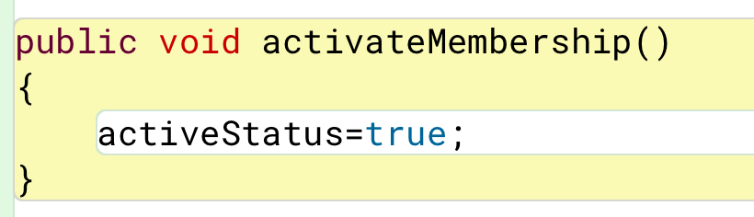

This method sets the active status variable which is declared as boolean to true when it is called upon.

**deactivateMembership()**

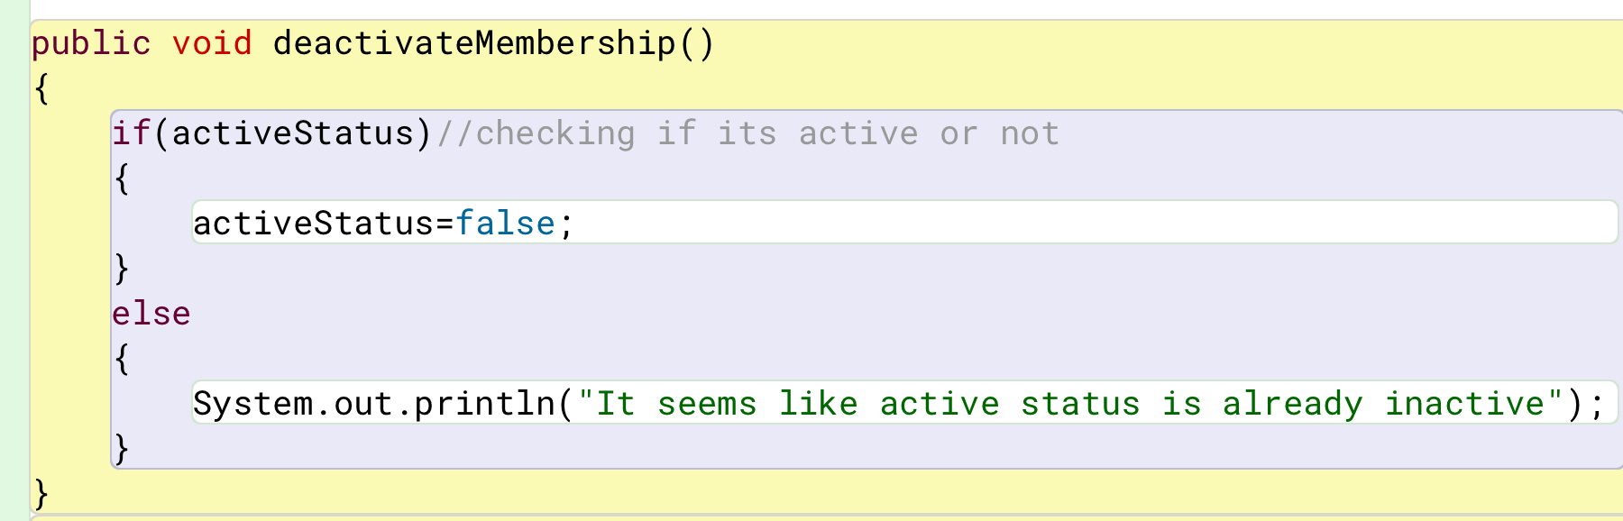

This method checks if the active status is false or not according to it, it decides to set the active status or display message. If the active status is on, it turns it off. If the active status is off, it displays a message stating that the active status is inactive.

**resetMembership()**

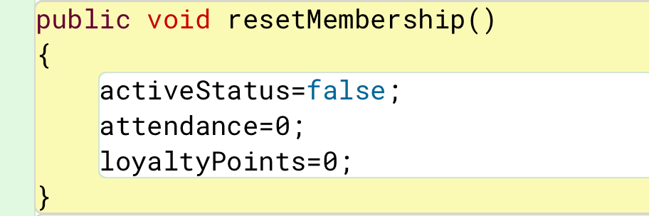

When this method is called upon, it resets the active status to false, attendance to 0 and loyalty points to 0.

**display()**

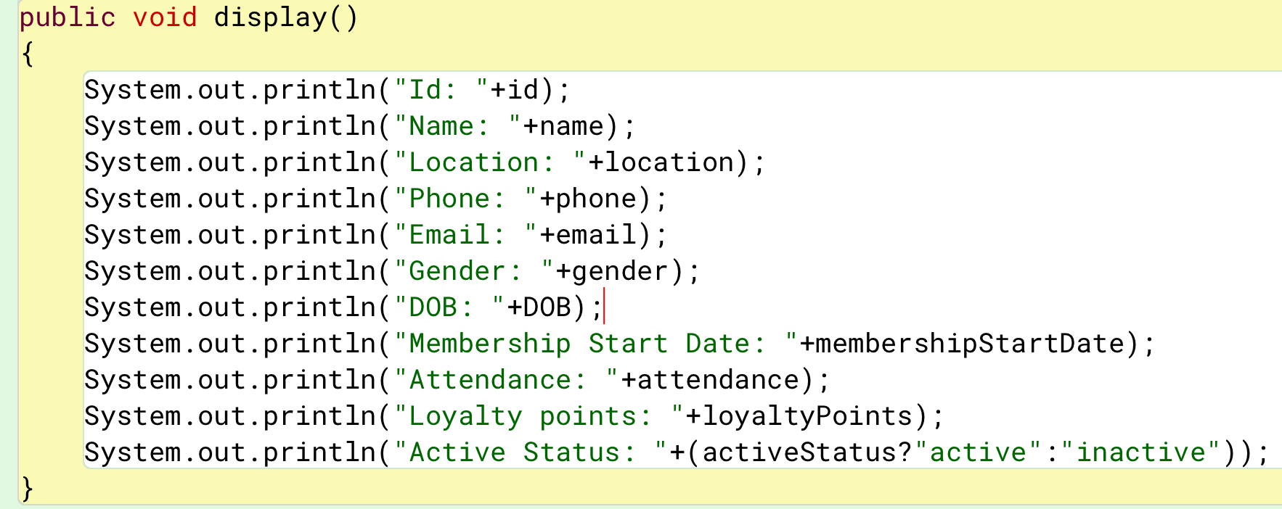

This method displays id, name, location, phone, email, gender, DOB, membership start date, attendance, loyalty points and active status of members.

## Methods in RegularMember class

**markAttendance**()

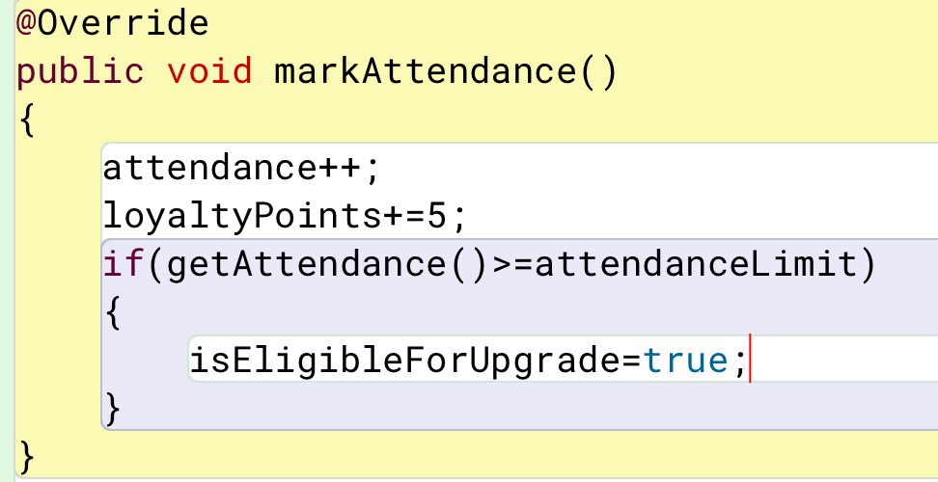

This method is overridden as RegularMember inherits the GymMember. In this method, attendance is increased by 1 and loyalty point is increased by 5 every time the method is called. It checks if the attendance is more than the attendance limit or not, if it is more, then isEligibleForUpgrade is set to true.

**getPlanPrice(String plan)**

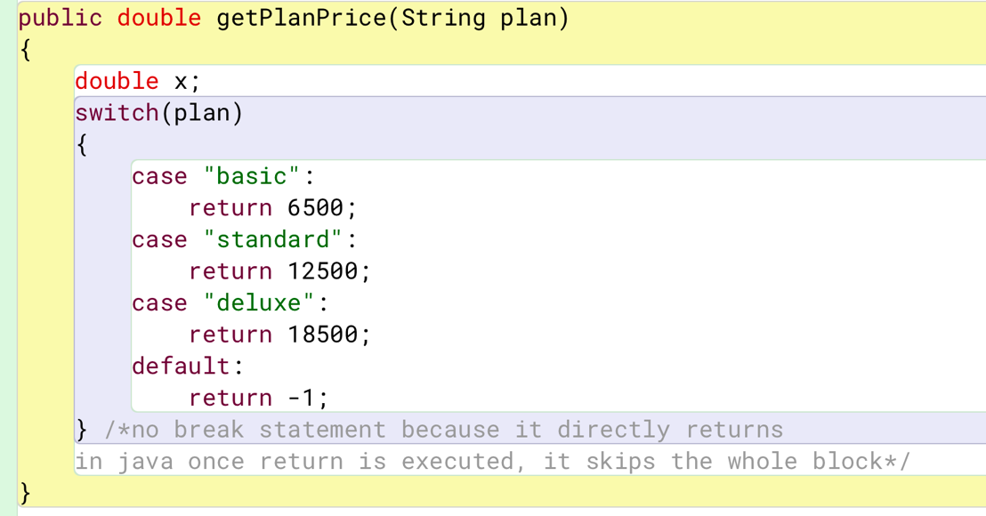

This method takes a parameter, String variable named plan, and has double as the return type. In this method, a switch statement is placed to check the selected plan and return the plan price. If basic is selected, it returns 6500. If standard is selected, it returns 12500. If deluxe is selected, it returns 18500. For default, it return -1.

**upgradePlan(String plan)**

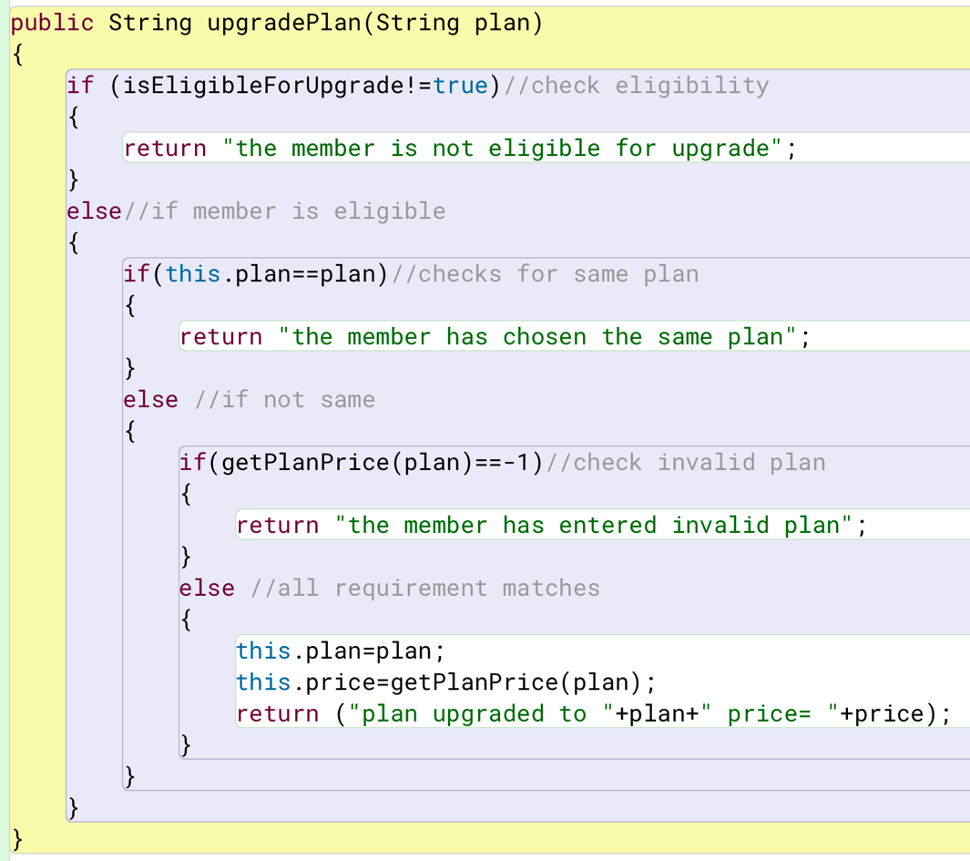

In this method, there is an if else statement. It takes a string variable named plan as parameter. It checks if the member is eligible for update. if not, then it displays a message saying member is not eligible for upgrade. If they are eligible, then it checks if the selected plan is same as current plan and displays a message saying the same. If not, then it again checks if available plan is entered or not and displays a message if not. If everything checks out, then it upgrades the plan.

**revertRegularMember(String removalReason)**

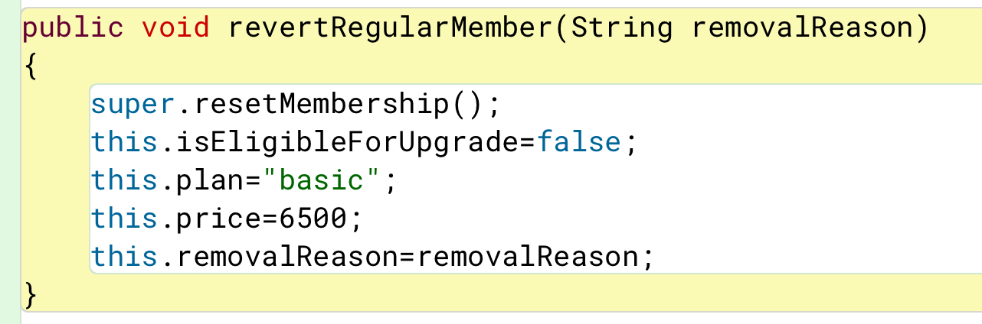

This method triggers the resetMembership() method of the parent class, GymMember. It takes a string variable named removalReason as parameter. It proceeds to set every variable value to the reset value which is false for isEligibleForUpgrade, basic for plan, 6500 for plan price and entered removal reason is also set.

**display()**

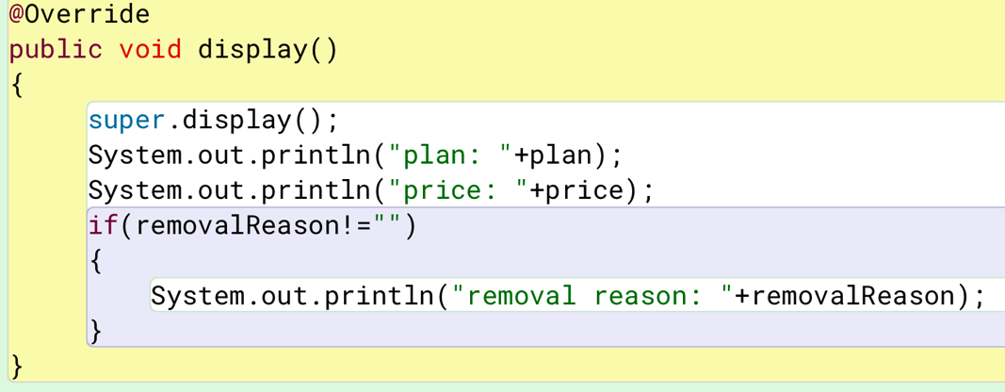

This method overrides the display() method in the GymMember class which is a parent class. It takes no parameter. It calls the display method of the parent class. It prints out plan, price and removal reason if any is entered.

## Methods in PremiumMember class

**payDueAmount(double paidAmount)**

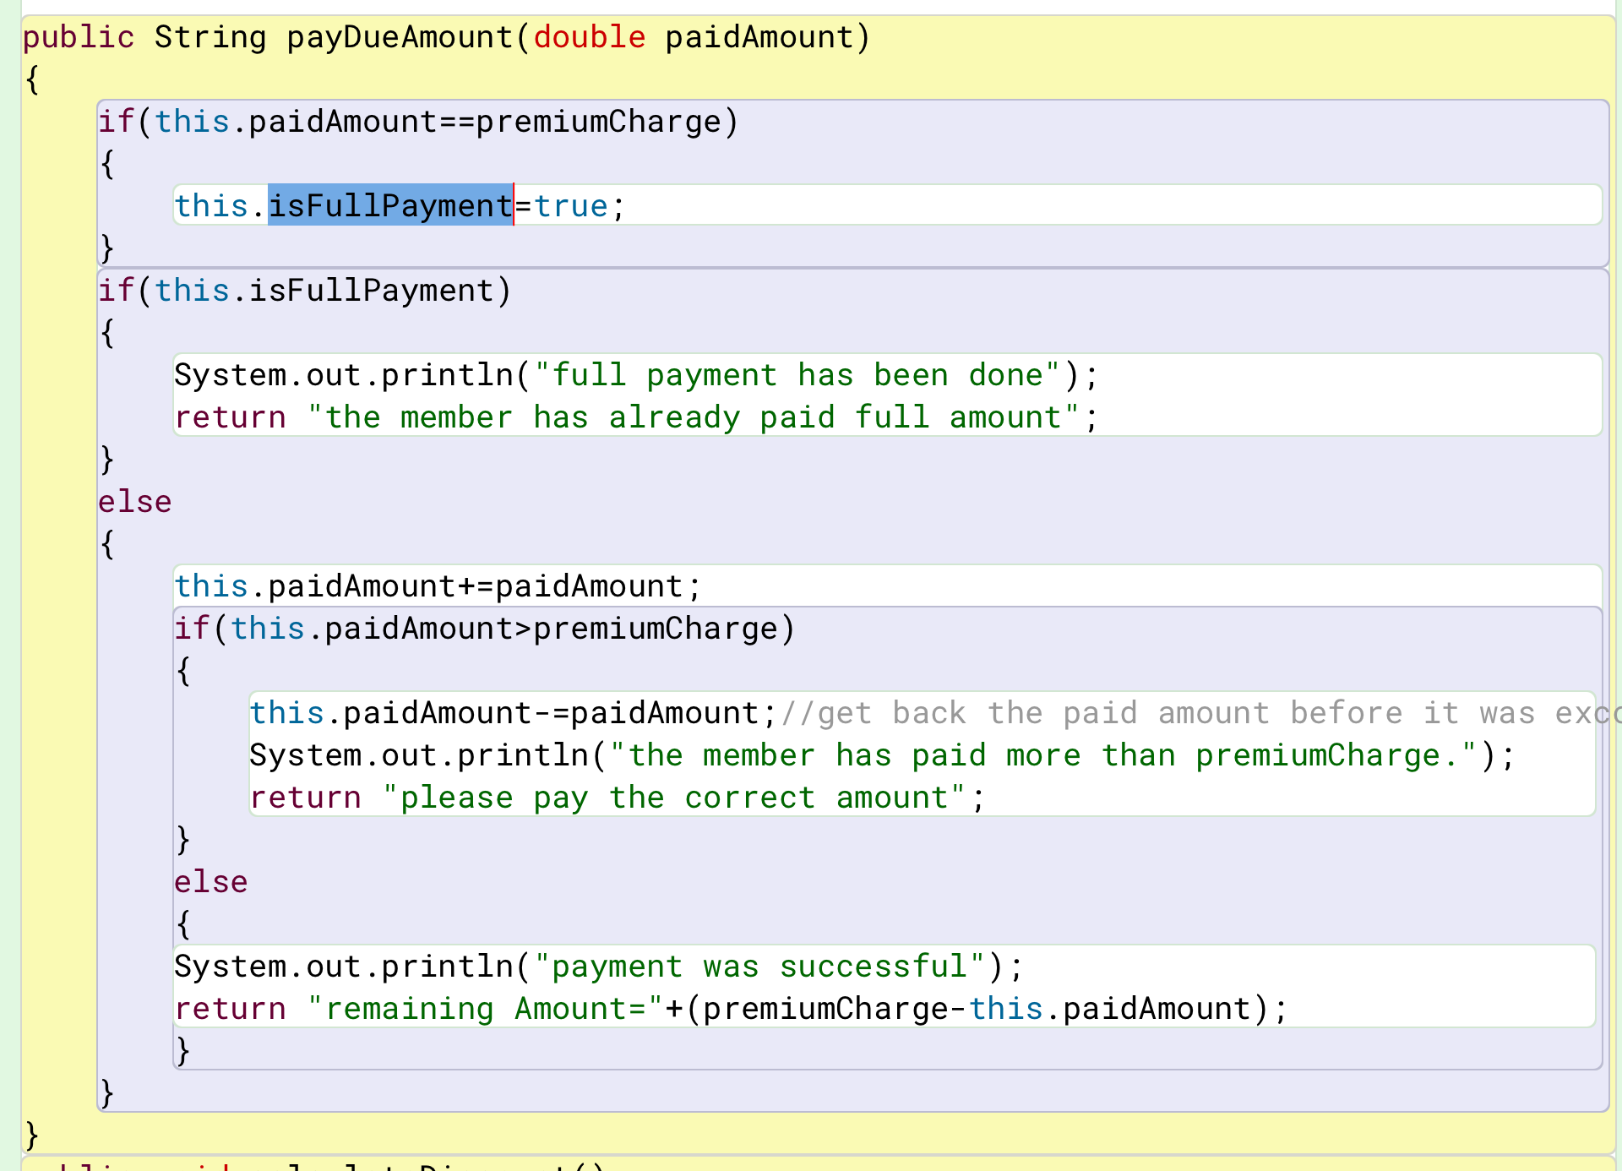

This method in the premium member class has string as return type and takes double variable named paidAmount as parameter. It checks if the paidAmount is equal to the premium charge or not and sets true to isFullPayment which is Boolean. After this, another if statement checks if there has been a full payment with the variable isFullPayment. If yes, then it displays a message saying that. If not, it adds the paidAmount to the total paid amount and proceeds to check if the paid amount is more than premium charge or not. If it is more, then it says so, doesn’t accept that payment and requests the correct amount. If not, it prints out the remaining amount.

**calculateDiscount()**

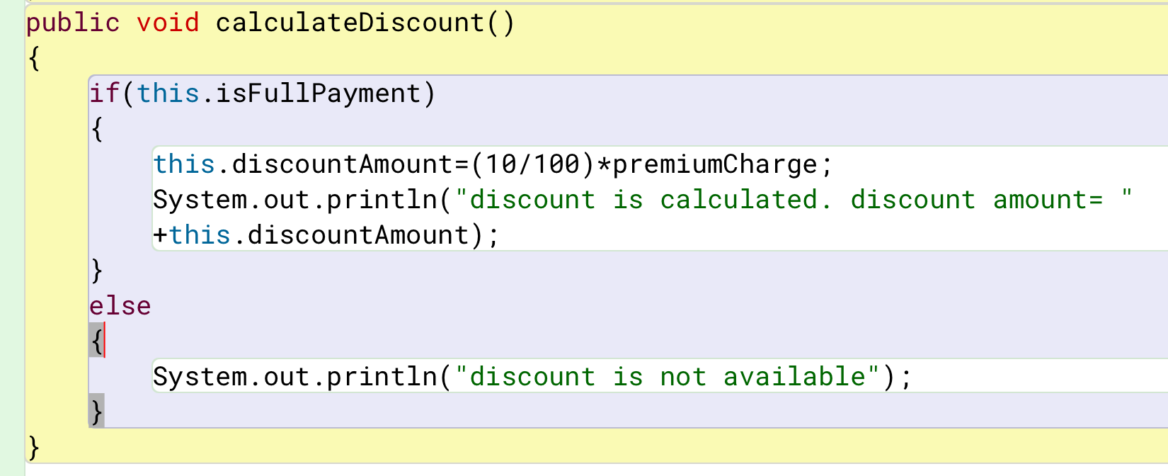

In this method, it has no return type nor any parameter. It checks if full payment is made or not. If it has, then it is eligible for discount and the discount is calculated and displayed. If not, then it prints out saying it is not eligible for discount.

**revertPremiumMember()**

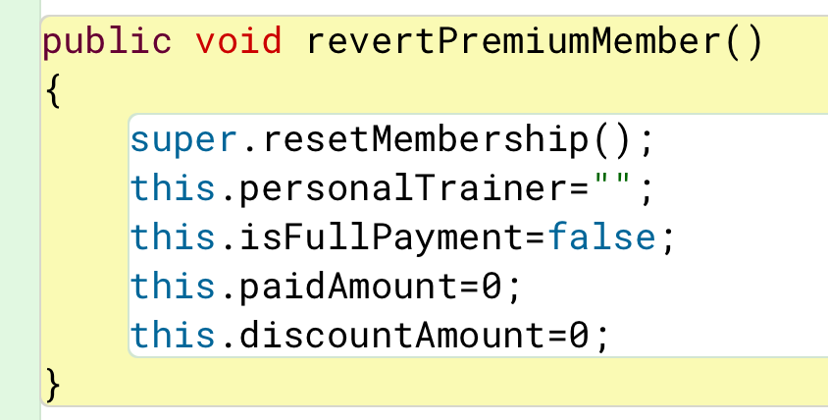

This method calls the parent class resetMembership() method and sets default values to the variables in the PremiumMember class. It sets trainer’s name to null, isFullPayment to false, paidAmount and discountAmount to zero.

markAttendance()

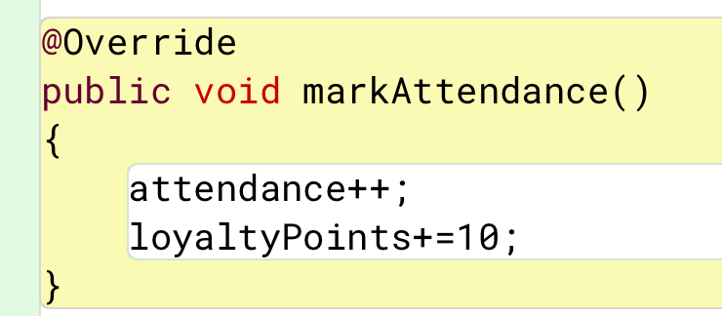

This method is overridden from the parent class method which is abstract. It inceases attendance by one and loyalty points by 10 when this method is called upon.

**display()**

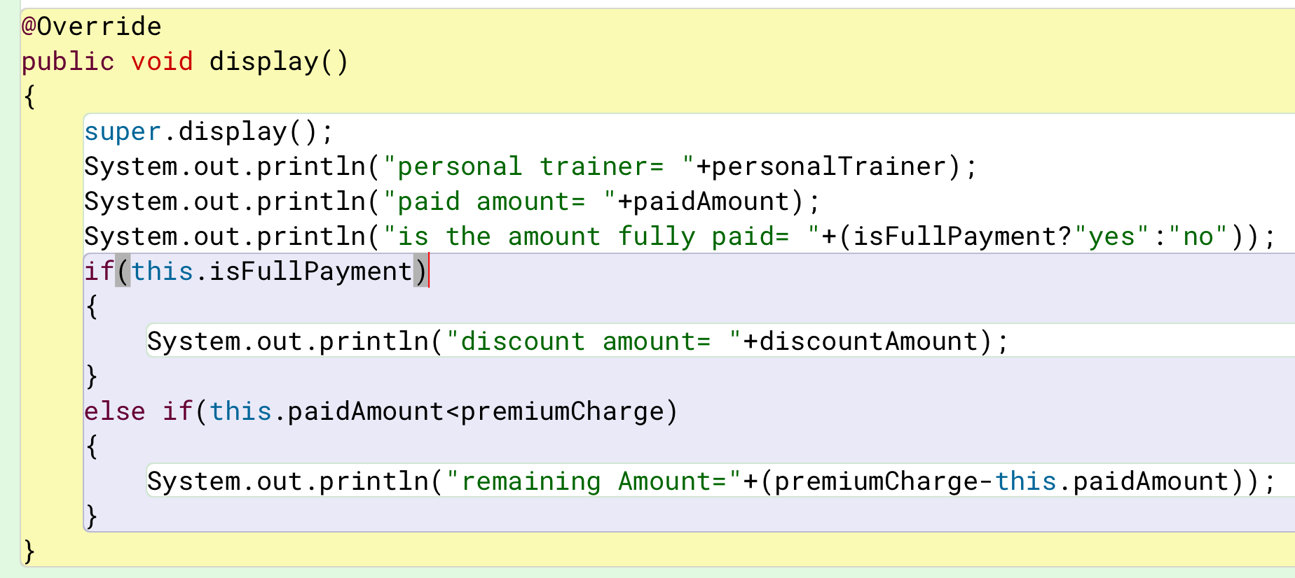

This method is overridden from the parent class. It calls for the parent class display method. It displays personal trainer, paid amount and if the payment has been made full or not. It checks for discount and prints it too.

## Method in GymGUI class

actionPerformed(ActionEvent ae)

This method in the GymGUI class does the work for all the button in it. Here it has separate working mechanism for all buttons. If any button is pressed, then it methods acts up to full fill what that button should do. The actions performed by the button are written in the form of if else if else statement where the condition is the button clicked.

The buttons work as follows:

Reg= opens regular member frame

Pre= opens premium member frame

Back1, back2= return back to the main option frame

Addregular = adds regular member

Addpremium = adds premium member

Markattendance = marks the attendance of the members

Activate = activates membership for the members

Deactivate = deactivates membership for the members

Clear = clears all text fields

Display = displays the information about the members

Revert membership = resets the membership back to the initial phase

Upgrade plan = upgrade the plan as per the user chooses only for regular member

Discount = calculates and returns the discount received by premium member

Save = saves the information about the users in a text file

Read from file = reads the information in the text file and displays it.

# Testing

## Test-1

|  |  |
| --- | --- |
| Objective | To compile and run the program in terminal. |
| Action | Write “javac GymGUI.java” & “java GymGUI.java” in terminal. |
| Expected Output | The option to choose for either regular membership or premium membership appears and when clicked on their respective GUI opens. |
| Actual Output | Option to choose appeared and when chosen one, it’s respective frame appeared. |
| Result | The test was successful. |

Table : test-1: compile and run the program

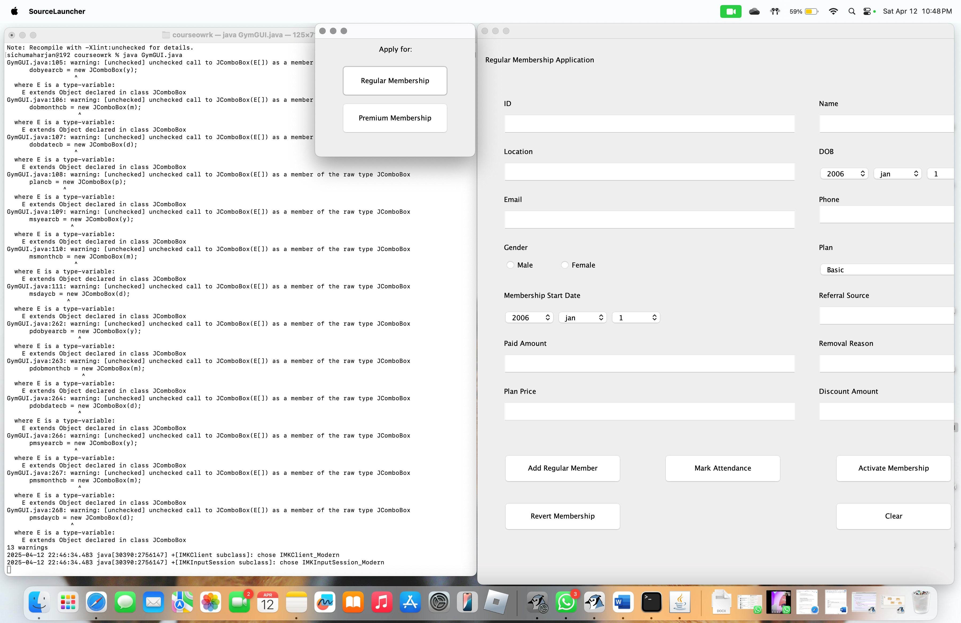

## Test-2

Table : test-2.1: add regular member

|  |  |
| --- | --- |
| Objective | To add regular member. |
| Action | 1. click ‘add regular member’ button.  2. enter alphabetical id.  3. fill in the application in correct manner. |
| Expected Output | The regular member details should be added and a dialog box showcasing the message with appear. |
| Actual Output | The details were added, and the dialog box appeared with a success message. |
| Result | The test was successful. |

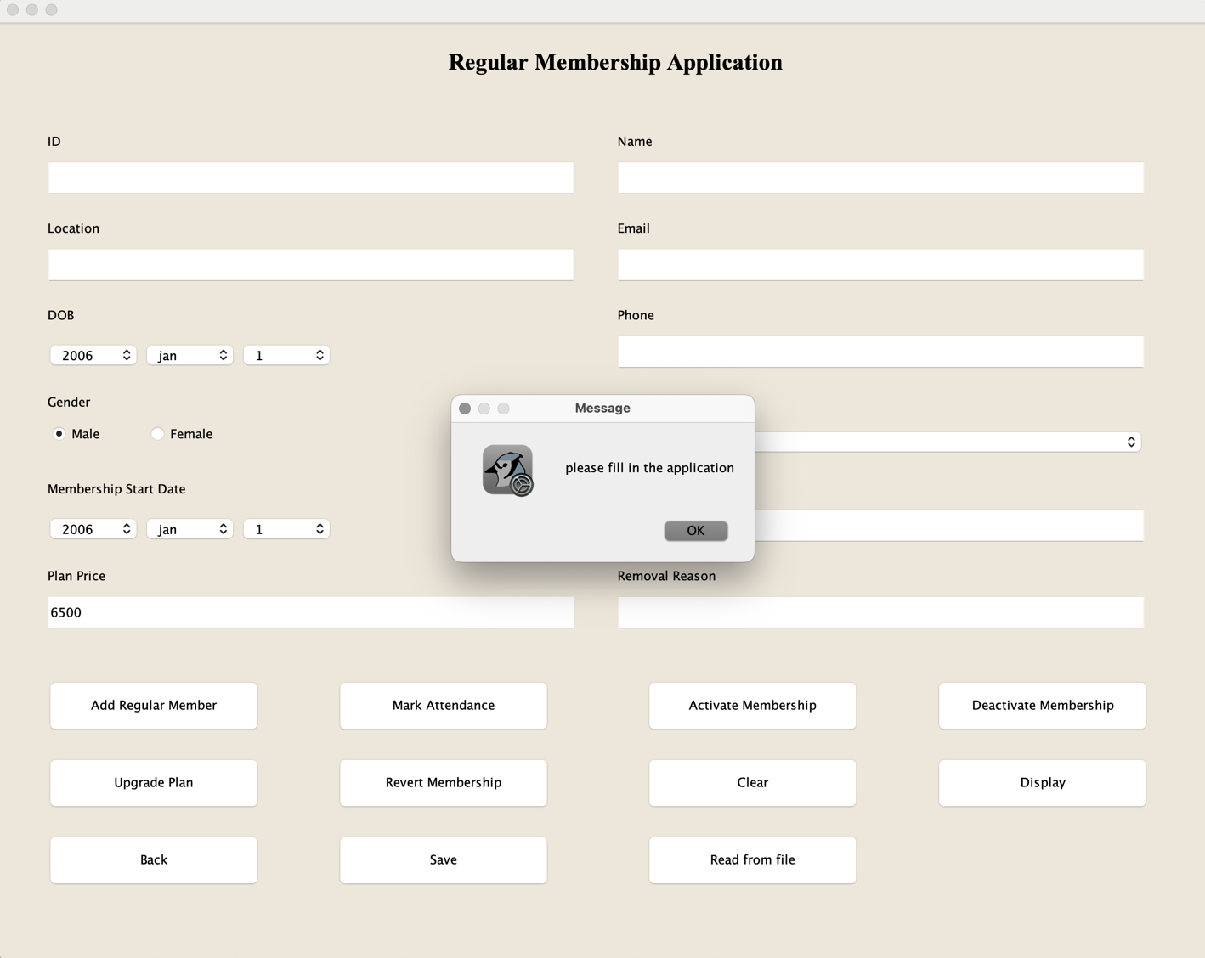

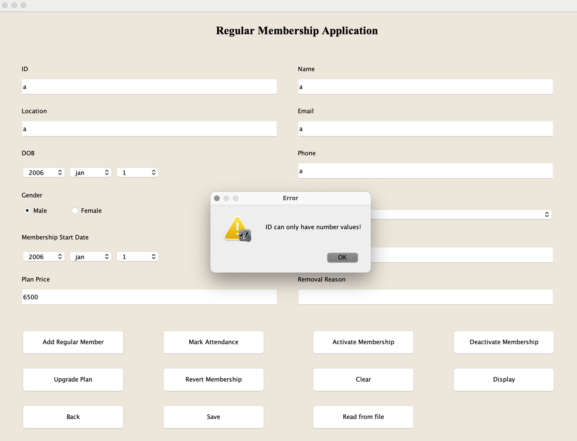

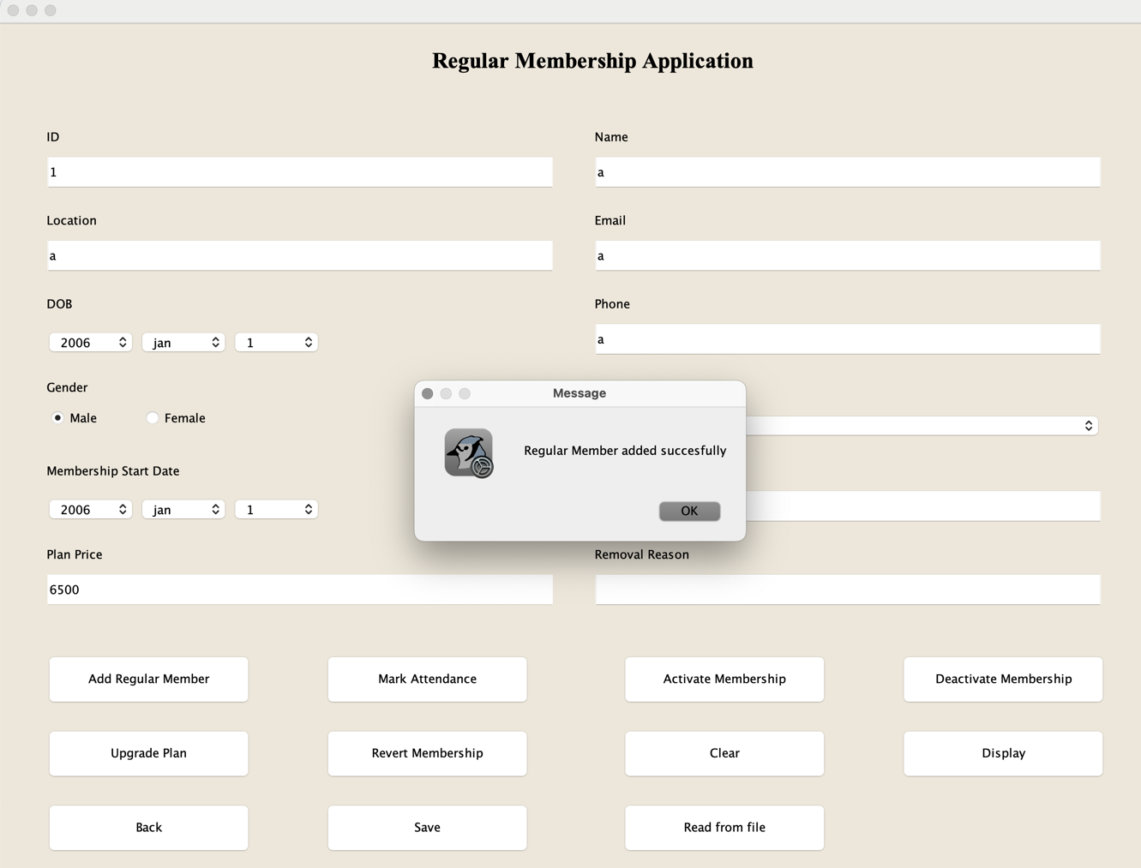

Table : test-2.2: add premium member

|  |  |
| --- | --- |
| Objective | To add premium member. |
| Action | 1. click ‘add premium member’ button.  2. enter alphabetical id.  3. already existing id was entered.  4. fill in the application in correct manner. |
| Expected Output | The premium member details will be added and a dialog box showcasing the message with appear. |
| Actual Output | The details were added, and the dialog box appeared with a success message. |
| Result | The test was successful. |

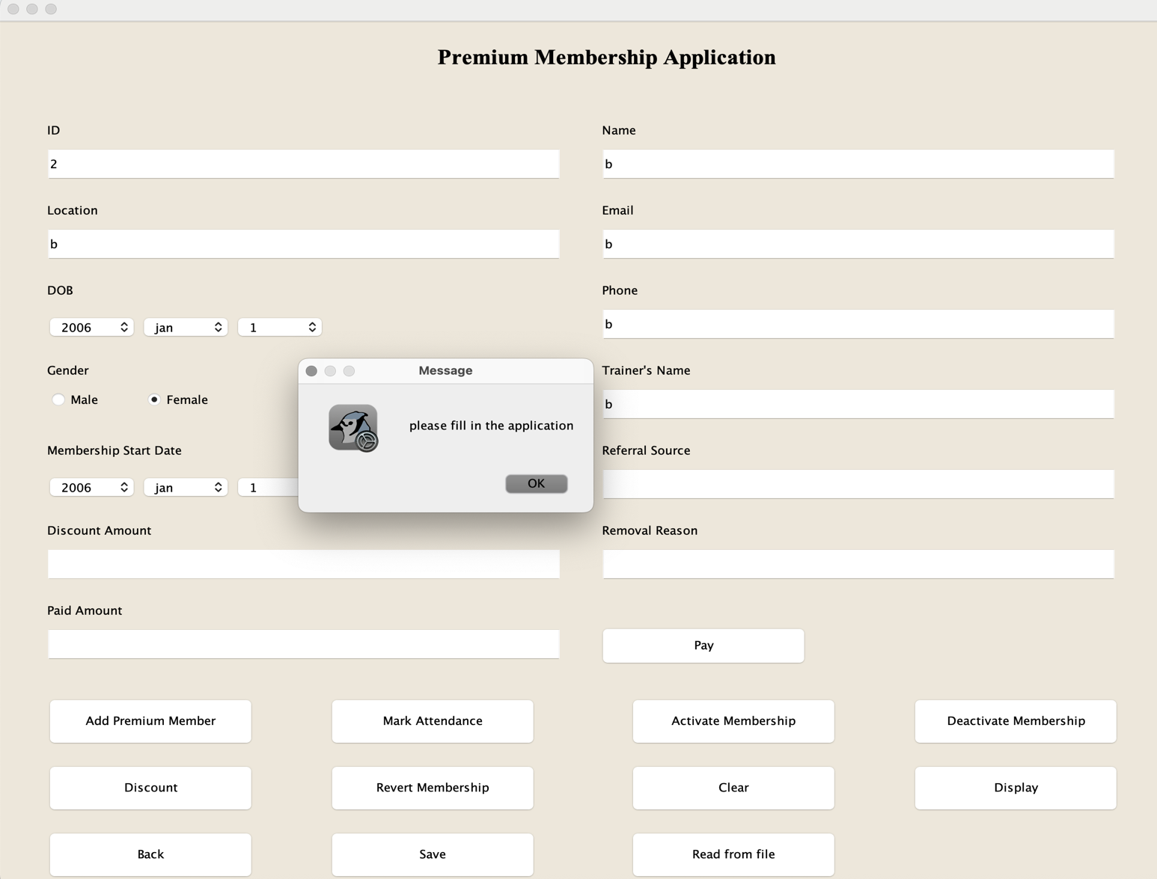

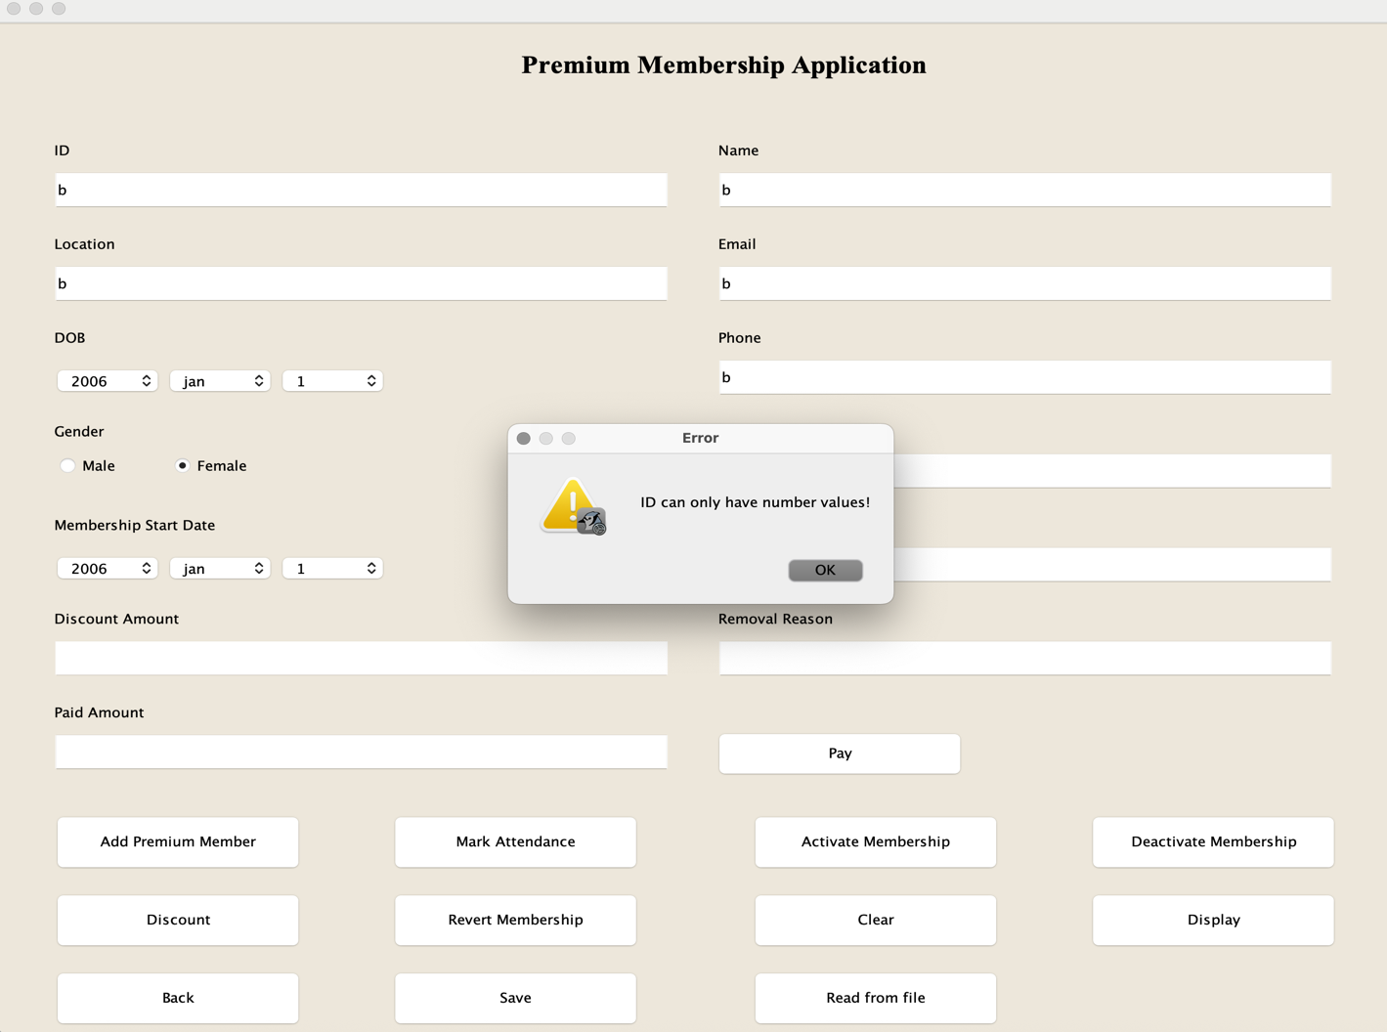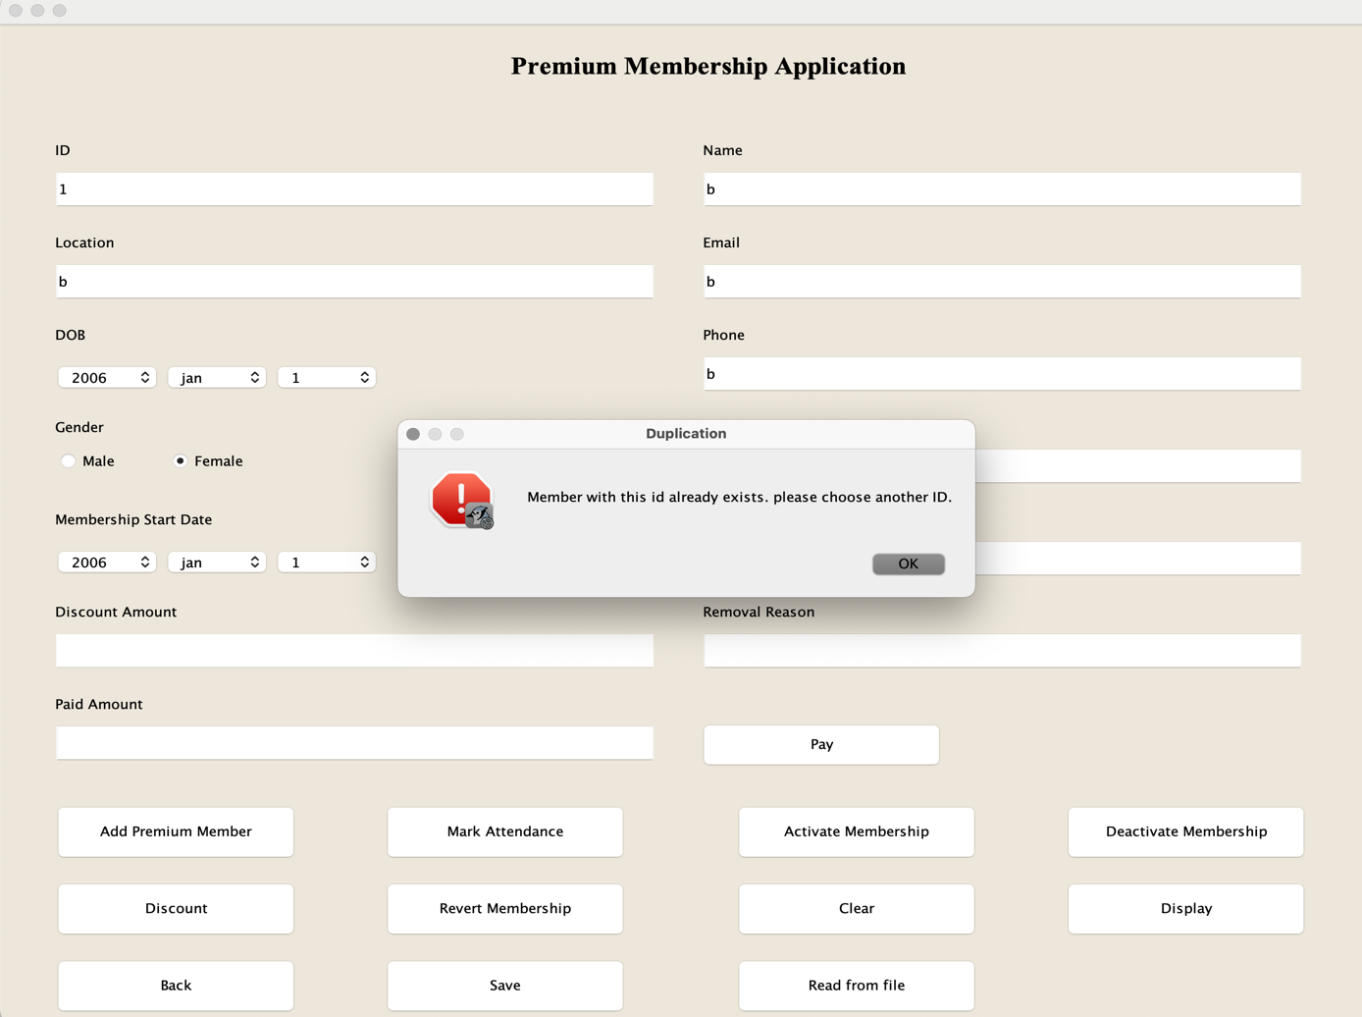

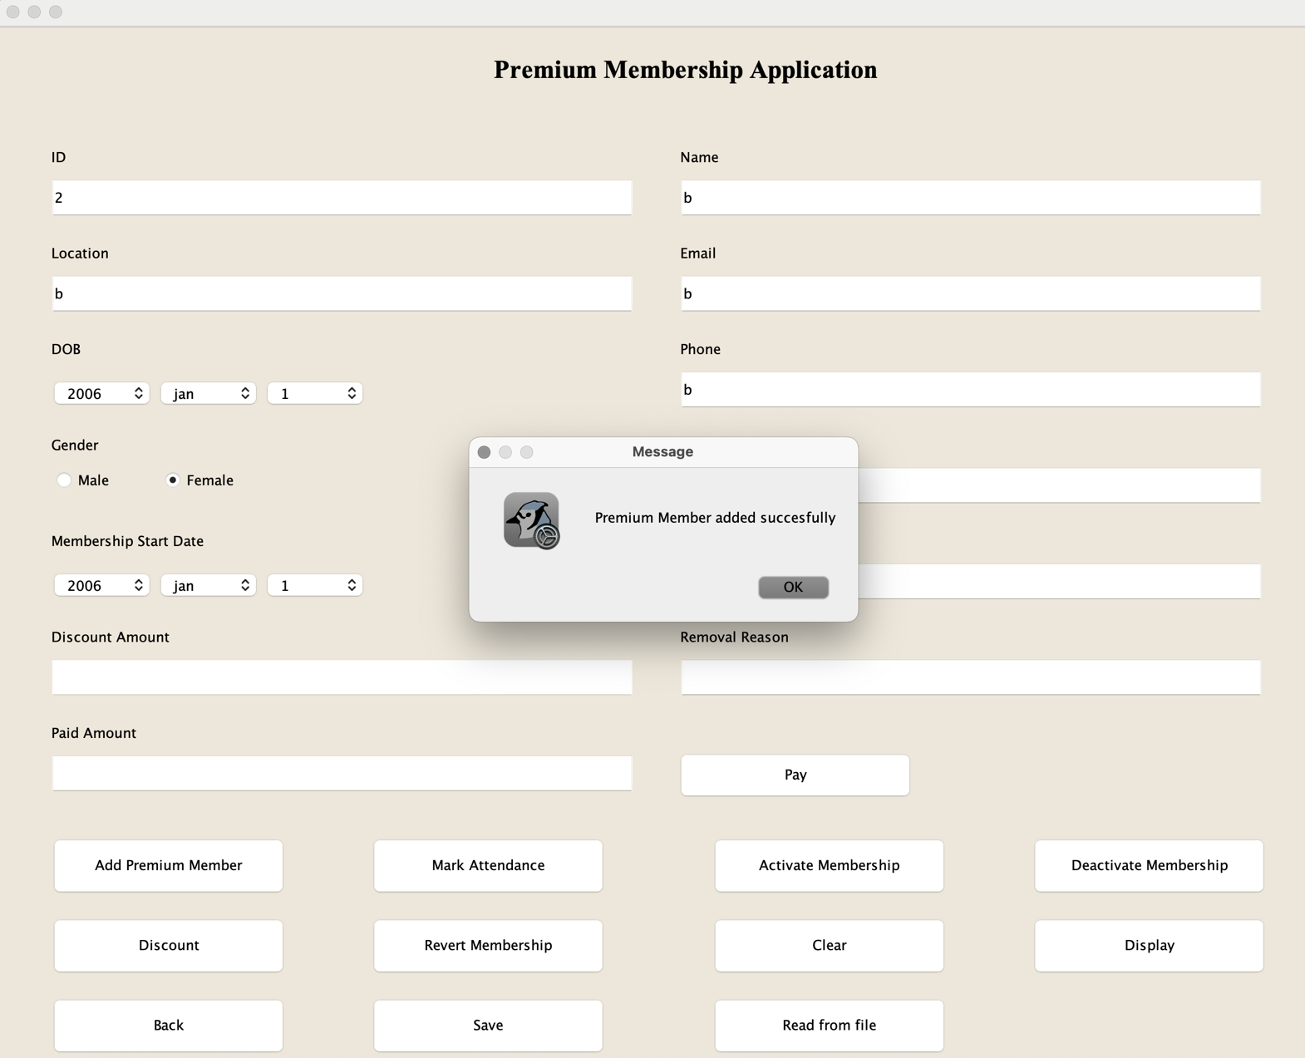

## Test-3

Table : test-3.1: increase mark attendance

|  |  |
| --- | --- |
| Objective | To increase mark attendance. |
| Action | 1. click ‘mark attendance button.  2. enter id without activating membership.  3. activate membership.  4. click ‘mark attendance button again. |
| Expected Output | The premium member details will be added and a dialog box showcasing the message with appear. |
| Actual Output | The details were added, and the dialog box appeared with a success message. |
| Result | The test was successful. |

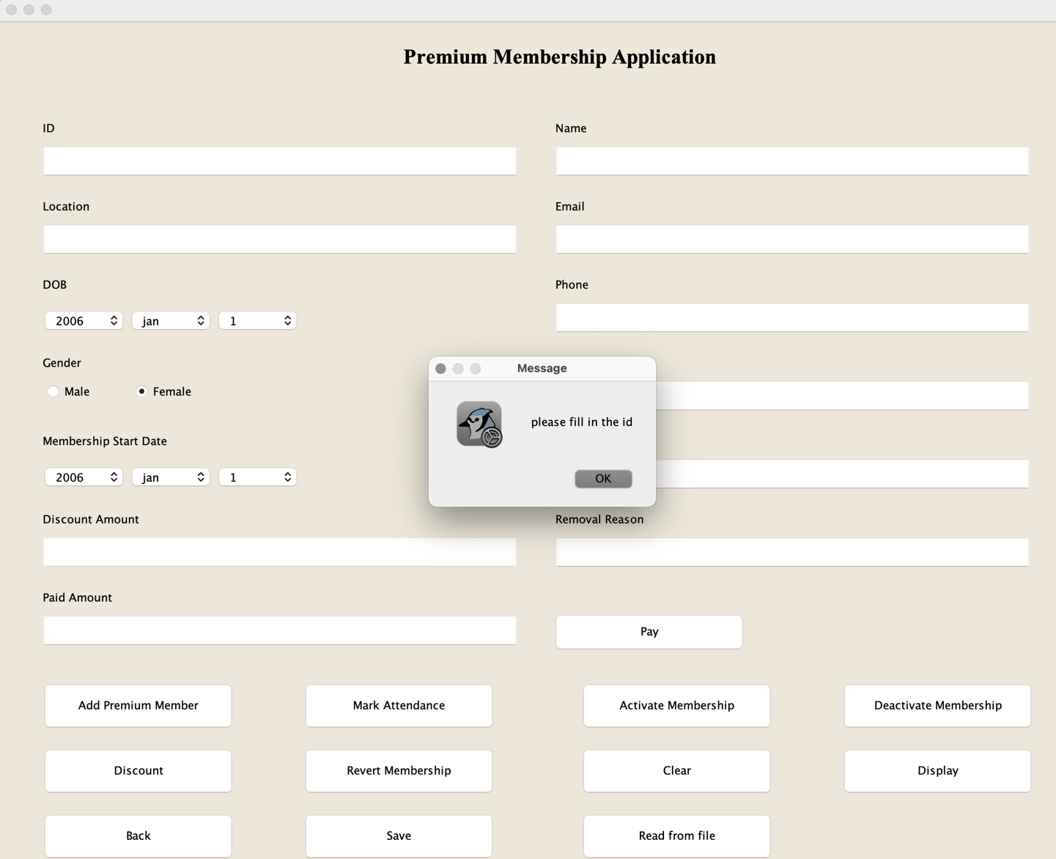

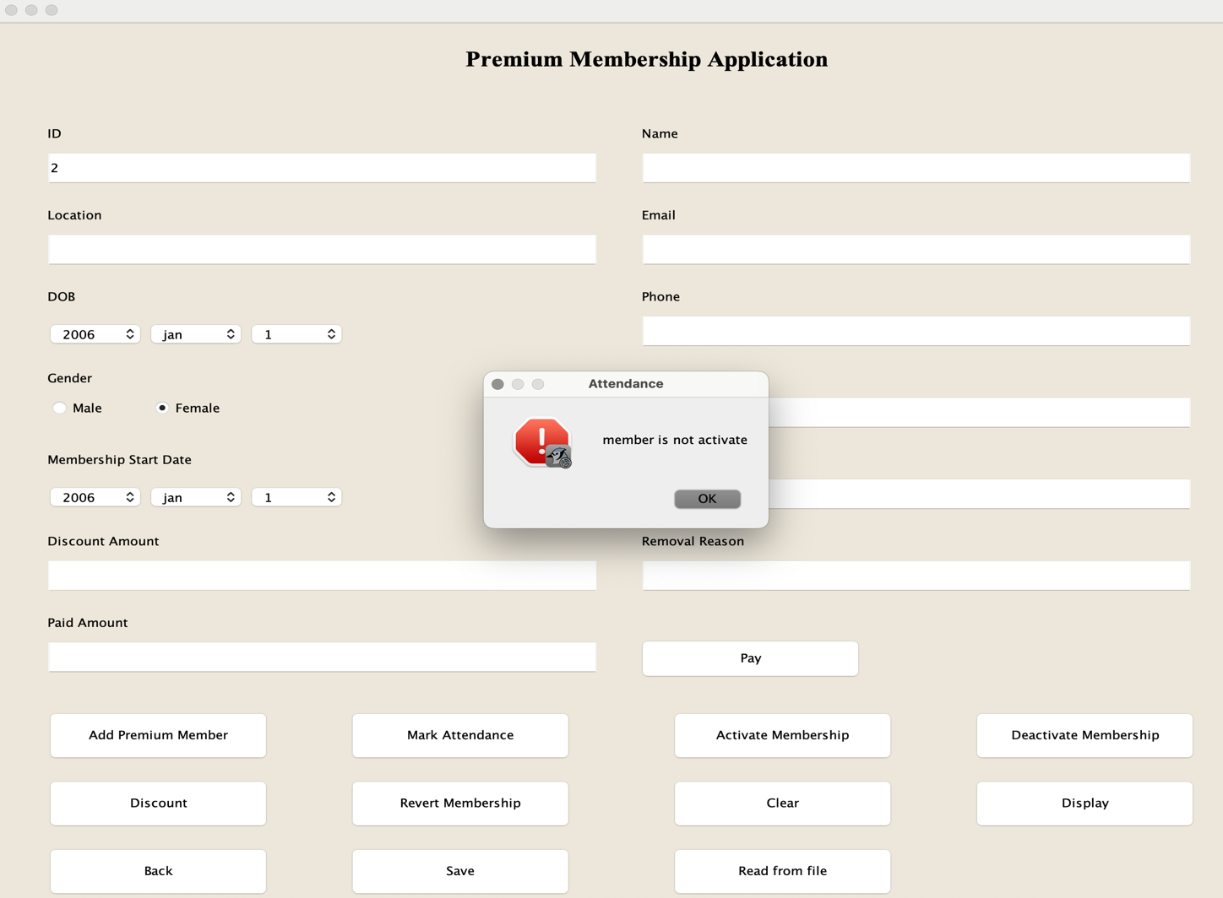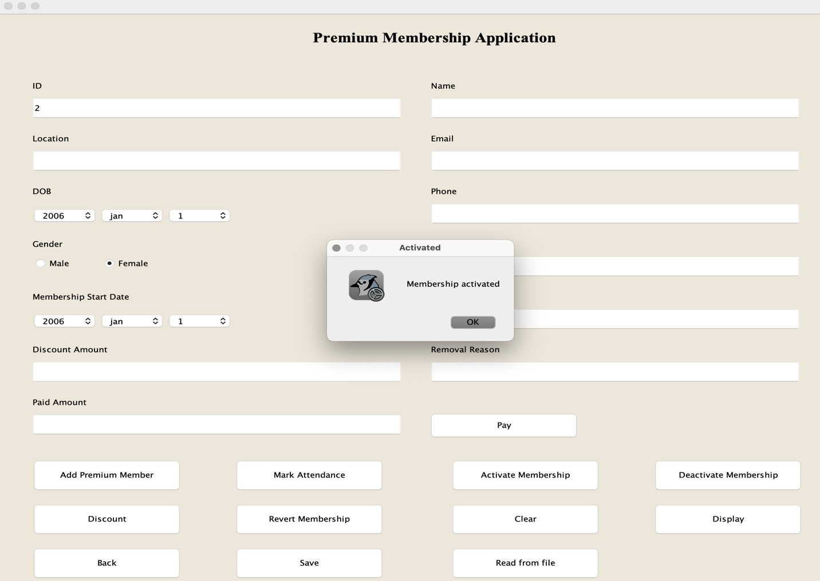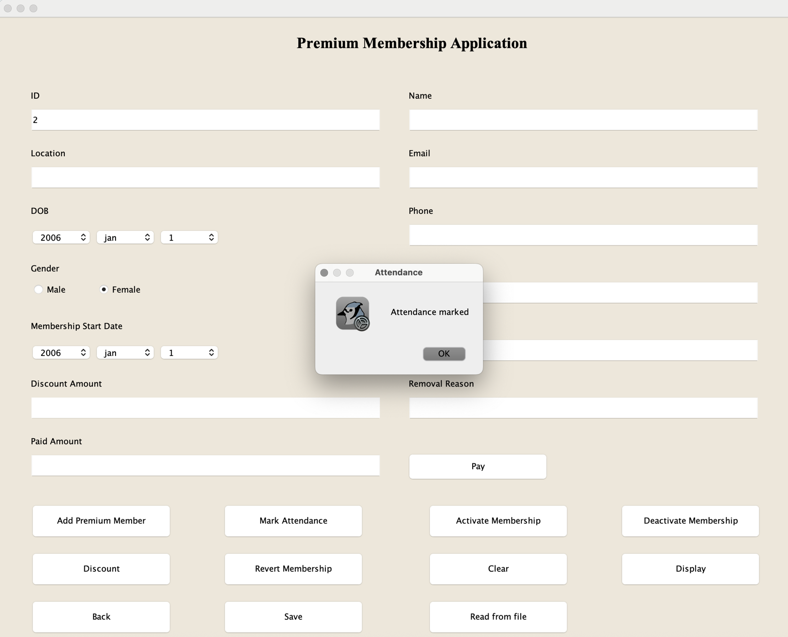

Table : test-3.2: update plan

|  |  |
| --- | --- |
| Objective | To upgrade the plan. |
| Action | 1. click “upgrade plan” button without filling id.  2. fill existing id without activating the membership.  3. activate the membership and click “upgrade plan” button.  4. mark attendance 30 times and select the same plan.  5. select different plan. |
| Expected Output | A message dialog box stating that the plan is upgraded should be displayed. |
| Actual Output | A message dialog box stating that the plan is upgraded is displayed. |
| Result | The test was successful. |

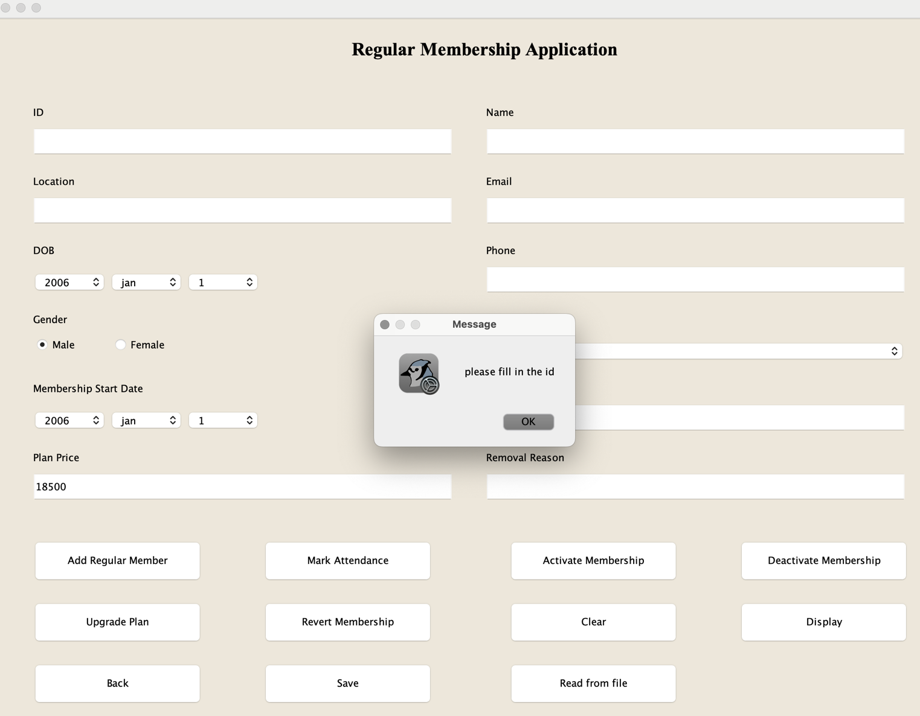

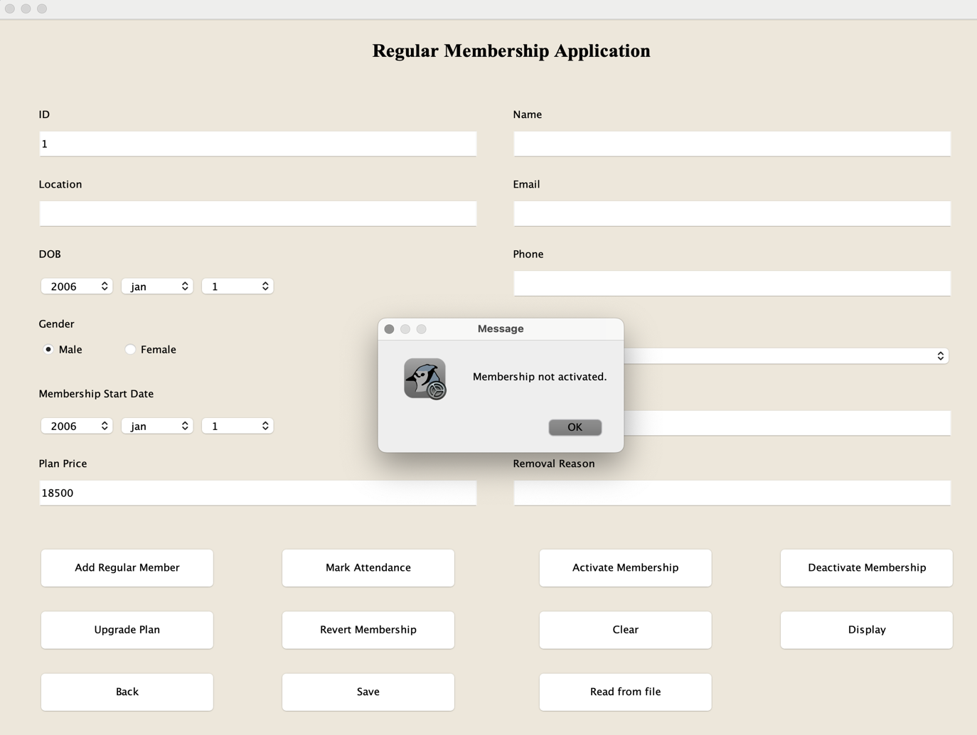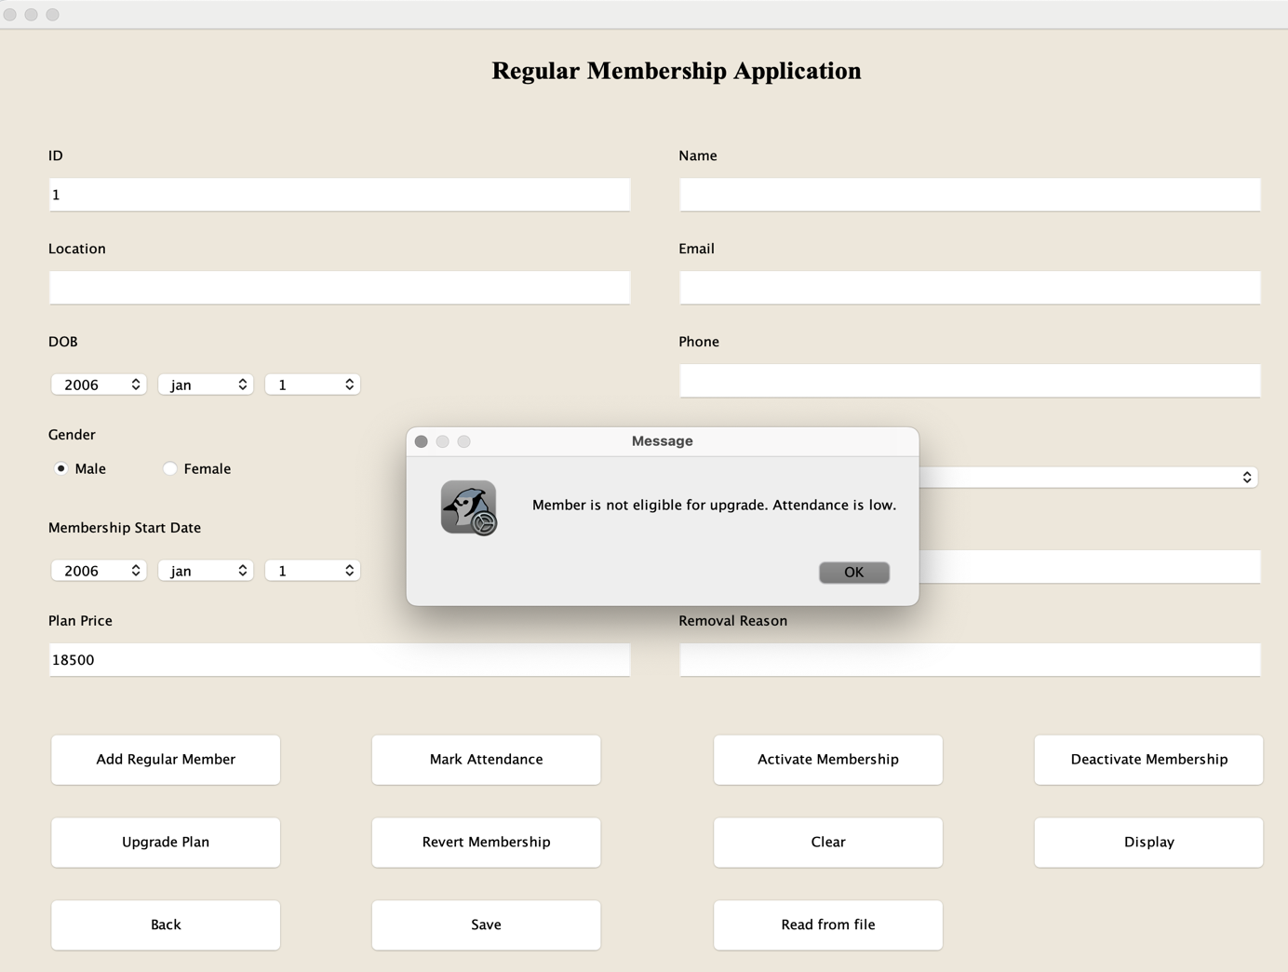

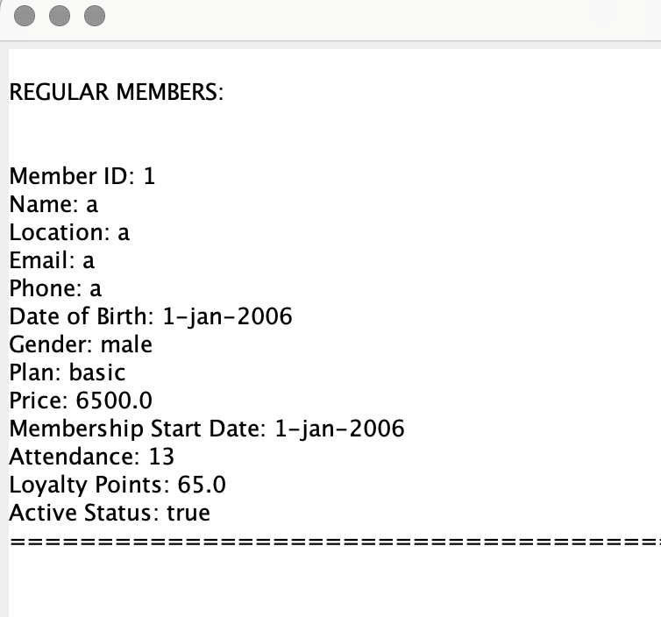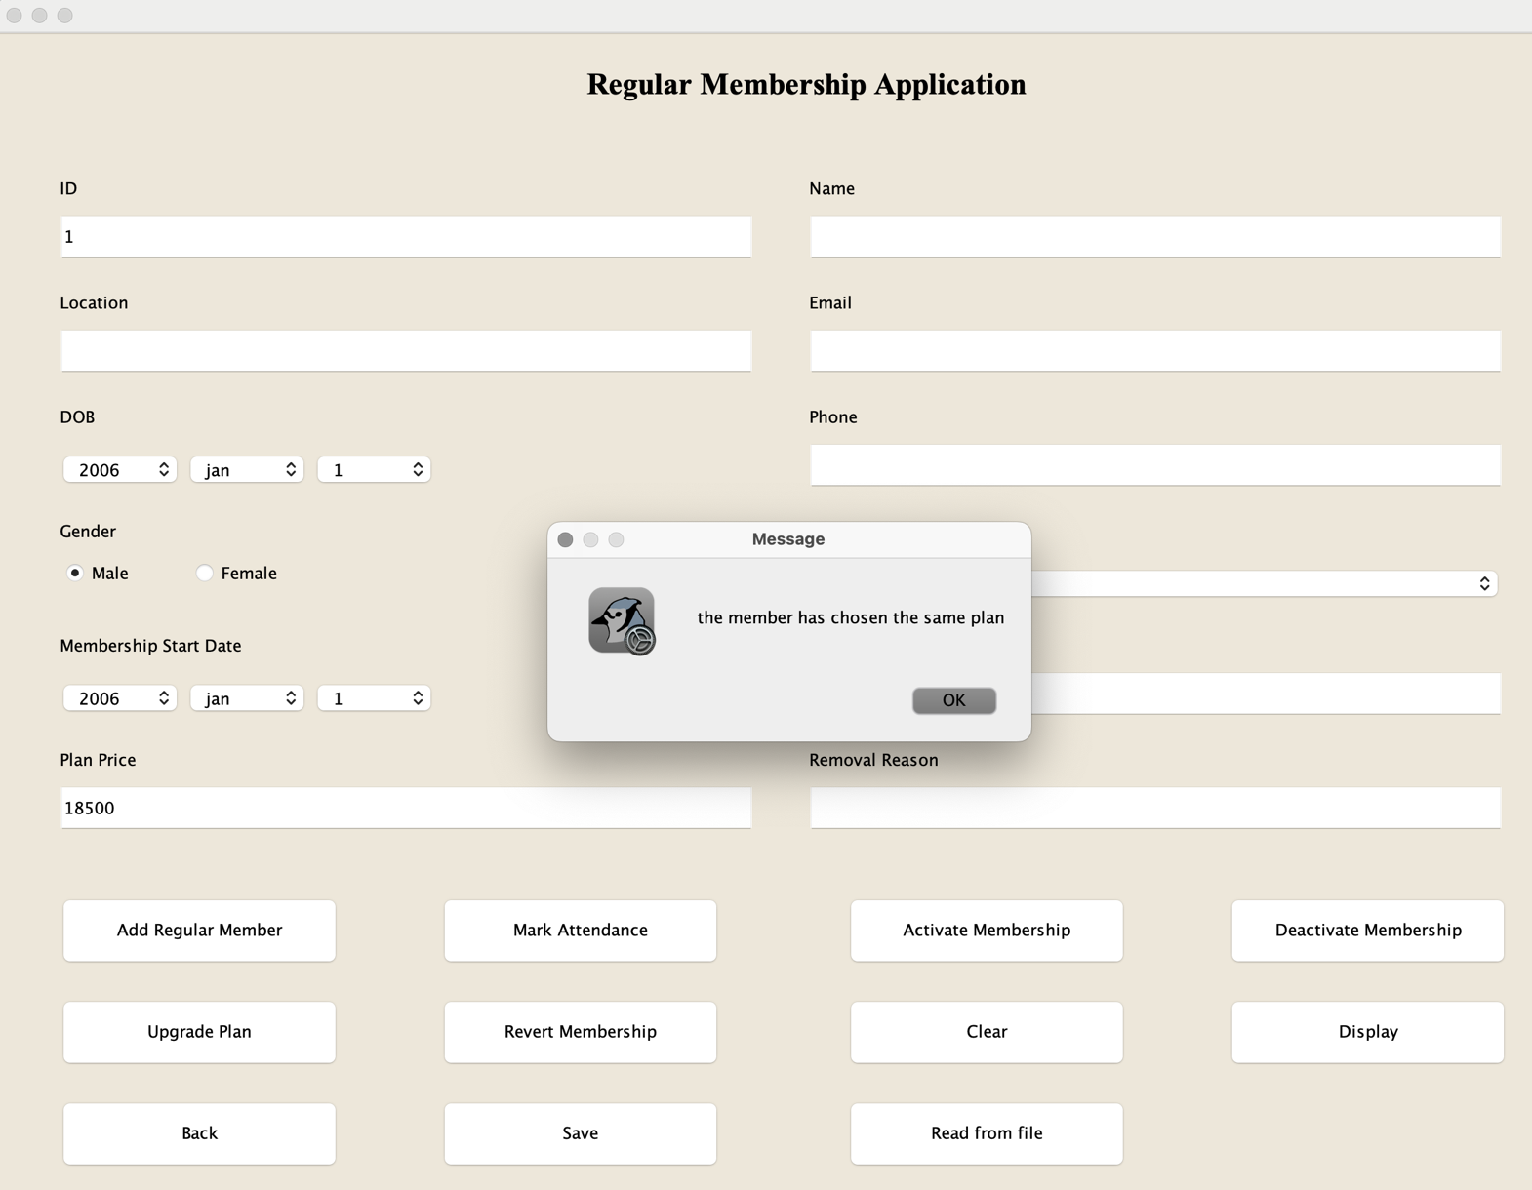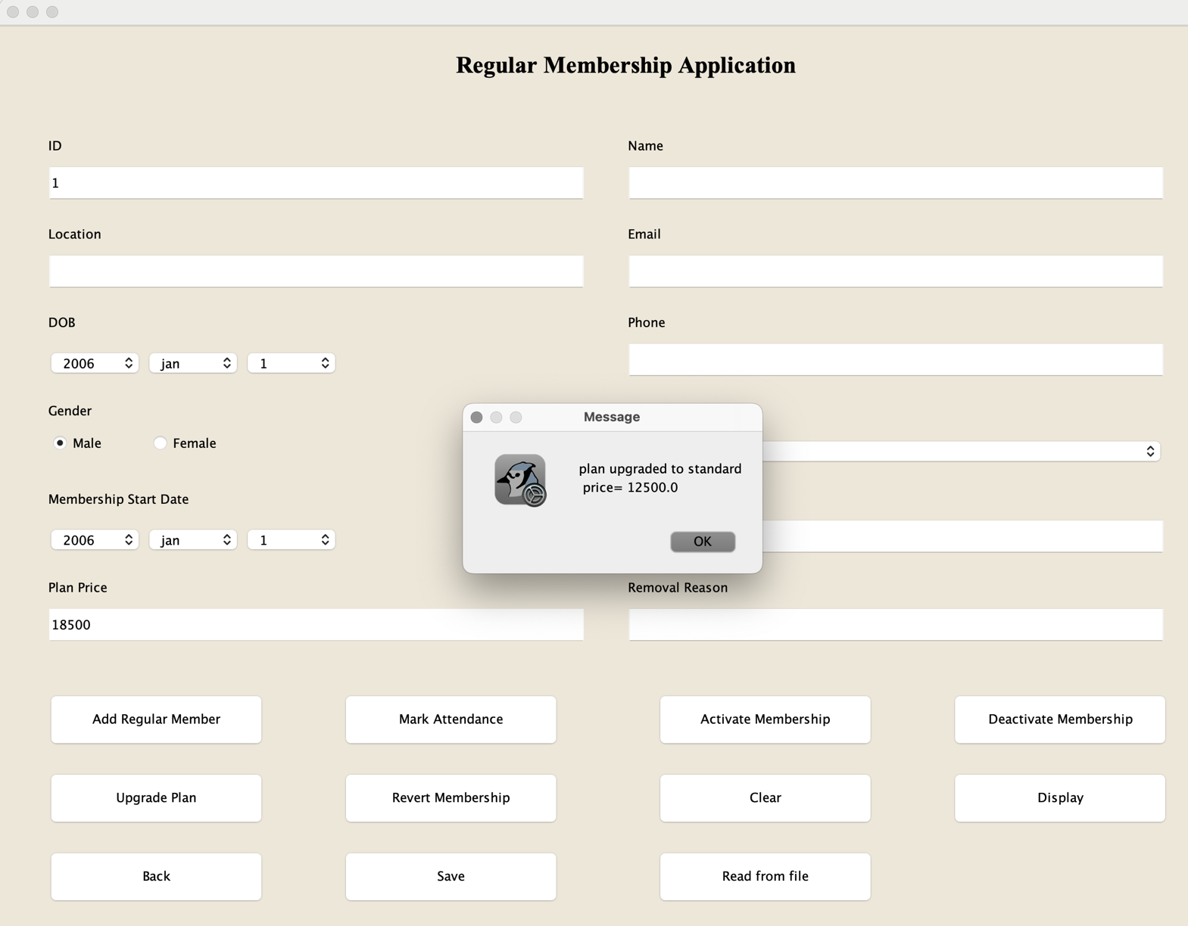

## Test-4

Table : test-4.1: calculate discount

|  |  |
| --- | --- |
| Objective | To calculate the discount. |
| Action | 1. fill in the id but pay full amount.  2. pay full amount.  3. click “calculate discount” button. |
| Expected Output | A message dialog box stating that member has received 10% discount should be visible. |
| Actual Output | A message dialog box stating that member has received 10% discount is visible. |
| Result | The test was successful. |

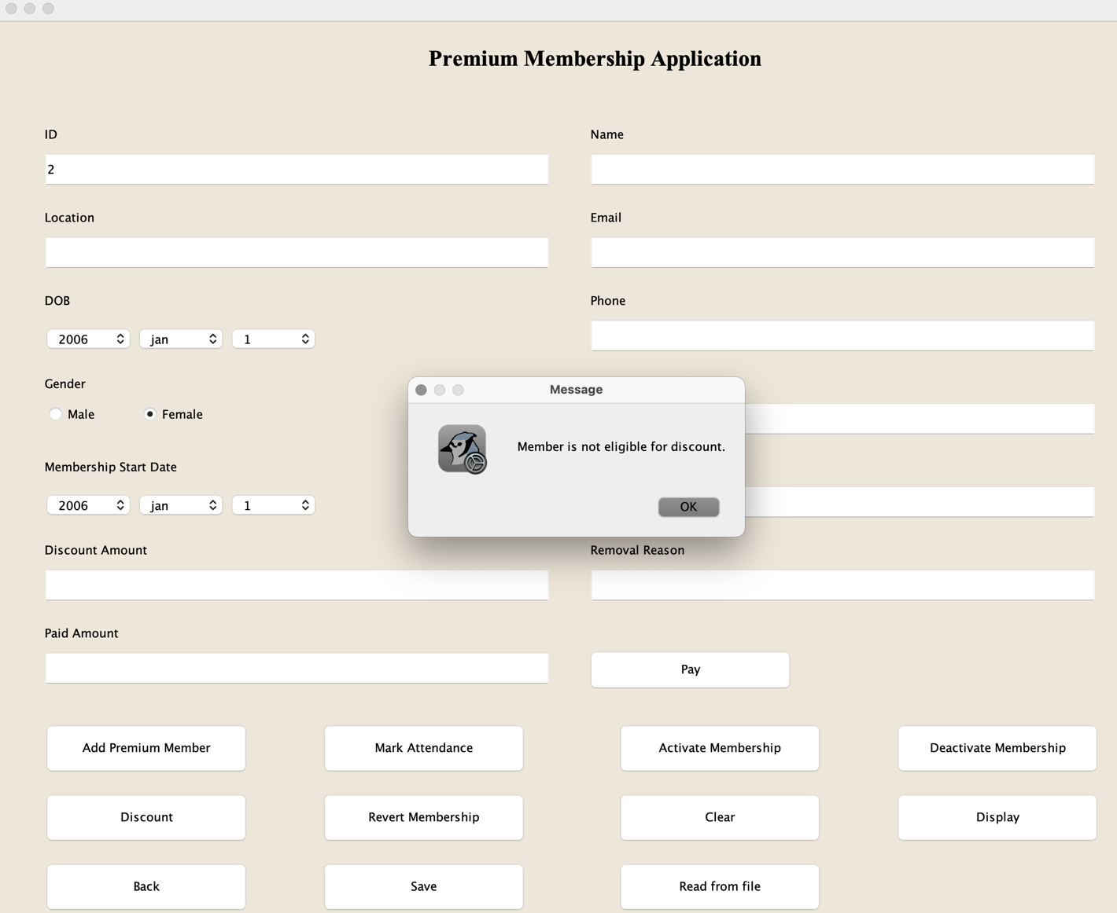

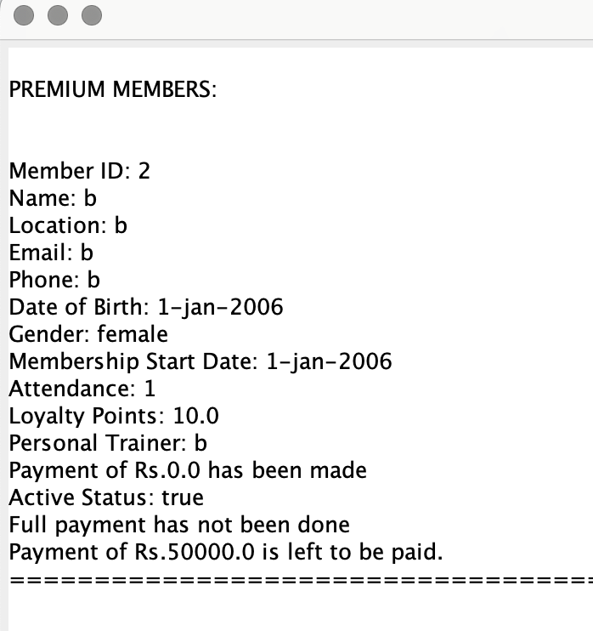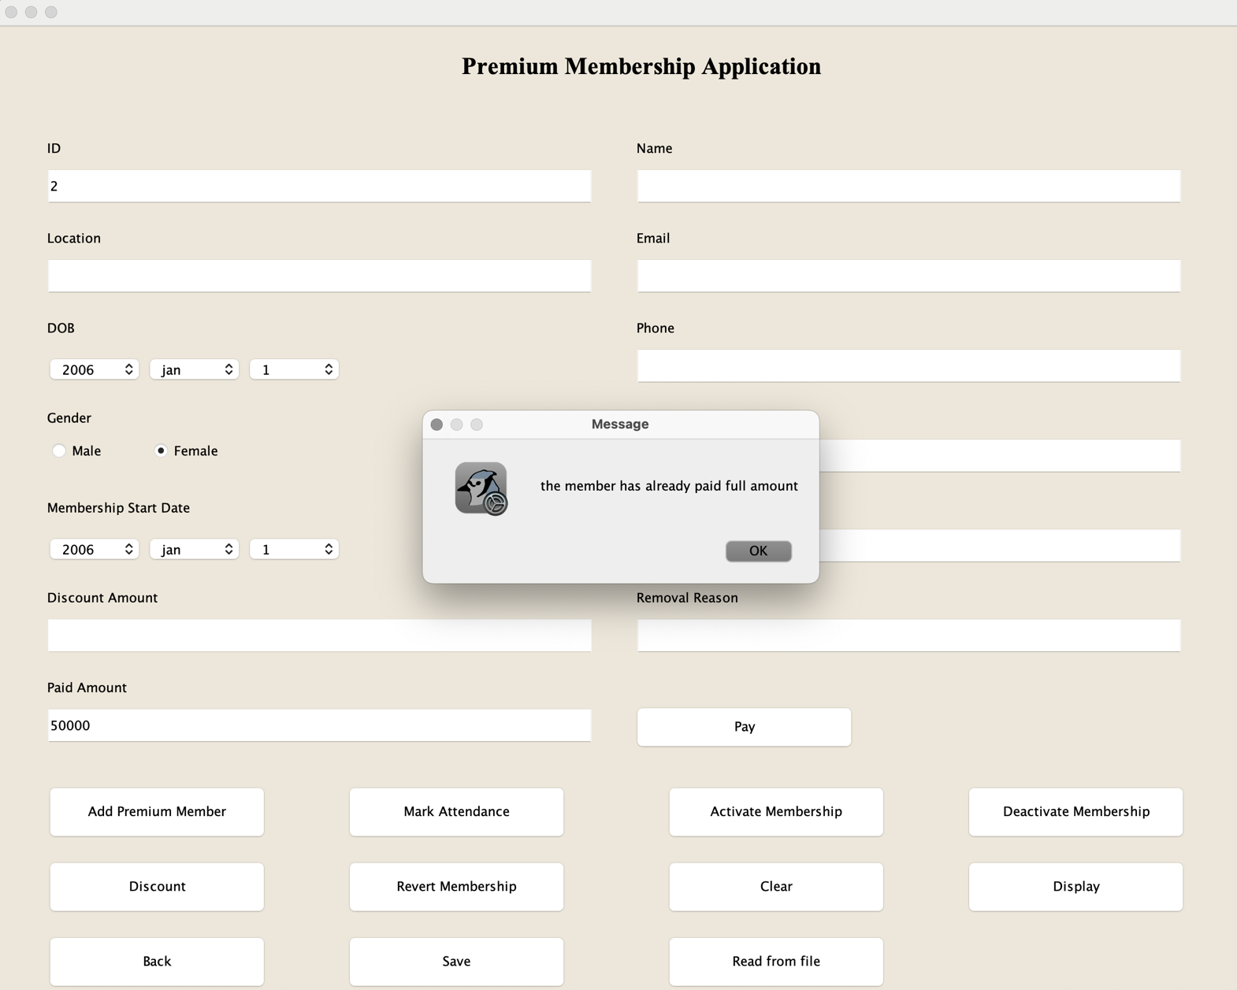

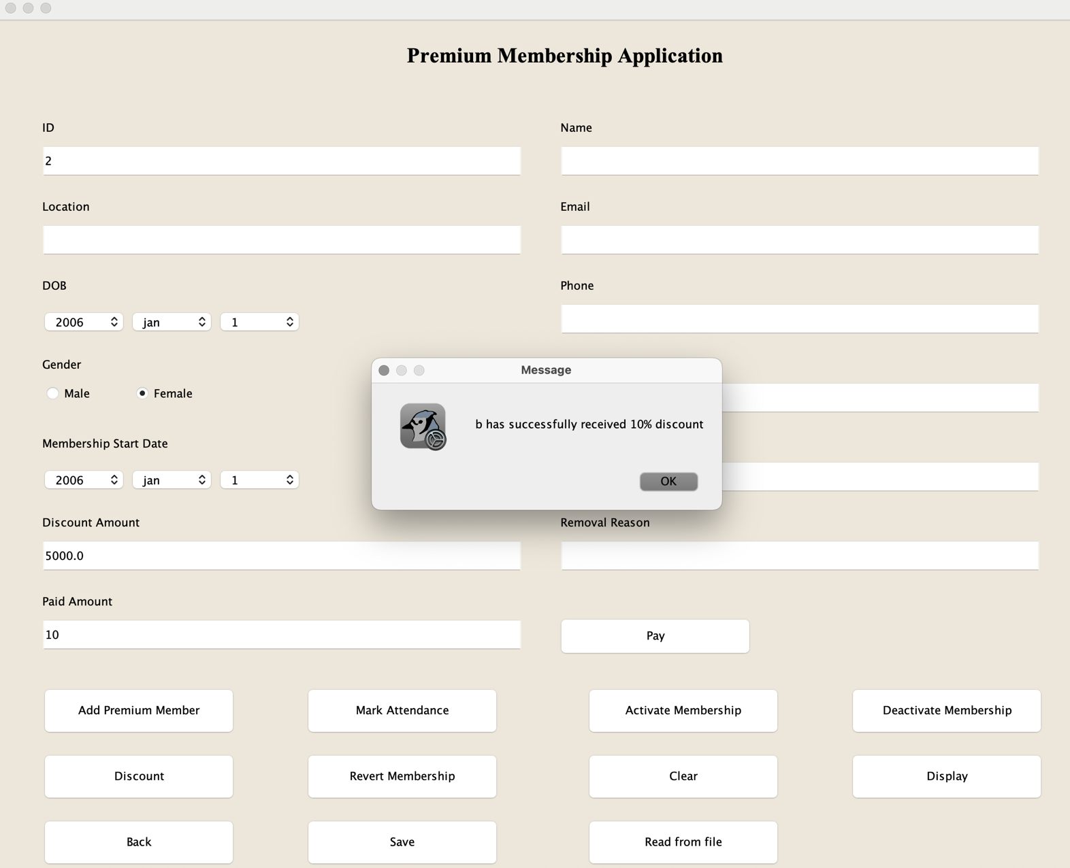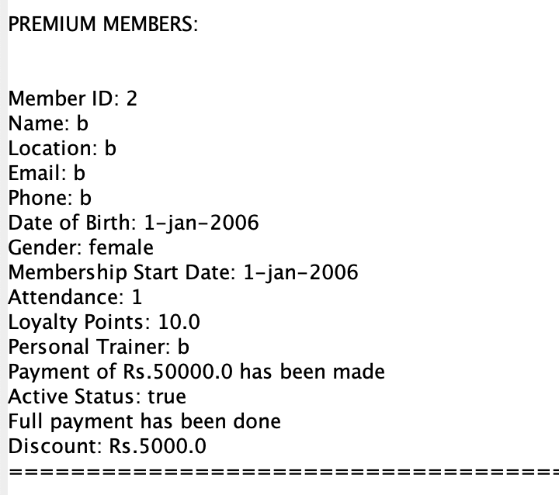

Table : test-4.2: pay due

|  |  |
| --- | --- |
| Objective | To pay the due amount. |
| Action | Fill the id, enter paid amount and click “pay”. |
| Expected Output | A message dialog box stating the remaining amount which needs to be paid should be displayed. |
| Actual Output | A message dialog box stating the remaining amount which needs to be paid is displayed. |
| Result | The test was successful. |



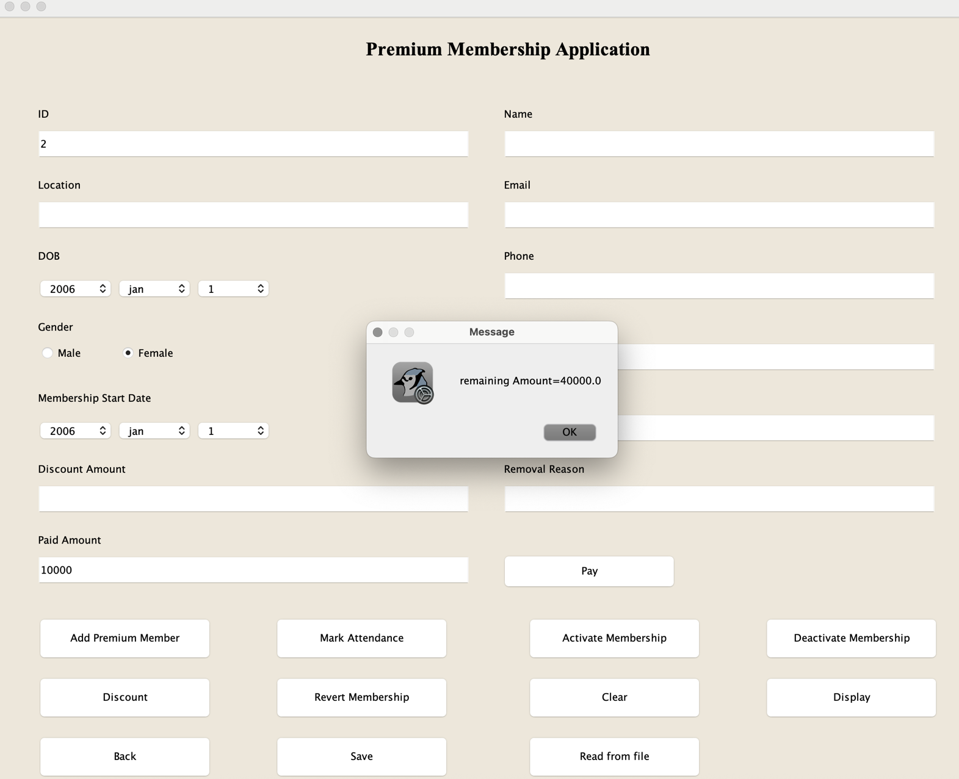

Table : test-4.3: revert member

|  |  |
| --- | --- |
| Objective | To revert the membership. |
| Action | Fill in the id, removal reason and click “revert membership” button. |
| Expected Output | A message dialog box stating that the membership is reverted should be displayed and the active status should be inactive, plan should be basic, attendance and loyalty points should be set to zero. |
| Actual Output | A message dialog box stating that the membership is reverted is displayed and the active status is inactive, plan is basic, attendance and loyalty points is set to zero. |
| Result | The test was successful. |

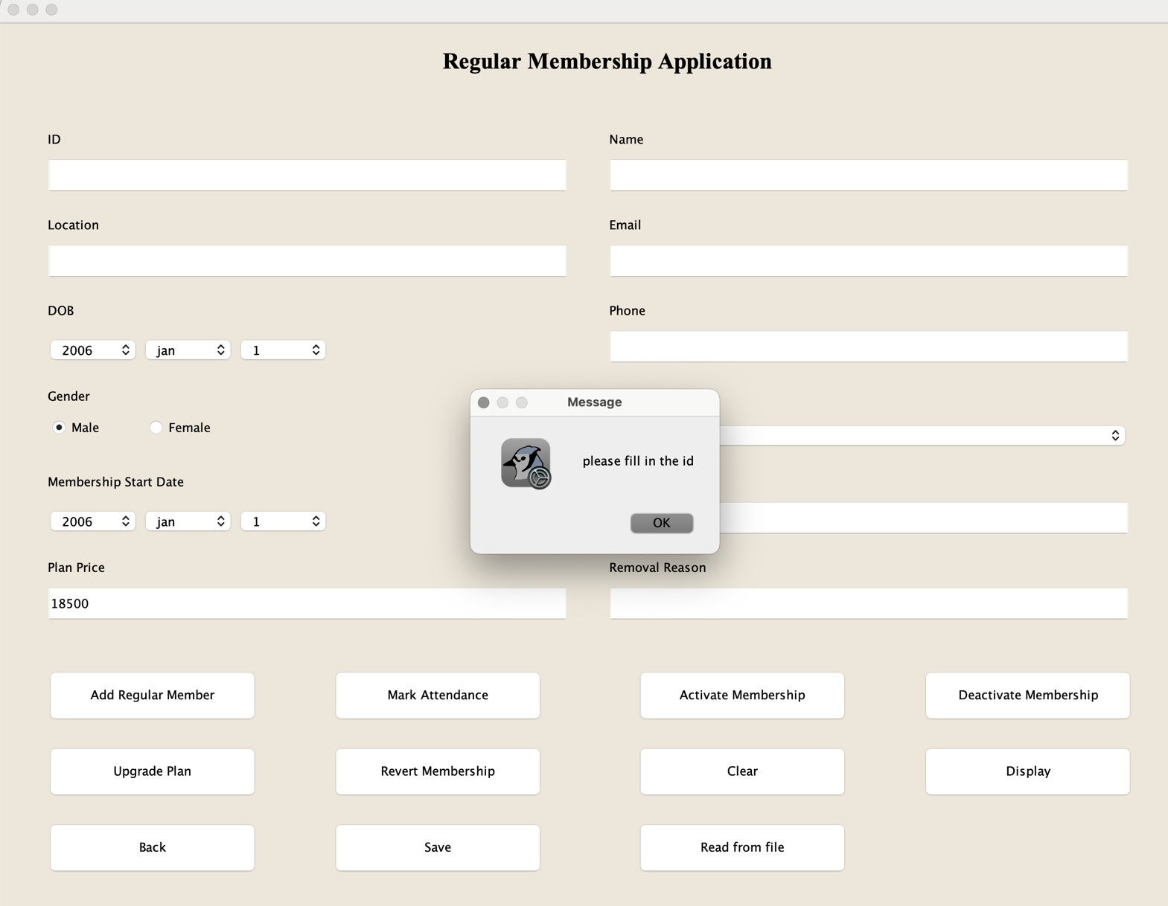

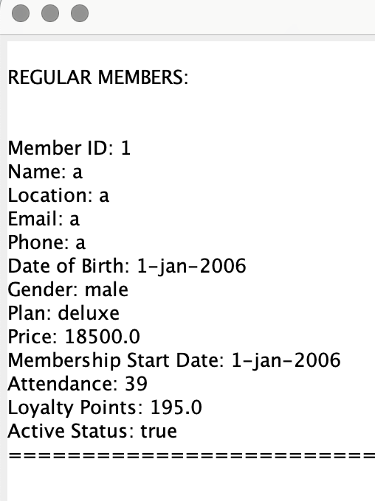

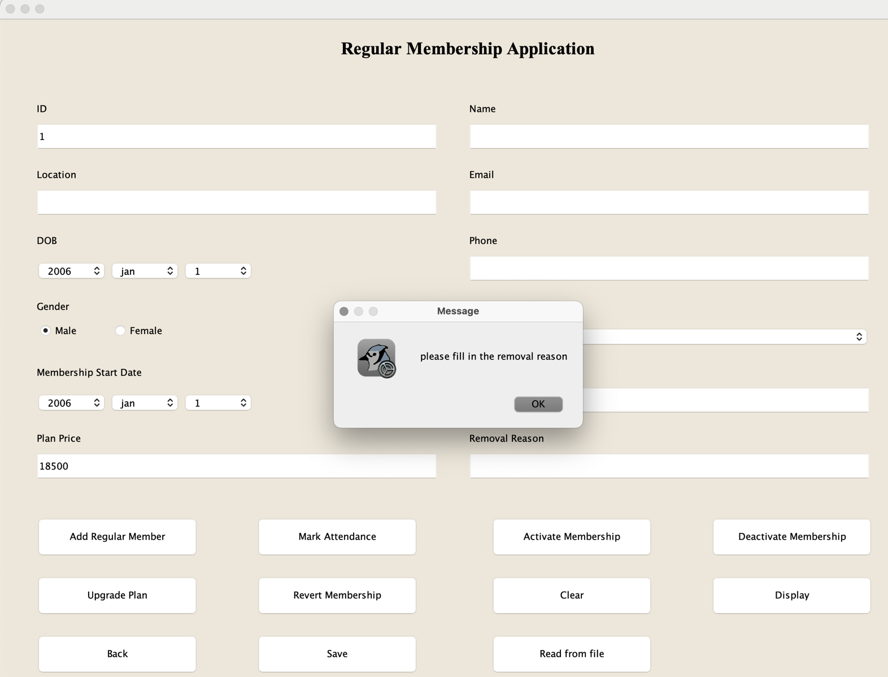

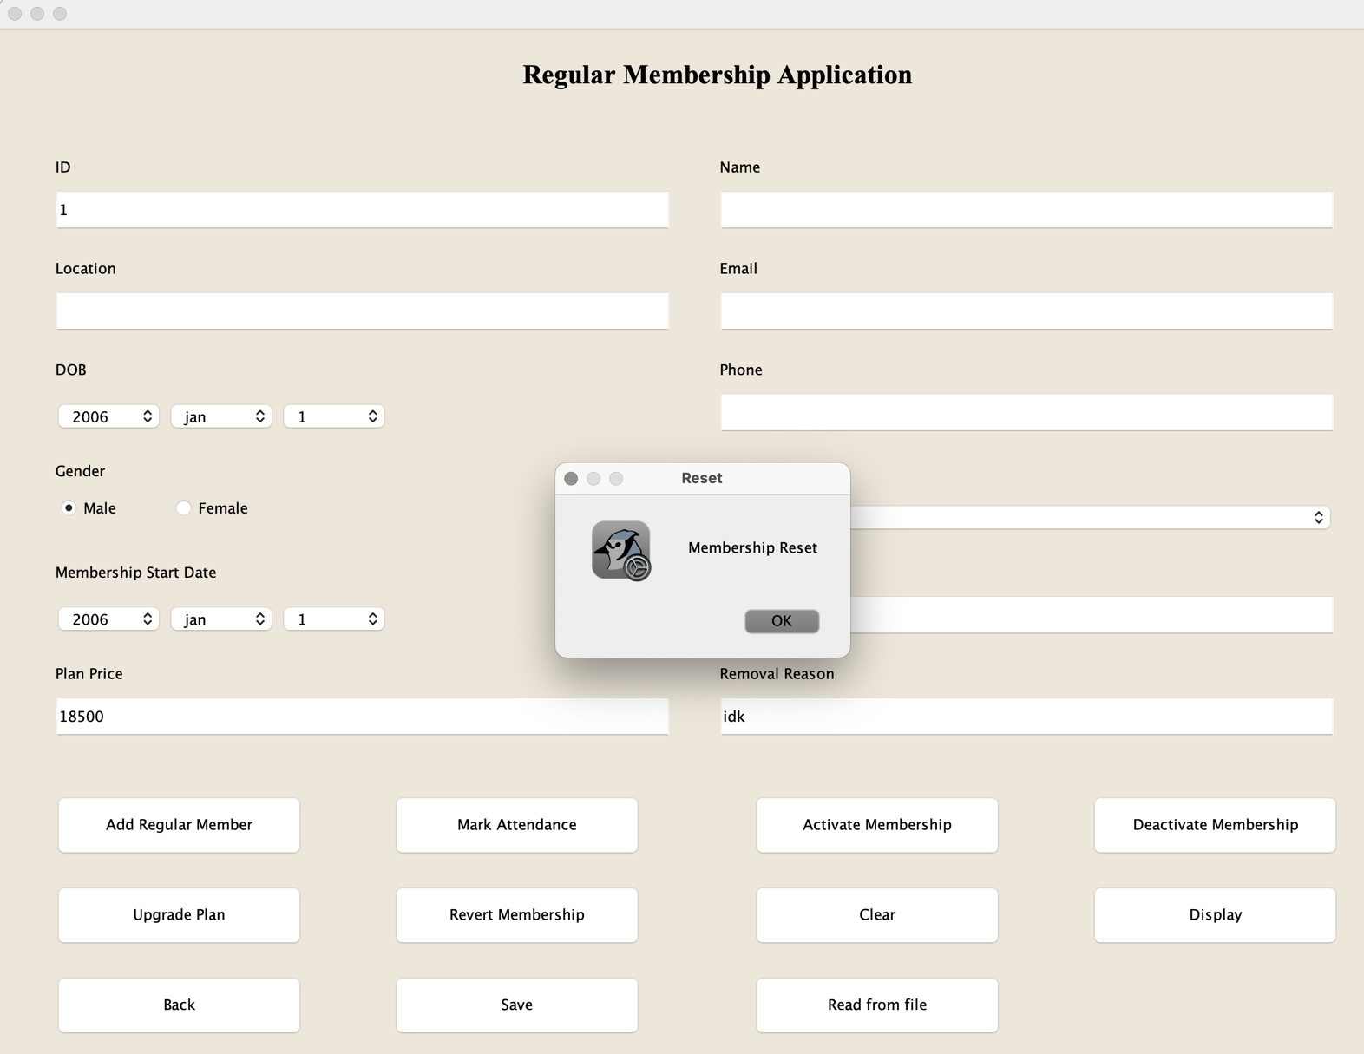

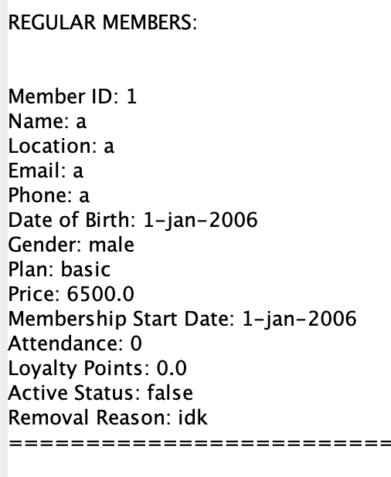

## Test-5

Table : test-5.1: save to file

|  |  |
| --- | --- |
| Objective | To save the file |
| Action | 1. click “save” button without adding any member  2. fill in the application. click “add premium member” button.  3. do the same in regular member frame as well as mark attendance and activate membership.  4. click “save” button. |
| Expected Output | A message dialog stating the file is saved should be displayed along with a text file with the name “MemberDetails.txt” containing those information should be visible. |
| Actual Output | A message dialog stating the file is saved is displayed along with a text file with the name “MemberDetails.txt” containing those information is visible. |
| Result | The test was successful. |

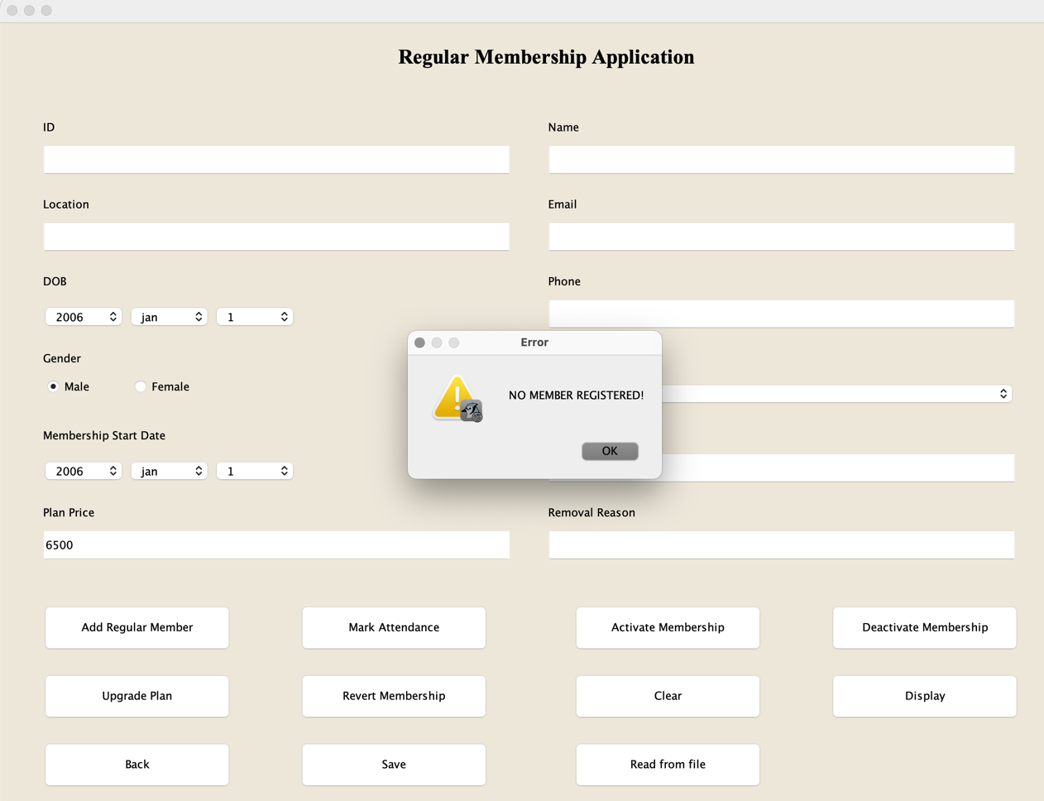

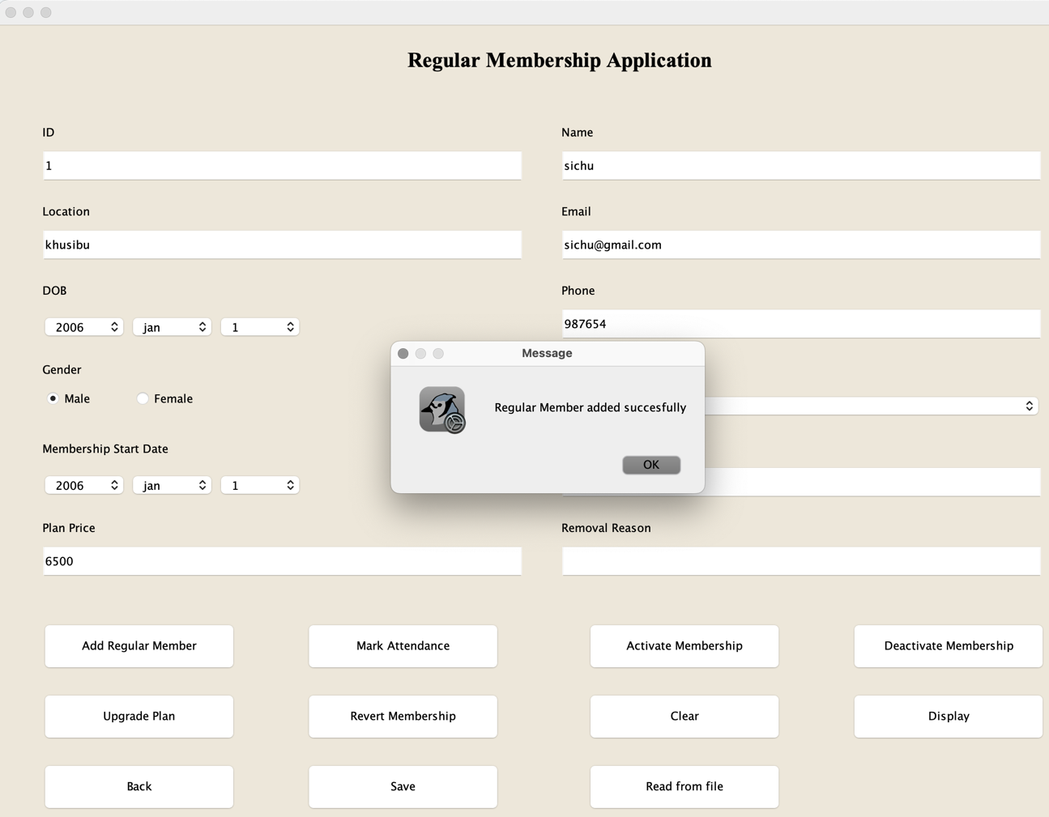

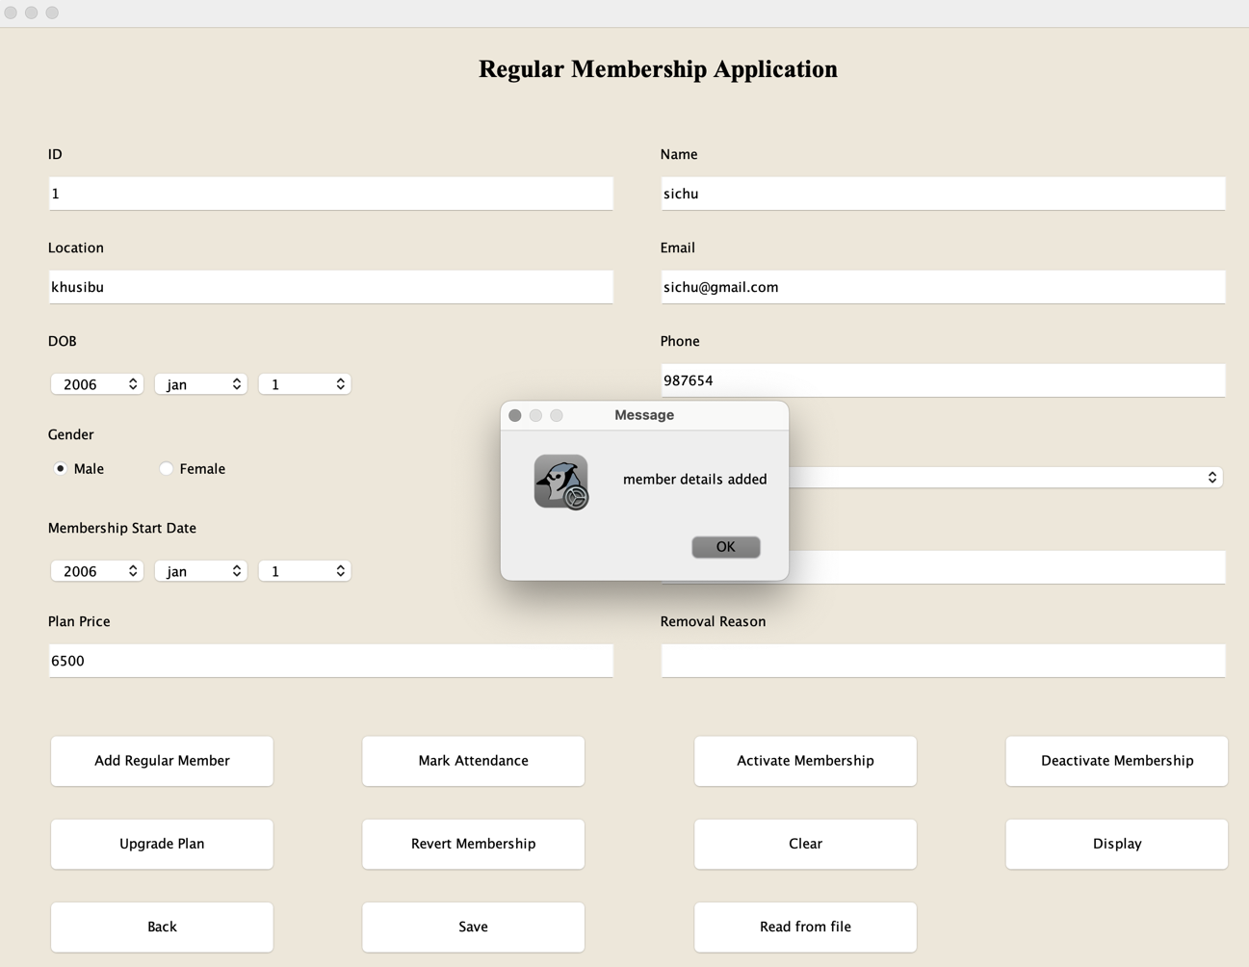

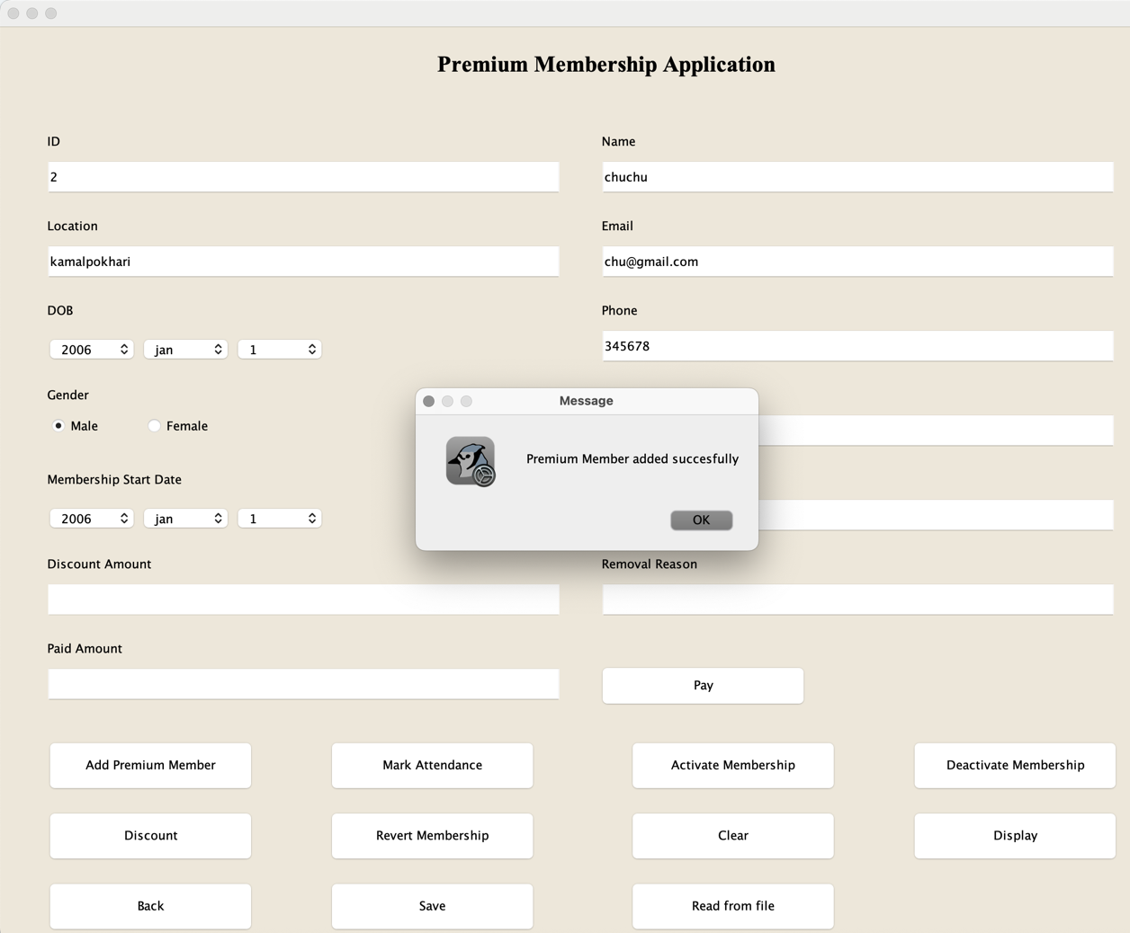

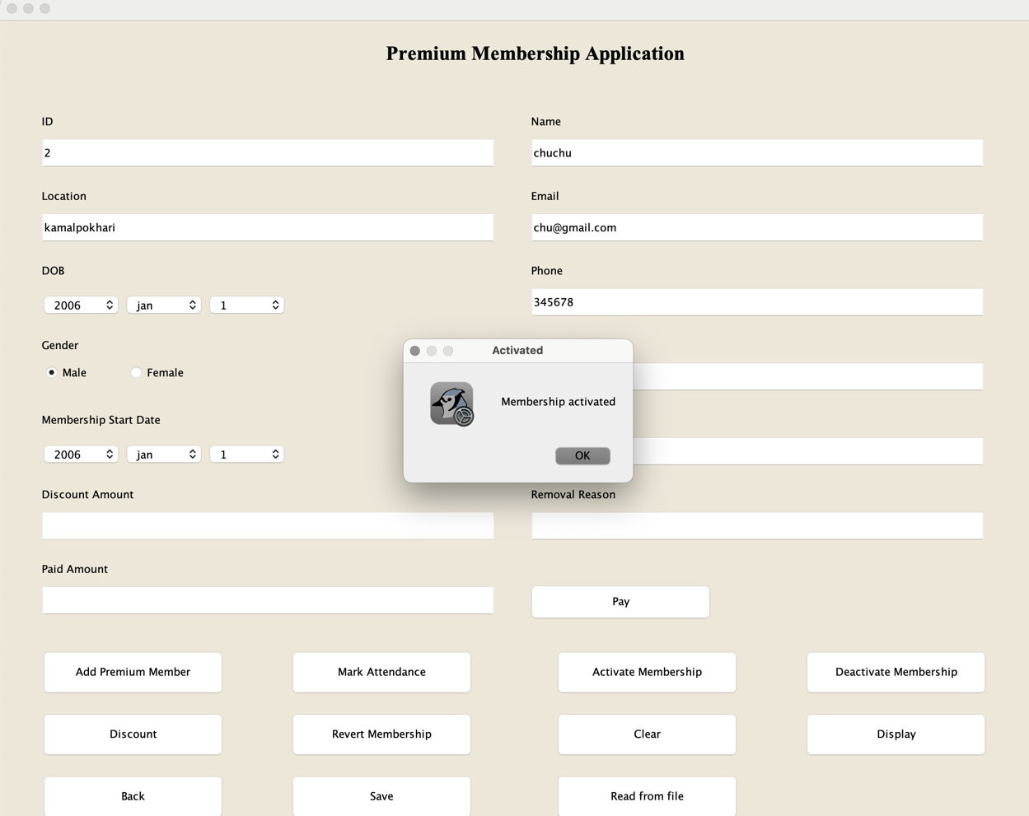

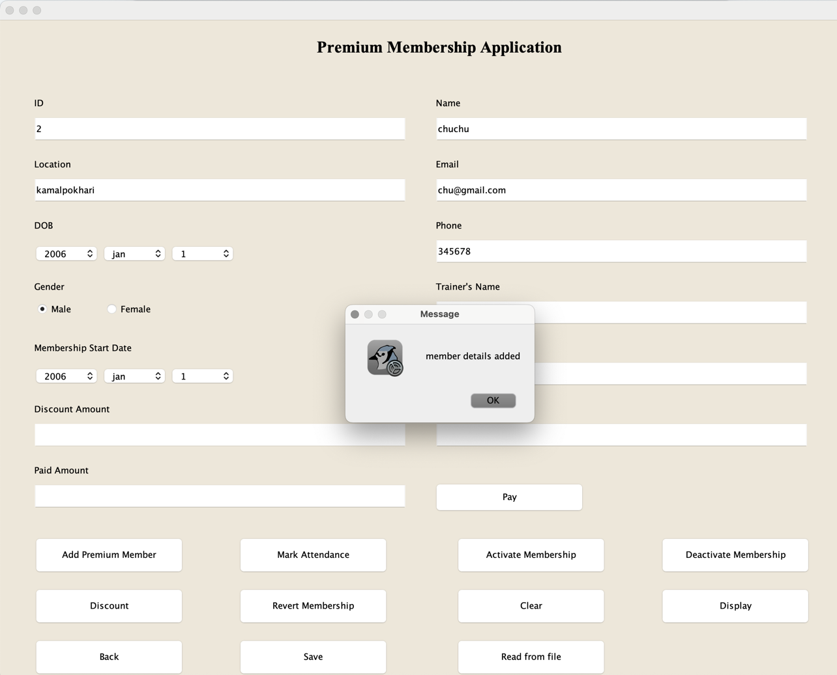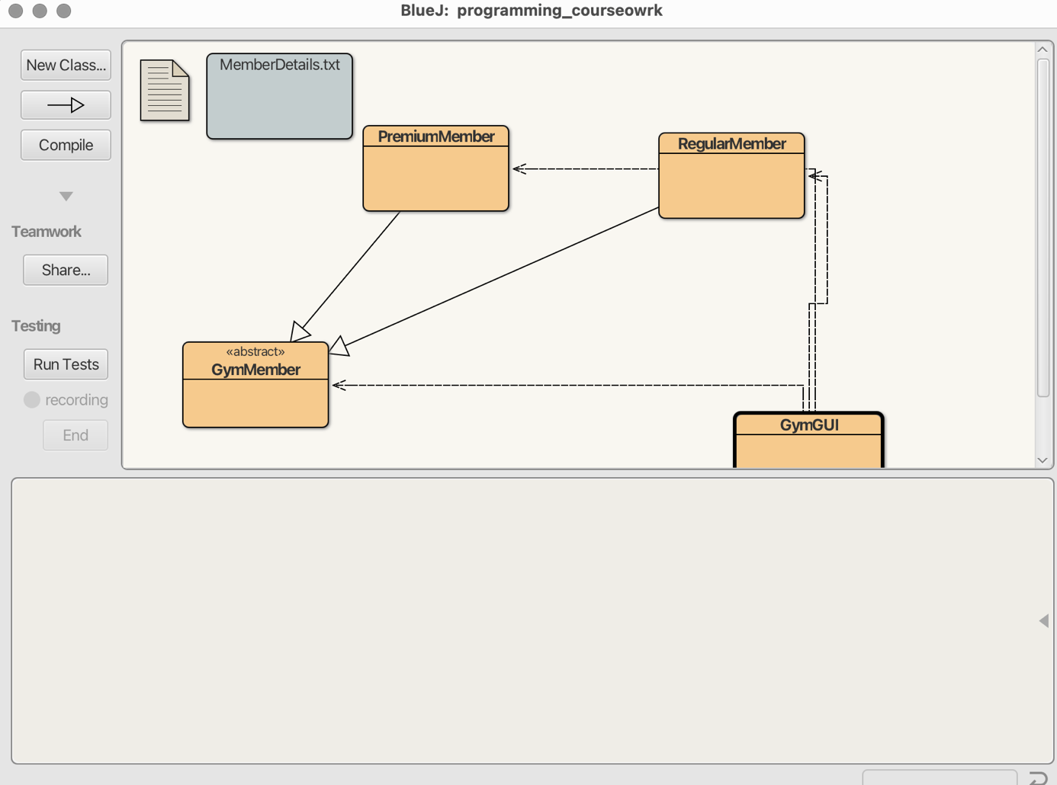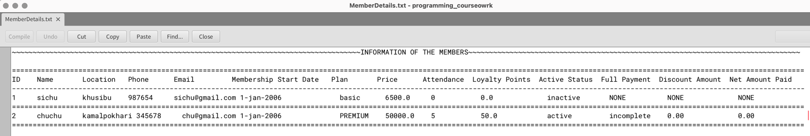

Table : test-5.2: read from file

|  |  |
| --- | --- |
| Objective | To read from file |
| Action | 1. fill in the application.  2. save the application.  3. click “read from file” button. |
| Expected Output | A frame should be opened where the information are stored. |
| Actual Output | A frame is opened where the information are stored. |
| Result | The test was successful. |

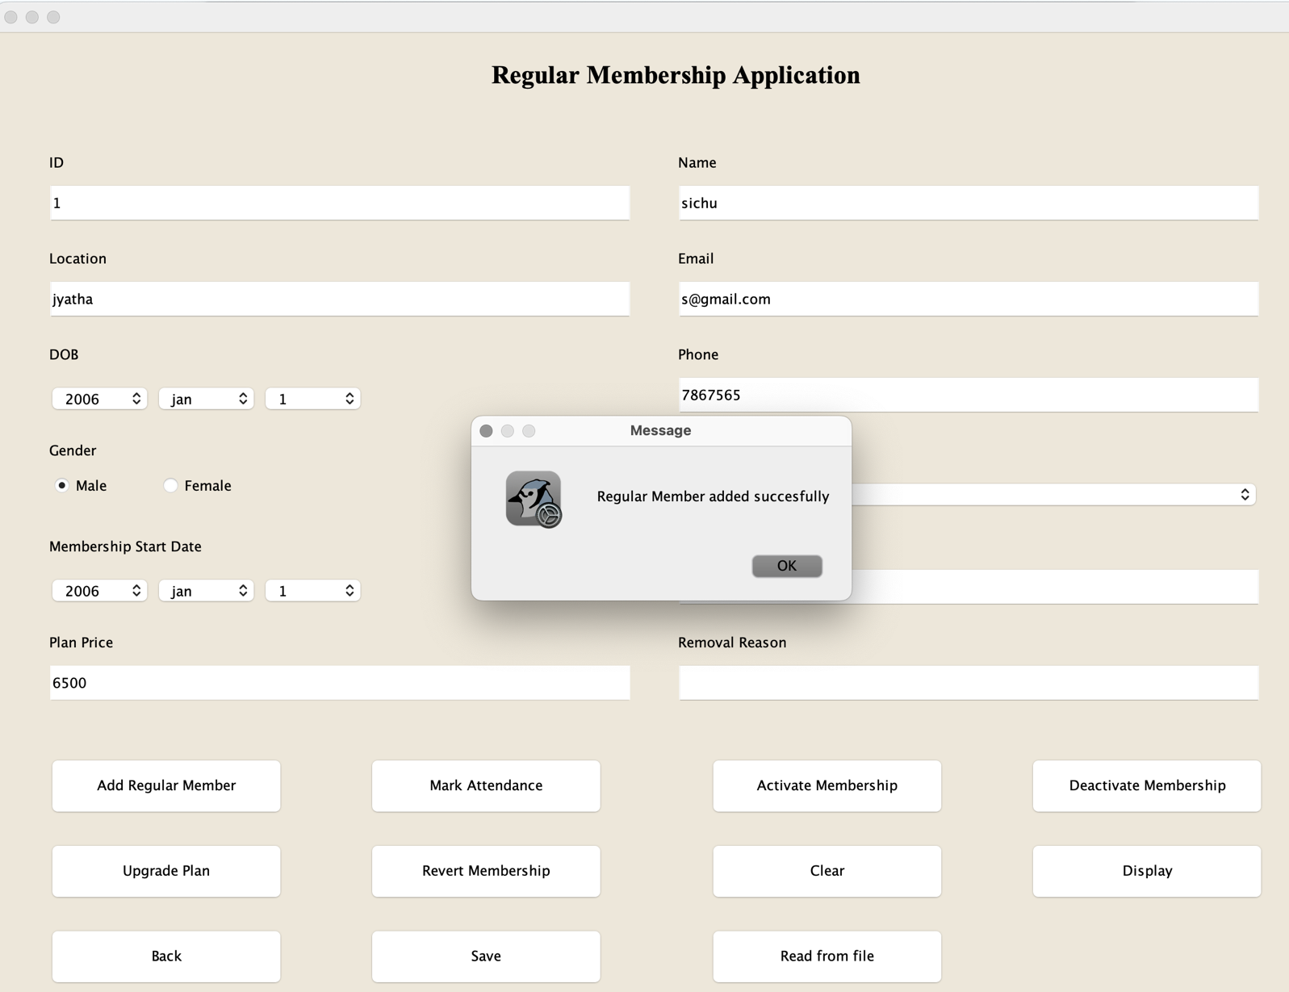

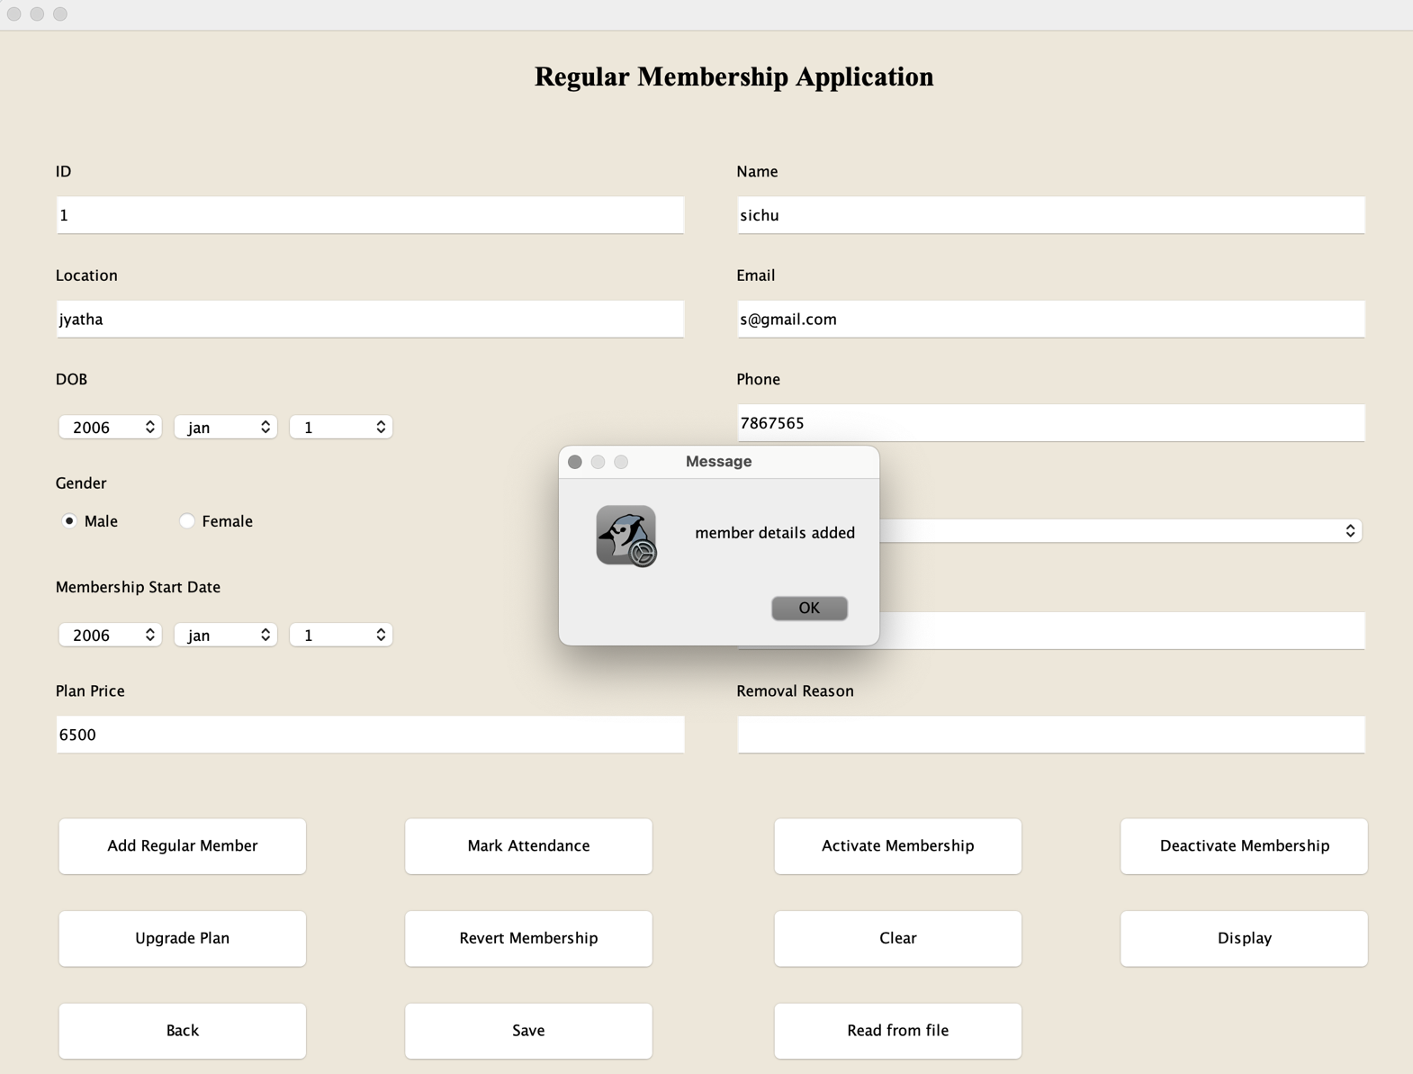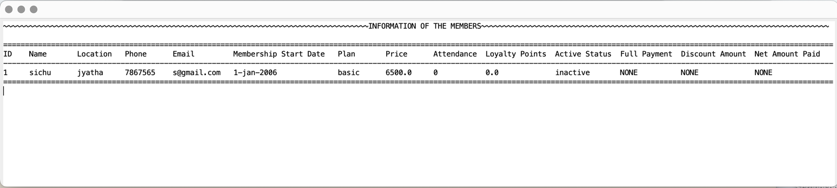

# Error Detection and Correction

Errors in programming are generally bugs which interfere with the execution of the program. These can be of any type. Errors prevents the program from running as expected. Crucial errors can harm the program to great extent. Error detection is a feature built into many programming platforms. Some errors are detected during the execution, and some are detected while writing the codes itself. Error detection and correction are important steps of programming to ensure that the codes are running smoothly without any disruption from any errors that may occur. There are many types of error but the are mostly divided into 3 types, syntax, runtime and logical error.

## Syntax Error

Programs have grammar the same way the language we spoke does. These grammar rules are known as syntax. It makes a errors in the language itself. It is detected during writing the program.

For example, missing a semicolon at the end or writing incorrect spelling to keywords can cause syntax error.

The main syntax error that occurred in this program was forgetting semicolon and forgetting to close a curly bracket. These errors were detected at compile time and corrected.

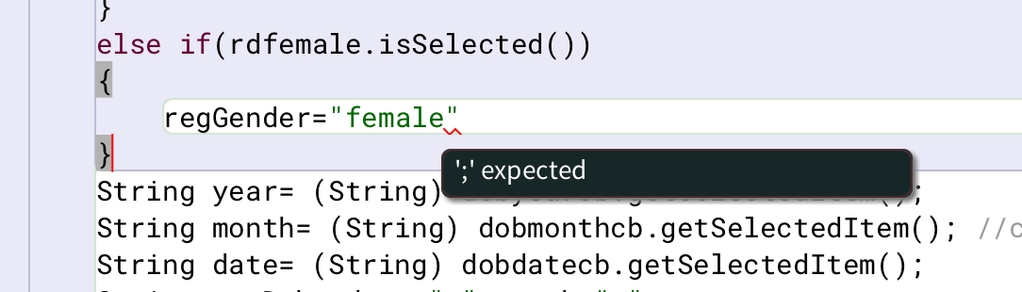

As you can see in this figure, a missing semicolon generates syntax error. These errors are detected as it BlueJ underlines them in red to make it easier to spot.

## Runtime error

The errors which occur during the execution of the program is known as runtime errors. These errors are not detected during compile time. These errors executes the program however the output is not there. For example, dividing by zero, accessing index which is not used, etc. are some runtime errors. These errors often causes the program to crash. These errors also include number format exception, file not found exception which were handled in the program.

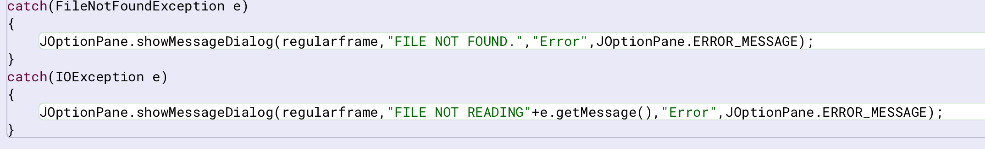

In this figure, the runtime errors are being handled to make sure the program doesn’t end abruptly. The file not found exception catches when the file isn’t found. The IO exception occurs when the program can’t read the file. The number format exception occurs due to entering alphabetical value for integer id.

## Logical error

The error which runs the program smoothly but will provide unexpected output is known as logical errors. These errors are mainly due to human mistakes. For example, using * instead of + or running an infinite loop. These kinds of errors are hardest to find.

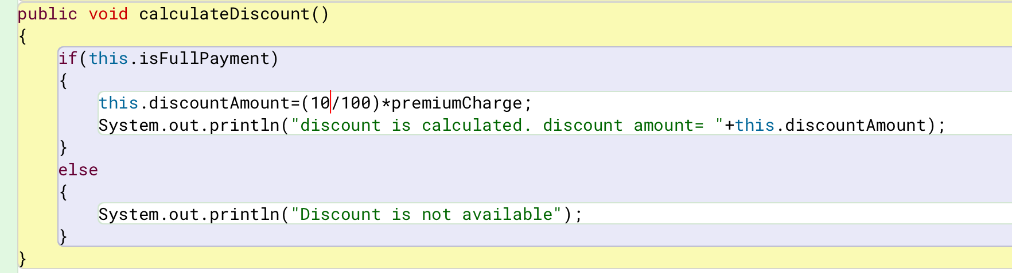

As you can see in this code, nothing seems to be the problem. There is no error during compile nor during runtime. However, this will give the discount amount 0.0 which is not our expected output. As the variable discountAmount is in double data type, atleast one part of that equation should be double.

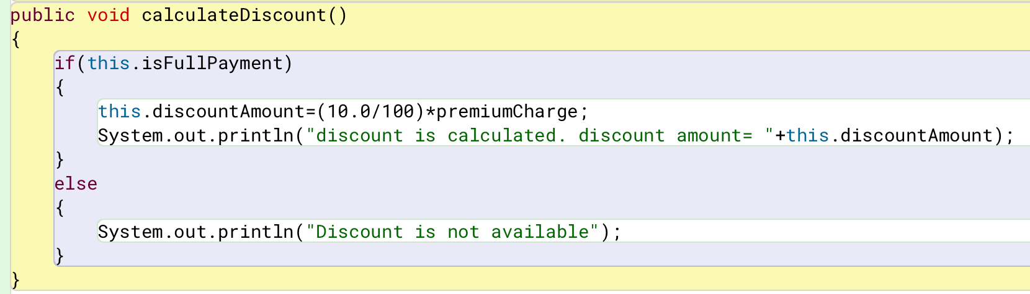

In this figure, we can see how the logical error was handled. By adding .0 in the equation, we get the desired output.

Errors are bugs which makes our program stop abruptly or doesn’t let it execute at all. These errors should be handled inorder to run the program smoothly.

Conclusion

This coursework utilizes the knowledge and lessons taught on java to develop a gym system which lets the user add regular member and premium member as per the user’s want. When adding the member, it requires few information like id, name, location, phone, email and many more. This system even saves the information to a text file and reads from that file too. This system does various works. We can activate and deactivate the membership as per our want. We can mark attendance. We can be eligible for upgrading to any other plan if your attendance exceeds 30.

While doing this coursework, I learned any new thing about java program. I learned topics which weren’t discussed in class. I got to know that there are many things which I don’t know about. This coursework presented an opportunity to leaned and use the java codes and know how to operate through them. It made me know just how much I am yet to learn. I learned the uses of object-oriented language’s concept, polymorphism, abstraction, inheritance and encapsulation.

Many difficulties were faced during the completion of this program. The difficulty ranged from not understanding the logic to few things to handling mistakes generated through various programming errors. Sometimes syntax was typed wrong and sometimes object name was different. During the start, understanding the function of few methods was troublesome. Trying to understand how and where to place few codes were tiring. As progressing through the coursework, the issues were raised from forgetting to add addActionListener to the button to the button not working even if all steps were done correctly due to frame’s visibility being set to false.

These difficulties were overcomed by asking teachers or discussing with friends. These difficulties were solved by simply adding actionlistener or putting .0 behind a number during calculation. Any difficulties faced during the completion of this program was handled. The program also handles several exceptions which were thrown. It may not handle every known exception, but it handles most of them which might occur in this system.

# Bibliography

Anon., n.d. *about bluej.* [Online]   
Available at: https://www.bluej.org/about.html

Anon., n.d. *draw.io.* [Online]   
Available at: https://www.drawio.com/?utm_source=chatgpt.com

Anon., n.d. *figma.* [Online]   
Available at: https://www.figma.com/about/

Anon., n.d. *introduction to BlueJ.* [Online]   
Available at: https://www.geeksforgeeks.org/introduction-of-bluej/

College, I., n.d. s.l.: s.n.

Appendix (Code Listing)

public abstract class GymMember

{

protected int id;

protected int attendance;

protected String name;

protected String location;

protected String phone;

protected String email;

protected String gender;

protected String DOB;

protected String membershipStartDate;

protected double loyaltyPoints;

protected boolean activeStatus;

//constructor

public GymMember(int id,String name,String location,String phone,String email,

String gender,String DOB,String membershipStartDate)

{

//assigning

this.id=id;

this.name=name;

this.location=location;

this.phone=phone;

this.email=email;

this.gender=gender;

this.DOB=DOB;

this.membershipStartDate=membershipStartDate;

//initializing

this.attendance=0;

this.loyaltyPoints=0;

this.activeStatus=false;

}

//accessor methods

public int getId()

{

return this.id;

}

public int getAttendance()

{

return this.attendance;

}

public String getName()

{

return this.name;

}

public String getLocation()

{

return this.location;

}

public String getPhone()

{

return this.phone;

}

public String getEmail()

{

return this.email;

}

public String getGender()

{

return this.gender;

}

public String getDOB()

{

return this.DOB;

}

public String getMembershipStartDate()

{

return this.membershipStartDate;

}

public double getLoyaltyPoints()

{

return this.loyaltyPoints;

}

public boolean getActiveStatus()

{

return this.activeStatus;

}

public abstract void markAttendance();

public void activateMembership()

{

activeStatus=true;

}

public void deactivateMembership()

{

if(activeStatus)//checking if its active or not

{

activeStatus=false;

}

else

{

System.out.println("It seems like active status is already inactive");

}

}

public void resetMembership()

{

activeStatus=false;

attendance=0;

loyaltyPoints=0;

}

public void display()

{

System.out.println("Id: "+id);

System.out.println("Name: "+name);

System.out.println("Location: "+location);

System.out.println("Phone: "+phone);

System.out.println("Email: "+email);

System.out.println("Gender: "+gender);

System.out.println("DOB: "+DOB);

System.out.println("Membership Start Date: "+membershipStartDate);

System.out.println("Attendance: "+attendance);

System.out.println("Loyalty points: "+loyaltyPoints);

System.out.println("Active Status: "+(activeStatus?"active":"inactive"));

}

}

public class RegularMember extends GymMember

{

private final int attendanceLimit; //final keyword is used so that the value cannot be changed

private boolean isEligibleForUpgrade;

private String removalReason;

private String referralSource;

private String plan;

private double price;

//constructor

public RegularMember(int id,String name,String location,String phone,String email,

String gender,String DOB,String membershipStartDate, String referralSource)

{

//calling parent class constructor

super(id, name, location, phone, email, gender, DOB, membershipStartDate);

//initializing

this.isEligibleForUpgrade=false;

this.attendanceLimit=30;

this.plan="basic";

this.price=6500;

this.removalReason="";

this.referralSource=referralSource;

}

//getter methods

public int getAttendanceLimit()

{

return this.attendanceLimit;

}

public boolean getIsEligibleForUpgrade()

{

return this.isEligibleForUpgrade;

}

public String getRemovalReason()

{

return this.removalReason;

}

public String getReferralSource()

{

return this.referralSource;

}

public String getPlan()

{

return this.plan;

}

public double getPrice()

{

return this.price;

}

@Override

public void markAttendance()

{

attendance++;

loyaltyPoints+=5;

if(getAttendance()>=attendanceLimit)

{

isEligibleForUpgrade=true;

}

}

public double getPlanPrice(String plan)

{

double x;

switch(plan)

{

case "basic":

return 6500;

case "standard":

return 12500;

case "deluxe":

return 18500;

default:

return -1;

} /*no break statement because it directly returns

in java once return is executed, it skips the whole block*/

}

public String upgradePlan(String plan)

{

if (isEligibleForUpgrade!=true)//check eligibility

{

return "the member is not eligible for upgrade";

}

else//if member is eligible

{

if(this.plan==plan)//checks for same plan

{

return "the member has chosen the same plan";

}

else //if not same

{

if(getPlanPrice(plan)==-1)//check invalid plan

{

return "the member has entered invalid plan";

}

else //all requirement matches

{

this.plan=plan;

this.price=getPlanPrice(plan);

return ("plan upgraded to "+plan+"\n price= "+price);

}

}

}

}

public void revertRegularMember(String removalReason)

{

super.resetMembership();

this.isEligibleForUpgrade=false;

this.plan="basic";

this.price=6500;

this.removalReason=removalReason;

}

@Override

public void display()

{

super.display();

System.out.println("plan: "+plan);

System.out.println("price: "+price);

if(removalReason!="")

{

System.out.println("removal reason: "+removalReason);

}

}

}

public class PremiumMember extends GymMember

{

final double premiumCharge;

String personalTrainer;

boolean isFullPayment;

double paidAmount;

double discountAmount;

public PremiumMember(int id, String name, String location, String phone, String

email, String gender, String DOB, String membershipStartDate, String personalTrainer)

{

//calling parent class constructor

super(id,name,location,phone,email,gender,DOB,membershipStartDate);

//initializing

this.premiumCharge=50000;

this.paidAmount=0;

this.isFullPayment=false;

this.discountAmount=0;

this.personalTrainer=personalTrainer;

}

//accessor/getter methods

public double getPremiumCharge()

{

return this.premiumCharge;

}

public String getPersonalTrainer()

{

return this.personalTrainer;

}

public boolean getIsFullPayment()

{

return this.isFullPayment;

}

public double getPaidAmount()

{

return this.paidAmount;

}

public double getDiscountAmount()

{

return this.discountAmount;

}

public String payDueAmount(double paidAmount)

{

if(this.paidAmount==premiumCharge)

{

this.isFullPayment=true;

}

if(this.isFullPayment)

{

System.out.println("full payment has been done");

return "the member has already paid full amount";

}

else

{

this.paidAmount+=paidAmount;

if(this.paidAmount>premiumCharge)

{

this.paidAmount-=paidAmount;//get back the paid amount before it was excceded

System.out.println("the member has paid more than premiumCharge.");

return "please pay the correct amount";

}

else

{

System.out.println("payment was successful");

return "remaining Amount="+(premiumCharge-this.paidAmount);

}

}

}

public void calculateDiscount()

{

if(this.isFullPayment)

{

this.discountAmount=(10.0/100)*premiumCharge;

System.out.println("discount is calculated. discount amount= "+this.discountAmount);

}

else

{

System.out.println("Discount is not available");

}

}

public void revertPremiumMember()

{

super.resetMembership();

this.personalTrainer="";

this.isFullPayment=false;

this.paidAmount=0;

this.discountAmount=0;

}

@Override

public void markAttendance()

{

attendance++;

loyaltyPoints+=10;

}

@Override

public void display()

{

super.display();

System.out.println("personal trainer= "+personalTrainer);

System.out.println("paid amount= "+paidAmount);

System.out.println("is the amount fully paid= "+(isFullPayment?"yes":"no"));

if(this.isFullPayment)

{

System.out.println("discount amount= "+discountAmount);

}

else if(this.paidAmount<premiumCharge)

{

System.out.println("remaining Amount="+(premiumCharge-this.paidAmount));

}

}

}

import java.util.ArrayList;

import javax.swing.JFrame;

import javax.swing.JLabel;

import javax.swing.JTextField;

import javax.swing.JTextArea;

import javax.swing.JComboBox;

import javax.swing.JRadioButton;

import javax.swing.JButton;

import javax.swing.ButtonGroup;

import java.awt.event.ActionListener;

import java.awt.event.ActionEvent;

import javax.swing.JOptionPane;

import java.awt.Font;

import java.awt.Color;

import java.io.File;

import java.io.FileWriter;

import java.io.IOException;

import java.io.FileReader;

import java.io.FileNotFoundException;

//import javax.swing.JSeparator;

public class GymGUI implements ActionListener

{

ArrayList<GymMember> al1 = new ArrayList<GymMember>();

public static void main(String[]args)

{

new GymGUI();

}

JFrame option, regularframe, premiumframe,displayframe,readframe;

JTextArea displayta,readta;

JLabel labelid, labelname, labellocation, labeldob, labelemail,

labelphone, labelgender, labelplan, labelmembershipsd,

labelreferral, labelremoval,labeltrainer, labelprice,

title1,regular,premium;

JTextField tfid,tflocation,tfemail, tfprice, tfname, tfphone, tfreferral,tfremoval;

JComboBox dobyearcb,dobmonthcb,dobdatecb, plancb, msyearcb,msmonthcb, msdaycb;

JRadioButton rdmale, rdfemale;

ButtonGroup grp;

JButton pre,reg,back1,back2;

JButton addregular, activate, deactivate, attendance,revert, clear, display, upgradePlan, save, read;

JLabel plabelid, plabelname, plabellocation, plabeldob, plabelemail,

plabelphone, plabelgender, plabelplan, plabelmembershipsd,

plabelreferral, plabelpaid, plabelremoval,plabeltrainer, plabeldiscount;

JTextField ptfid,ptflocation,ptfemail, ptfpaid, ptfname, ptfphone, ptfreferral,ptfremoval, ptfdiscount, ptftrainer;

JComboBox pdobyearcb,pdobmonthcb,pdobdatecb, pplancb, pmsyearcb,pmsmonthcb, pmsdaycb;

JRadioButton prdmale, prdfemale;

ButtonGroup bg;

JButton addpremium, pactivate, pdeactivate, pattendance,prevert, pclear, pdisplay,calculateDiscount,pay,psave,pread;

public GymGUI()

{

//option gui

option = new JFrame("");

title1 = new JLabel("Apply for:");

title1.setForeground(Color.WHITE);

title1.setFont(new Font("Times New Roman",Font.BOLD,20));

reg = new JButton("Regular Membership");

pre = new JButton("Premium Membership");

option.getContentPane().setBackground(Color.decode("#1c382c"));

title1.setBounds(110,5,120,30);

reg.setBounds(50,50,200,60);

pre.setBounds(50,120,200,60);

reg.setBackground(Color.decode("#f0e6d3"));

pre.setBackground(Color.decode("#f0e6d3"));

reg.setOpaque(true);

reg.setBorderPainted(false);

pre.setOpaque(true);//false=no bg color

pre.setBorderPainted(false);//true=no custom color

option.add(title1);

option.add(reg);

option.add(pre);

option.setLayout(null);

option.setVisible(true);

option.setSize(300,250);

//application member gui

regularframe = new JFrame("");

regularframe.getContentPane().setBackground(Color.decode("#ede7da"));

regular = new JLabel("Regular Membership Application");

regular.setFont(new Font("Times New Roman",Font.BOLD,24));

labelid = new JLabel("ID");

labelname = new JLabel("Name");

labellocation = new JLabel("Location");

labeldob = new JLabel("DOB");

labelemail = new JLabel("Email");

labelphone = new JLabel("Phone");

labelgender = new JLabel("Gender");

labelplan = new JLabel("Plan");

labelmembershipsd = new JLabel("Membership Start Date");

labelreferral = new JLabel("Referral Source");

labelremoval = new JLabel("Removal Reason");

labeltrainer = new JLabel("Trainer's Name");

labelprice = new JLabel("Plan Price");

tfid = new JTextField();

tflocation = new JTextField();

tfemail = new JTextField();

tfprice = new JTextField("6500");

tfname = new JTextField();

tfphone = new JTextField();

tfreferral = new JTextField();

tfremoval = new JTextField();

String y[]={"2006","2007","2008","2009","2010","2011","2012","2013","2014","2015","2016"};

String m[]={"jan","feb","mar","apr","may","jun","jul","aug",

"sept","oct","nov","dec"};

String d[]={"1","2","3","4","5","6","7","8","9","10","11","12",

"13","14","15","16","17","18","19","20","21","22","23","24",

"25","26","27","28","29","30","31"};

String p[]= {"basic","standard","deluxe"};

dobyearcb = new JComboBox(y);

dobmonthcb = new JComboBox(m);

dobdatecb = new JComboBox(d);

plancb = new JComboBox(p);

msyearcb = new JComboBox(y);

msmonthcb = new JComboBox(m);

msdaycb = new JComboBox(d);

rdmale = new JRadioButton("Male",true);

rdfemale = new JRadioButton("Female");

grp = new ButtonGroup();

addregular = new JButton("Add Regular Member");

addpremium = new JButton("Add Premium Member");

activate = new JButton("Activate Membership");

deactivate = new JButton("Deactivate Membership");

attendance = new JButton("Mark Attendance");

revert = new JButton("Revert Membership");

clear = new JButton("Clear");

display = new JButton("Display");

back1 = new JButton("Back");

upgradePlan = new JButton("Upgrade Plan");

save = new JButton("Save");

read = new JButton("Read from file");

tfprice.setEditable(false);

regular.setBounds(465,15,400,50);

labelid.setBounds(50,110,100,25);

labellocation.setBounds(50,200,100,25);

labeldob.setBounds(50,290,100,25);

labelgender.setBounds(50,380,100,25);

labelmembershipsd.setBounds(50,470,150,25);

labelprice.setBounds(50,560,100,25);

labelname.setBounds(640,110,100,25);

labelemail.setBounds(640,200,100,25);

labelphone.setBounds(640,290,100,25);

labelplan.setBounds(640,380,100,25);

labelreferral.setBounds(640,470,100,25);

labelremoval.setBounds(640,560,150,25);

addregular.setBounds(50,680,220,55);

attendance.setBounds(350,680,220,55);

activate.setBounds(670,680,220,55);

deactivate.setBounds(970,680,220,55);

revert.setBounds(350,760,220,55);

clear.setBounds(670,760,220,55);

display.setBounds(970,760,220,55);

upgradePlan.setBounds(50,760,220,55);

back1.setBounds(50,840,220,55);

save.setBounds(350,840,220,55);

read.setBounds(670,840,220,55);

tfid.setBounds(48,140,550,40);

tflocation.setBounds(48,230,550,40);

tfemail.setBounds(638,230,550,40);

tfprice.setBounds(48,590,550,40);

tfname.setBounds(638,140,550,40);

tfphone.setBounds(638,320,550,40);

tfreferral.setBounds(638,500,550,40);

tfremoval.setBounds(638,590,550,40);

rdmale.setBounds(48,410,100,30);

rdfemale.setBounds(150,410,100,30);

plancb.setBounds(638,400,550,70);

dobyearcb.setBounds(48,320,100,50);

dobmonthcb.setBounds(148,320,100,50);

dobdatecb.setBounds(248,320,100,50);

msyearcb.setBounds(48,500,100,50);

msmonthcb.setBounds(148,500,100,50);

msdaycb.setBounds(248,500,100,50);

regularframe.add(regular);

regularframe.add(labelid);

regularframe.add(labelname);

regularframe.add(labellocation);

regularframe.add(labelemail);

regularframe.add(labelphone);

regularframe.add(labelgender);

regularframe.add(labelplan);

regularframe.add(labeldob);

regularframe.add(labelmembershipsd);

regularframe.add(labelreferral);

regularframe.add(labelremoval);

regularframe.add(labelprice);

regularframe.add(tfid);

regularframe.add(tflocation);

regularframe.add(tfemail);

regularframe.add(tfprice);

regularframe.add(tfname);

regularframe.add(tfphone);

regularframe.add(tfreferral);

regularframe.add(tfremoval);

regularframe.add(rdmale);

regularframe.add(rdfemale);

regularframe.add(dobyearcb);

regularframe.add(dobmonthcb);

regularframe.add(dobdatecb);

regularframe.add(plancb);

regularframe.add(msyearcb);

regularframe.add(msmonthcb);

regularframe.add(msdaycb);

regularframe.add(addregular);

regularframe.add(attendance);

regularframe.add(activate);

regularframe.add(deactivate);

regularframe.add(clear);

regularframe.add(display);

regularframe.add(revert);

regularframe.add(back1);

regularframe.add(upgradePlan);

regularframe.add(save);

regularframe.add(read);

grp.add(rdmale);

grp.add(rdfemale);

regularframe.setLayout(null);

regularframe.setVisible(false);

regularframe.setSize(1250,950);

//premium frame

premiumframe = new JFrame("");

premiumframe.getContentPane().setBackground(Color.decode("#ede7da"));

premium = new JLabel("Premium Membership Application");

premium.setFont(new Font("Times New Roman",Font.BOLD,24));

plabelid = new JLabel("ID");

plabelname = new JLabel("Name");

plabellocation = new JLabel("Location");

plabeldob = new JLabel("DOB");

plabelemail = new JLabel("Email");

plabelphone = new JLabel("Phone");

plabelgender = new JLabel("Gender");

plabelplan = new JLabel("Plan");

plabelmembershipsd = new JLabel("Membership Start Date");

plabelreferral = new JLabel("Referral Source");

plabelpaid = new JLabel("Paid Amount");

plabelremoval = new JLabel("Removal Reason");

plabeltrainer = new JLabel("Trainer's Name");

plabeldiscount = new JLabel("Discount Amount");

ptfid = new JTextField();

ptflocation = new JTextField();

ptfemail = new JTextField();

ptfpaid = new JTextField();

ptfname = new JTextField();

ptfphone = new JTextField();

ptfreferral = new JTextField();

ptfremoval = new JTextField();

ptfdiscount = new JTextField();

ptftrainer = new JTextField();

pdobyearcb = new JComboBox(y);

pdobmonthcb = new JComboBox(m);

pdobdatecb = new JComboBox(d);

pmsyearcb = new JComboBox(y);

pmsmonthcb = new JComboBox(m);

pmsdaycb = new JComboBox(d);

prdmale = new JRadioButton("Male",true);

prdfemale = new JRadioButton("Female");

bg = new ButtonGroup();

addpremium = new JButton("Add Premium Member");

pactivate = new JButton("Activate Membership");

pdeactivate = new JButton("Deactivate Membership");

pattendance = new JButton("Mark Attendance");

prevert = new JButton("Revert Membership");

pclear = new JButton("Clear");

pdisplay = new JButton("Display");

back2 = new JButton("Back");

psave = new JButton("Save");

pread = new JButton("Read from file");

calculateDiscount = new JButton("Discount");

pay = new JButton("Pay");

ptfdiscount.setEditable(false);

premium.setBounds(465,15,500,50);

plabelid.setBounds(50,110,100,25);

plabellocation.setBounds(50,200,100,25);

plabeldob.setBounds(50,290,100,25);

plabelgender.setBounds(50,380,100,25);

plabelmembershipsd.setBounds(50,470,150,25);

plabeldiscount.setBounds(50,560,150,25);

plabelpaid.setBounds(50,650,100,25);

plabelname.setBounds(640,110,100,25);

plabelemail.setBounds(640,200,100,25);

plabelphone.setBounds(640,290,100,25);

labeltrainer.setBounds(640,380,100,25);

plabelreferral.setBounds(640,470,100,25);

plabelremoval.setBounds(640,560,150,25);

pay.setBounds(638,680,220,45);

addpremium.setBounds(50,760,220,55);

pattendance.setBounds(350,760,220,55);

pactivate.setBounds(670,760,220,55);

pdeactivate.setBounds(970,760,220,55);

prevert.setBounds(350,835,220,55);

pclear.setBounds(670,835,220,55);

pdisplay.setBounds(970,835,220,55);

calculateDiscount.setBounds(50,835,220,55);

back2.setBounds(50,910,220,55);

psave.setBounds(350,910,220,55);

pread.setBounds(670,910,220,55);

ptfid.setBounds(48,140,550,40);

ptflocation.setBounds(48,230,550,40);

ptfemail.setBounds(638,230,550,40);

ptfdiscount.setBounds(48,590,550,40);

ptfpaid.setBounds(48,680,550,40);

ptfname.setBounds(638,140,550,40);

ptfphone.setBounds(638,320,550,40);

ptfreferral.setBounds(638,500,550,40);

ptfremoval.setBounds(638,590,550,40);

ptftrainer.setBounds(638,410,550,40);

prdmale.setBounds(48,410,100,30);

prdfemale.setBounds(150,410,100,30);

pdobyearcb.setBounds(48,320,100,50);

pdobmonthcb.setBounds(148,320,100,50);

pdobdatecb.setBounds(248,320,100,50);

pmsyearcb.setBounds(48,500,100,50);

pmsmonthcb.setBounds(148,500,100,50);

pmsdaycb.setBounds(248,500,100,50);

premiumframe.add(premium);

premiumframe.add(plabelid);

premiumframe.add(plabelname);

premiumframe.add(plabellocation);

premiumframe.add(plabelemail);

premiumframe.add(plabelgender);

premiumframe.add(plabeldob);

premiumframe.add(plabelphone);

premiumframe.add(plabelmembershipsd);

premiumframe.add(plabelreferral);

premiumframe.add(plabelpaid);

premiumframe.add(plabelremoval);

premiumframe.add(labeltrainer);

premiumframe.add(plabeldiscount);

premiumframe.add(ptfid);

premiumframe.add(ptflocation);

premiumframe.add(ptfemail);

premiumframe.add(ptfpaid);

premiumframe.add(ptfname);

premiumframe.add(ptfphone);

premiumframe.add(ptfreferral);

premiumframe.add(ptfremoval);

premiumframe.add(ptfdiscount);

premiumframe.add(ptftrainer);

premiumframe.add(prdmale);

premiumframe.add(prdfemale);

premiumframe.add(pdobyearcb);

premiumframe.add(pdobmonthcb);

premiumframe.add(pdobdatecb);

premiumframe.add(pmsyearcb);

premiumframe.add(pmsmonthcb);

premiumframe.add(pmsdaycb);

premiumframe.add(addpremium);

premiumframe.add(pattendance);

premiumframe.add(pactivate);

premiumframe.add(pdeactivate);

premiumframe.add(pclear);

premiumframe.add(pdisplay);

premiumframe.add(prevert);

premiumframe.add(back2);

premiumframe.add(calculateDiscount);

premiumframe.add(pay);

premiumframe.add(psave);

premiumframe.add(pread);

bg.add(prdmale);

bg.add(prdfemale);

reg.addActionListener(this);

pre.addActionListener(this);

addregular.addActionListener(this);

addpremium.addActionListener(this);

activate.addActionListener(this);

deactivate.addActionListener(this);

attendance.addActionListener(this);

revert.addActionListener(this);

clear.addActionListener(this);

display.addActionListener(this);

save.addActionListener(this);

read.addActionListener(this);

upgradePlan.addActionListener(this);

back1.addActionListener(this);

back2.addActionListener(this);

pactivate.addActionListener(this);

pdeactivate.addActionListener(this);

pattendance.addActionListener(this);

prevert.addActionListener(this);

pclear.addActionListener(this);

pdisplay.addActionListener(this);

calculateDiscount.addActionListener(this);

pay.addActionListener(this);

psave.addActionListener(this);

pread.addActionListener(this);

plancb.addActionListener(this);

premiumframe.setLayout(null);

premiumframe.setVisible(false);

premiumframe.setSize(1250,1000);

//display frame

displayframe = new JFrame();

displayta = new JTextArea();

displayta.setBounds(5,5,890,890);

displayframe.add(displayta);

displayframe.setLayout(null);

displayframe.setVisible(false);

displayframe.setSize(900,900);

//read frame

readframe = new JFrame();

readta = new JTextArea();

readta.setBounds(5,5,1340,290);

readframe.add(readta);

readta.setFont(new Font("Monospaced", Font.PLAIN, 12));

//when the file is read, monospaced makes sure all letter, symbol take same amount of space

//for format purpose

readframe.setLayout(null);

readframe.setVisible(false);

readframe.setSize(1350,300);

}

@Override

public void actionPerformed(ActionEvent ae)

{

if(ae.getSource()==reg)

{

option.setVisible(false);

regularframe.setVisible(true);

premiumframe.setVisible(false);

}

else if(ae.getSource()==plancb)

{

String s= (String)plancb.getSelectedItem();

if(s=="Basic")

{

tfprice.setText("6500");

}

else if(s=="Standard")

{

tfprice.setText("12500");

}

else

{

tfprice.setText("18500");

}

}

else if(ae.getSource()==pre)

{

option.setVisible(false);

premiumframe.setVisible(true);

regularframe.setVisible(false);

}

else if(ae.getSource()==back1)

{

option.setVisible(true);

regularframe.setVisible(false);

}

else if(ae.getSource()==back2)

{

option.setVisible(true);

premiumframe.setVisible(false);

}

else if(ae.getSource()==addregular)

{

if(tfid.getText().isEmpty()|| tflocation.getText().isEmpty()|| tfemail.getText().isEmpty()||

tfname.getText().isEmpty()||tfphone.getText().isEmpty()||tfreferral.getText().isEmpty())

{

JOptionPane.showMessageDialog(regularframe,"please fill in the application");

}

else

{

try{

int regId = Integer.parseInt(tfid.getText());

String regLocation = tflocation.getText();

String regEmail = tfemail.getText();

String regName = tfname.getText();

String regPhone = tfphone.getText();

String regReferral = tfreferral.getText();

String regGender="";

String regPlan= (String) plancb.getSelectedItem();

if(rdmale.isSelected())

{

regGender="male";

}

else if(rdfemale.isSelected())

{

regGender="female";

}

String year= (String) dobyearcb.getSelectedItem();

String month= (String) dobmonthcb.getSelectedItem(); //combo box creates object and (String) converts it into string

String date= (String) dobdatecb.getSelectedItem();

String regDob= date+"-"+month+"-"+year;

String myear= (String) msyearcb.getSelectedItem();

String mmonth= (String) msmonthcb.getSelectedItem(); //combo box creates object and (String) converts it into string

String mdate= (String) msdaycb.getSelectedItem();

String regMembershipsd= mdate+"-"+mmonth+"-"+myear;

if(al1.isEmpty())

{

//creating object

RegularMember regobj = new RegularMember(regId,regName,regLocation,regPhone,regEmail,

regGender,regDob, regMembershipsd, regReferral);

al1.add(regobj);

JOptionPane.showMessageDialog(regularframe,"Regular Member added succesfully");

}

else

{

boolean idexistence=false;

for(GymMember mem : al1)

{

//not displaying message in it because otherwise it is add same id again

if(mem.getId()==regId) //for each loop le array ma vako id haru tanera bhakhar input gareko id sanga same xa xaina check garxa

{

idexistence=true;

break;//loop bata baira niskinxa

}

}

if(idexistence)

{

JOptionPane.showMessageDialog(regularframe,"Member with this id already exists. please choose another ID.","Duplication",JOptionPane.ERROR_MESSAGE);

}

else

{

RegularMember regobj = new RegularMember(regId,regName,regLocation,regPhone,regEmail,

regGender,regDob, regMembershipsd, regReferral);

al1.add(regobj);

JOptionPane.showMessageDialog(regularframe,"Regular Member added succesfully");

}

}

}

catch(NumberFormatException ex)

{

JOptionPane.showMessageDialog(regularframe,"ID can only have number values!","Error",JOptionPane.WARNING_MESSAGE);

}

}

}

else if(ae.getSource()==attendance)

{

if(tfid.getText().isEmpty())

{

JOptionPane.showMessageDialog(regularframe,"please fill in the id");

}

else

{

try{

int regId=Integer.parseInt(tfid.getText());

boolean idexistence=false;

GymMember memberexistence = null;

for(GymMember member : al1)

{

if(member.getId()==regId)

{

idexistence=true;

memberexistence = member;

break;

}

}

if(idexistence)

{

if(memberexistence.getActiveStatus()){

memberexistence.markAttendance();

JOptionPane.showMessageDialog(regularframe,"Attendance marked","Attendance",JOptionPane.INFORMATION_MESSAGE);

}

else

{

JOptionPane.showMessageDialog(regularframe,"member is not activate","Attendance",JOptionPane.ERROR_MESSAGE);

}

}

else

{

JOptionPane.showMessageDialog(regularframe, "Member with this ID does not exist.","Error", JOptionPane.ERROR_MESSAGE);

}

}

catch(NumberFormatException ex)

{

JOptionPane.showMessageDialog(regularframe,"ID can only have number values!","Error",JOptionPane.WARNING_MESSAGE);

}

}

}

else if(ae.getSource()==activate)

{

if(tfid.getText().isEmpty())

{

JOptionPane.showMessageDialog(regularframe,"please fill in the id");

}

else

{

try{

int regId=Integer.parseInt(tfid.getText());

boolean idexistence=false;

GymMember memberexistence = null;

for(GymMember member : al1)

{

if(member.getId()==regId)

{

idexistence=true;

memberexistence = member;

break;

}

}

if(idexistence)

{

if(memberexistence.getActiveStatus()){

JOptionPane.showMessageDialog(regularframe,"Membership is already activated","Activated",JOptionPane.INFORMATION_MESSAGE);

}

else

{

memberexistence.activateMembership();//calling method to activate membership

JOptionPane.showMessageDialog(regularframe,"Membership activated","Activated",JOptionPane.INFORMATION_MESSAGE);

}

}

else

{

JOptionPane.showMessageDialog(regularframe, "Member with this ID does not exist.","Error", JOptionPane.ERROR_MESSAGE);

}

}

catch(NumberFormatException ex)

{

JOptionPane.showMessageDialog(regularframe,"ID can only have number values!","Error",JOptionPane.WARNING_MESSAGE);

}

}

}

else if(ae.getSource()==deactivate)

{

if(tfid.getText().isEmpty())

{

JOptionPane.showMessageDialog(regularframe,"please fill in the id");

}

else

{

try{

int regId=Integer.parseInt(tfid.getText());

boolean idexistence=false;

GymMember memberexistence = null;

for(GymMember member : al1)

{

//not displaying message in it because otherwise it is add same id again

if(member.getId()==regId) //for each loop le array ma vako id haru tanera bhakhar input gareko id sanga same xa xaina check garxa

{

idexistence=true;

memberexistence = member;

break;//loop bata baira niskinxa

}

}

if(idexistence)

{

if(memberexistence.getActiveStatus()==false){

JOptionPane.showMessageDialog(regularframe,"Membership is already deactivated","Deactivated",JOptionPane.INFORMATION_MESSAGE);

}

else

{

memberexistence.deactivateMembership();//calling method to activate membership

JOptionPane.showMessageDialog(regularframe,"Membership deactivated","Deactivated",JOptionPane.INFORMATION_MESSAGE);

}

}

else

{

JOptionPane.showMessageDialog(regularframe, "Member with this ID does not exist.","Error", JOptionPane.ERROR_MESSAGE);

}

}

catch(NumberFormatException ex)

{

JOptionPane.showMessageDialog(regularframe,"ID can only have number values!","Error",JOptionPane.WARNING_MESSAGE);

}

}

}

else if(ae.getSource()==revert)

{

if(tfid.getText().isEmpty())

{

JOptionPane.showMessageDialog(regularframe,"please fill in the id");

}

else if(tfremoval.getText().isEmpty())

{

JOptionPane.showMessageDialog(regularframe,"please fill in the removal reason");

}

else

{

try{

int regId=Integer.parseInt(tfid.getText());

String regRemoval=tfremoval.getText();

boolean idexistence=false;

RegularMember memberexistence = null;

for(GymMember member : al1)

{

if (member instanceof RegularMember)

{

RegularMember regMember = (RegularMember) member;

if(regMember.getId()==regId)

{

idexistence=true;

memberexistence = regMember;

break;

}

}

}

if(idexistence)

{

memberexistence.revertRegularMember(regRemoval);

JOptionPane.showMessageDialog(regularframe,"Membership Reset","Reset",JOptionPane.INFORMATION_MESSAGE);

}

else

{

JOptionPane.showMessageDialog(regularframe, "Member with this ID does not exist.","Error", JOptionPane.ERROR_MESSAGE);

}

}

catch(NumberFormatException ex)

{

JOptionPane.showMessageDialog(regularframe,"ID can only have number values!","Error",JOptionPane.WARNING_MESSAGE);

}

}

}

else if(ae.getSource()==display)

{

displayframe.setVisible(true);

displayta.setText("");

if(al1.isEmpty())

{

displayta.append("NO MEMBER REGISTERED!!!");

}

else

{

displayta.append("\nREGULAR MEMBERS: \n\n ");

boolean memberExistence=false;

//checking if there are regular members

for(GymMember member : al1)

{

if(member instanceof RegularMember)

{

memberExistence= true;

break;

}

}

if(memberExistence)

{

for(GymMember member:al1)

{

if(member instanceof RegularMember)

{

RegularMember regular = (RegularMember) member;

displayta.append("\nMember ID: "+regular.getId()+"\n");

displayta.append("Name: "+regular.getName()+"\n");

displayta.append("Location: "+regular.getLocation()+"\n");

displayta.append("Email: "+regular.getEmail()+"\n");

displayta.append("Phone: "+regular.getPhone()+"\n");

displayta.append("Date of Birth: "+regular.getDOB()+"\n");

displayta.append("Gender: "+regular.getGender()+"\n");

displayta.append("Plan: "+regular.getPlan()+"\n");

displayta.append("Price: "+regular.getPrice()+"\n");

displayta.append("Membership Start Date: "+regular.getMembershipStartDate()+"\n");

displayta.append("Attendance: "+regular.getAttendance()+"\n");

displayta.append("Loyalty Points: "+regular.getLoyaltyPoints()+"\n");

displayta.append("Active Status: "+regular.getActiveStatus()+"\n");

if(regular.getRemovalReason()!="")

{

displayta.append("Removal Reason: "+regular.getRemovalReason()+"\n");

}

displayta.append("===============================================================================");

}

}

}

else

{

displayta.append("NO REGULAR MEMBER REGISTERED!!!");

}

}

}

else if(ae.getSource()==clear || ae.getSource()==pclear)

{

tfid.setText("");

tflocation.setText("");

tfemail.setText("");

tfprice.setText("");

tfname.setText("");

tfphone.setText("");

tfreferral.setText("");

tfremoval.setText("");

ptfid.setText("");

ptflocation.setText("");

ptfemail.setText("");

ptfpaid.setText("");

ptfname.setText("");

ptfphone.setText("");

ptfreferral.setText("");

ptfremoval.setText("");

ptfdiscount.setText("");

ptftrainer.setText("");

dobmonthcb.setSelectedItem("January");

dobyearcb.setSelectedItem("2006");

dobdatecb.setSelectedItem("1");

msdaycb.setSelectedItem("1");

msmonthcb.setSelectedItem("January");

msyearcb.setSelectedItem("2006");

plancb.setSelectedItem("basic");

}

else if(ae.getSource()==addpremium)

{

try{

if(ptfid.getText().isEmpty()|| ptflocation.getText().isEmpty()|| ptfemail.getText().isEmpty()||

ptfname.getText().isEmpty()||ptfphone.getText().isEmpty()||ptfreferral.getText().isEmpty())

{

JOptionPane.showMessageDialog(premiumframe,"please fill in the application");

}

else

{

int preId = Integer.parseInt(ptfid.getText());

String preLocation = ptflocation.getText();

String preEmail = ptfemail.getText();

String preName = ptfname.getText();

String prePhone = ptfphone.getText();

String preTrainer = ptftrainer.getText();

String preGender="";

if(prdmale.isSelected())

{

preGender="male";

}

else if(prdfemale.isSelected())

{

preGender="female";

}

String year= (String) pdobyearcb.getSelectedItem();

String month= (String) pdobmonthcb.getSelectedItem(); //combo box creates object and (String) converts it into string

String date= (String) pdobdatecb.getSelectedItem();

String preDob= date+"-"+month+"-"+year;

String myear= (String) pmsyearcb.getSelectedItem();

String mmonth= (String) pmsmonthcb.getSelectedItem(); //combo box creates object and (String) converts it into string

String mdate= (String) pmsdaycb.getSelectedItem();

String preMembershipsd= mdate+"-"+mmonth+"-"+myear;

if(al1.isEmpty())

{

//creating object

PremiumMember preobj = new PremiumMember(preId,preName,preLocation,prePhone,preEmail,

preGender,preDob, preMembershipsd, preTrainer);

al1.add(preobj);

JOptionPane.showMessageDialog(premiumframe,"Premium Member added succesfully");

}

else

{

boolean idexistence=false;

for(GymMember mem : al1)

{

//not displaying message in it because otherwise it is add same id again

if(mem.getId()==preId) //for each loop le array ma vako id haru tanera bhakhar input gareko id sanga same xa xaina check garxa

{

idexistence=true;

break;//loop bata baira niskinxa

}

}

if(idexistence)

{

JOptionPane.showMessageDialog(premiumframe,"Member with this id already exists. please choose another ID.","Duplication",JOptionPane.ERROR_MESSAGE);

}

else

{

PremiumMember preobj = new PremiumMember(preId,preName,preLocation,prePhone,preEmail,

preGender,preDob, preMembershipsd, preTrainer);

al1.add(preobj);

JOptionPane.showMessageDialog(premiumframe,"Premium Member added succesfully");

}

}

}

}

catch(NumberFormatException ex){

JOptionPane.showMessageDialog(premiumframe,"ID can only have number values!","Error",JOptionPane.WARNING_MESSAGE);

}

}

else if (ae.getSource()==pattendance)

{

if(ptfid.getText().isEmpty())

{

JOptionPane.showMessageDialog(premiumframe,"please fill in the id");

}

else

{

try{

int preId=Integer.parseInt(ptfid.getText());

boolean idexistence=false;

GymMember memberexistence = null;

for(GymMember member : al1)

{

if(member.getId()==preId)

{

idexistence=true;

memberexistence = member;

break;

}

}

if(idexistence)

{

if(memberexistence.getActiveStatus()){

memberexistence.markAttendance(); //calling to mark attendance

JOptionPane.showMessageDialog(premiumframe,"Attendance marked","Attendance",JOptionPane.INFORMATION_MESSAGE);

}

else

{

JOptionPane.showMessageDialog(premiumframe,"member is not activate","Attendance",JOptionPane.ERROR_MESSAGE);

}

}

else

{

JOptionPane.showMessageDialog(premiumframe, "Member with this ID does not exist.","Error", JOptionPane.ERROR_MESSAGE);

}

}

catch(NumberFormatException ex){

JOptionPane.showMessageDialog(premiumframe,"ID can only have number values!","Error",JOptionPane.WARNING_MESSAGE);

}

}

}

else if(ae.getSource()==prevert)

{

if(ptfid.getText().isEmpty())

{

JOptionPane.showMessageDialog(premiumframe,"please fill in the id");

}

else if(ptfremoval.getText().isEmpty())

{

JOptionPane.showMessageDialog(premiumframe,"please fill in the removal reason");

}

else

{

try{

int preId=Integer.parseInt(ptfid.getText());

String preRemoval=ptfremoval.getText();

boolean idexistence=false;

PremiumMember memberexistence = null;

for(GymMember member : al1)

{

if(member instanceof PremiumMember)

{

PremiumMember preMember = (PremiumMember) member;

if(preMember.getId()==preId)

{

idexistence=true;

memberexistence = preMember;

break;

}

}

}

if(idexistence)

{

memberexistence.revertPremiumMember();

JOptionPane.showMessageDialog(premiumframe,"Membership Reset","Reset",JOptionPane.INFORMATION_MESSAGE);

}

else

{

JOptionPane.showMessageDialog(premiumframe, "Member with this ID does not exist.","Error", JOptionPane.ERROR_MESSAGE);

}

}

catch(NumberFormatException ex)

{

JOptionPane.showMessageDialog(premiumframe,"ID can only have number values!","Error",JOptionPane.WARNING_MESSAGE);

}

}

}

else if(ae.getSource()==pactivate)

{

if(ptfid.getText().isEmpty())

{

JOptionPane.showMessageDialog(premiumframe,"please fill in the id");

}

else

{

try{

int preId=Integer.parseInt(ptfid.getText());

boolean idexistence=false;

GymMember memberexistence = null;

for(GymMember member : al1)

{

//not displaying message in it because otherwise it is add same id again

if(member.getId()==preId) //for each loop le array ma vako id haru tanera bhakhar input gareko id sanga same xa xaina check garxa

{

idexistence=true;

memberexistence = member;

break;//loop bata baira niskinxa

}

}

if(idexistence)

{

if(memberexistence.getActiveStatus()){

JOptionPane.showMessageDialog(premiumframe,"Membership is already activated","Activated",JOptionPane.INFORMATION_MESSAGE);

}

else

{

memberexistence.activateMembership();//calling method to activate membership

JOptionPane.showMessageDialog(premiumframe,"Membership activated","Activated",JOptionPane.INFORMATION_MESSAGE);

}

}

else

{

JOptionPane.showMessageDialog(premiumframe, "Member with this ID does not exist.","Error", JOptionPane.ERROR_MESSAGE);

}

}

catch(NumberFormatException ex)

{

JOptionPane.showMessageDialog(premiumframe,"ID can only have number values!","Error",JOptionPane.WARNING_MESSAGE);

}

}

}

else if(ae.getSource()==pdeactivate)

{

if(ptfid.getText().isEmpty())

{

JOptionPane.showMessageDialog(premiumframe,"please fill in the id");

}

else

{

try{

int preId=Integer.parseInt(ptfid.getText());

boolean idexistence=false;

GymMember memberexistence = null;

for(GymMember member : al1)

{

//not displaying message in it because otherwise it is add same id again

if(member.getId()==preId) //for each loop le array ma vako id haru tanera bhakhar input gareko id sanga same xa xaina check garxa

{

idexistence=true;

memberexistence = member;

break;//loop bata baira niskinxa

}

}

if(idexistence)

{

if(memberexistence.getActiveStatus()==false){

JOptionPane.showMessageDialog(premiumframe,"Membership is already deactivated","Deactivated",JOptionPane.INFORMATION_MESSAGE);

}

else

{

memberexistence.deactivateMembership();//calling method to activate membership

JOptionPane.showMessageDialog(premiumframe,"Membership deactivated","Deactivated",JOptionPane.INFORMATION_MESSAGE);

}

}

else

{

JOptionPane.showMessageDialog(premiumframe, "Member with this ID does not exist.","Error", JOptionPane.ERROR_MESSAGE);

}

}

catch(NumberFormatException ex){

JOptionPane.showMessageDialog(premiumframe,"ID can only have number values!","Error",JOptionPane.WARNING_MESSAGE);

}

}

}

else if(ae.getSource()==pdisplay)

{

displayframe.setVisible(true);

displayta.setText("");

if(al1.isEmpty())

{

displayta.append("NO MEMBER REGISTERED!!!");

}

else

{

displayta.append("\nPREMIUM MEMBERS: \n\n ");

boolean memberExistence=false;

//checking if there are premium members

for(GymMember member : al1)

{

if(member instanceof PremiumMember)

{

memberExistence= true;

break;

}

}

if(memberExistence)

{

for(GymMember member:al1)

{

if(member instanceof PremiumMember)

{

PremiumMember premium = (PremiumMember) member;

displayta.append("\nMember ID: "+premium.getId()+"\n");

displayta.append("Name: "+premium.getName()+"\n");

displayta.append("Location: "+premium.getLocation()+"\n");

displayta.append("Email: "+premium.getEmail()+"\n");

displayta.append("Phone: "+premium.getPhone()+"\n");

displayta.append("Date of Birth: "+premium.getDOB()+"\n");

displayta.append("Gender: "+premium.getGender()+"\n");

displayta.append("Membership Start Date: "+premium.getMembershipStartDate()+"\n");

displayta.append("Attendance: "+premium.getAttendance()+"\n");

displayta.append("Loyalty Points: "+premium.getLoyaltyPoints()+"\n");

displayta.append("Personal Trainer: "+premium.getPersonalTrainer()+"\n");

displayta.append("Payment of Rs."+premium.getPaidAmount()+" has been made\n");

displayta.append("Active Status: "+premium.getActiveStatus()+"\n");

displayta.append(premium.getIsFullPayment()?"Full payment has been done":"Full payment has not been done"+"\n");

if(premium.getIsFullPayment()==false)

{

double remainingAmount=premium.getPremiumCharge()-premium.getPaidAmount();

displayta.append("Payment of Rs."+remainingAmount+" is left to be paid.\n");

}

else

{

displayta.append("\nDiscount: Rs."+premium.getDiscountAmount()+"\n");

}

displayta.append("===============================================================================");

}

}

}

else

{

displayta.append("NO PREMIUM MEMBER REGISTERED!!!");

}

}

}

else if(ae.getSource()==calculateDiscount)

{

if(ptfid.getText().isEmpty())

{

JOptionPane.showMessageDialog(premiumframe,"please fill in the id");

}

try

{

int preId=Integer.parseInt(ptfid.getText());

boolean idexistence=false;

PremiumMember memberexistence = null;

for(GymMember member: al1)

{

if(member instanceof PremiumMember)

{

PremiumMember preMember = (PremiumMember) member;

if(member.getId()==preId)

{

idexistence=true;

memberexistence = preMember;

break;

}

}

}

if(idexistence)

{

if(memberexistence.getActiveStatus())

{

if(memberexistence.getIsFullPayment())

{

memberexistence.calculateDiscount();

ptfdiscount.setText(String.valueOf(memberexistence.getDiscountAmount()));

JOptionPane.showMessageDialog (premiumframe,""+memberexistence.getName()+" has successfully received 10% discount");

}

else

{

JOptionPane.showMessageDialog (premiumframe,"Member is not eligible for discount.");

}

}

else

{

JOptionPane.showMessageDialog (premiumframe,"Membership not activated.");

}

}

else

{

JOptionPane.showMessageDialog(premiumframe,"Member with this ID does not exist.","Error", JOptionPane.ERROR_MESSAGE);

}

}

catch(NumberFormatException e)

{

JOptionPane.showMessageDialog(premiumframe,"ID can only have number values.","Error",JOptionPane.WARNING_MESSAGE);

}

}

else if(ae.getSource()==pay)

{

if(ptfid.getText().isEmpty())

{

JOptionPane.showMessageDialog(premiumframe,"please fill in the id");

}

else if(ptfpaid.getText().isEmpty())

{

JOptionPane.showMessageDialog(premiumframe,"please fill in the paid amount.");

}

else

{

try

{

int preId=Integer.parseInt(ptfid.getText());

double paidAmount=Double.parseDouble(ptfpaid.getText());

boolean idexistence=false;

PremiumMember memberexistence = null;

for(GymMember member: al1)

{

if(member instanceof PremiumMember)

{

PremiumMember preMember = (PremiumMember) member;

if(member.getId()==preId)

{

idexistence=true;

memberexistence = preMember;

break;

}

}

}

if(idexistence)

{

if(memberexistence.getActiveStatus())

{

String message = memberexistence.payDueAmount(paidAmount);

JOptionPane.showMessageDialog(premiumframe,message);

}

else

{

JOptionPane.showMessageDialog (premiumframe,"Membership not activated.");

}

}

else

{

JOptionPane.showMessageDialog(premiumframe,"Member with this ID does not exist.","Error", JOptionPane.ERROR_MESSAGE);

}

}

catch(NumberFormatException e)

{

JOptionPane.showMessageDialog(premiumframe,"ID can only have number values.","Error",JOptionPane.WARNING_MESSAGE);

}

}

}

else if(ae.getSource()==upgradePlan)

{

if(tfid.getText().isEmpty())

{

JOptionPane.showMessageDialog(regularframe,"please fill in the id");

}

else

{

try

{

int regId=Integer.parseInt(tfid.getText());

String plan = (String) plancb.getSelectedItem();

boolean idexistence=false;

RegularMember memberexistence = null;

for(GymMember member: al1)

{

if(member instanceof RegularMember)

{

RegularMember regMember = (RegularMember) member;

if(regMember.getId()==regId)

{

idexistence=true;

memberexistence = regMember;

break;

}

}

}

if(idexistence)

{

if(memberexistence.getActiveStatus())

{

if(memberexistence.getIsEligibleForUpgrade())

{

String message = memberexistence.upgradePlan(plan);

JOptionPane.showMessageDialog(regularframe,message);

}

else

{

JOptionPane.showMessageDialog(regularframe,"Member is not eligible for upgrade. Attendance is low.");

}

}

else

{

JOptionPane.showMessageDialog (regularframe,"Membership not activated.");

}

}

else

{

JOptionPane.showMessageDialog(regularframe,"Member with this ID does not exist.","Error", JOptionPane.ERROR_MESSAGE);

}

}

catch(NumberFormatException e)

{

JOptionPane.showMessageDialog(regularframe,"ID can only have number values.","Error",JOptionPane.WARNING_MESSAGE);

}

}

}

else if(ae.getSource()==save || ae.getSource()==psave)

{

try{

if(al1.isEmpty())

{

JOptionPane.showMessageDialog(regularframe,"NO MEMBER REGISTERED!","Error",JOptionPane.WARNING_MESSAGE);

}

else

{

File file = new File("MemberDetails.txt");

FileWriter writer = new FileWriter(file);

writer.write("~~~~~~~~~~~~~~~~~~~~~~~~~~~~~~~~~~~~~~~~~~~~~~~~~~~~~~~~~~~~~~~~~~~~~~~~~~~~~~~~~~~~INFORMATION OF THE MEMBERS~~~~~~~~~~~~~~~~~~~~~~~~~~~~~~~~~~~~~~~~~~~~~~~~~~~~~~~~~~~~~~~~~~~~~~~~~~~~~~~~\n\n");

writer.write("===============================================================================================================================================================================================\n");

String header = String.format("%-5s %-10s %-10s %-10s %-13s %-23s %-10s %-10s %-11s %-15s %-14s %-13s %-16s %-16s \n",

"ID", "Name", "Location", "Phone", "Email","Membership Start Date", "Plan",

"Price", "Attendance", "Loyalty Points", "Active Status", "Full Payment",

"Discount Amount", "Net Amount Paid");

//s- string d-int f-float/double

//% begining

//- left align

//.2 for 2 decimal place

writer.write(header);

writer.write("-----------------------------------------------------------------------------------------------------------------------------------------------------------------------------------------------\n");

for(GymMember member:al1)

{

if(member instanceof RegularMember)

{

RegularMember regMember = (RegularMember) member;

String line = String.format("%-5d %-10s %-10s %-10s %-13s %-23s %-10s %-10s %-11s %-15s %-14s %-13s %-16s %-16s \n",

regMember.getId(),

regMember.getName(),

regMember.getLocation(),

regMember.getPhone(),

regMember.getEmail(),

regMember.getMembershipStartDate(),

regMember.getPlan(),

regMember.getPrice(),

regMember.getAttendance(),

regMember.getLoyaltyPoints(),

regMember.getActiveStatus()?"active":"inactive",

"NONE","NONE","NONE");

writer.write(line);

writer.write("===============================================================================================================================================================================================\n");

}

else if(member instanceof PremiumMember)

{

PremiumMember preMember = (PremiumMember) member;

String line = String.format("%-5d %-10s %-10s %-10s %-13s %-23s %-10s %-10s %-11s %-15s %-14s %-13s %-16.2f %-16.2f \n",

preMember.getId(),

preMember.getName(),

preMember.getLocation(),

preMember.getPhone(),

preMember.getEmail(),

preMember.getMembershipStartDate(),

"PREMIUM",

preMember.getPremiumCharge(),

preMember.getAttendance(),

preMember.getLoyaltyPoints(),

preMember.getActiveStatus()?"active":"inactive",

preMember.getIsFullPayment()?"complete":"incomplete",

preMember.getDiscountAmount(),

preMember.getPaidAmount());

writer.write(line);

writer.write("===============================================================================================================================================================================================\n");

}

}

writer.close();

JOptionPane.showMessageDialog(regularframe,"member details added");

//JOptionPane.showMessageDialog(premiumframe,"member details added");

}

}

catch(IOException e)

{

JOptionPane.showMessageDialog(regularframe, "An error has occured."+e.getMessage()) ;

}

}

else if(ae.getSource()==read || ae.getSource()==pread)

{

readframe.setVisible(true);

readta.setText("");

try

{

FileReader fileRead = new FileReader("MemberDetails.txt");

int ch;

while((ch = fileRead.read())!= -1)

{

char cha=(char) ch; //converting ascii values into character

readta.append(String.valueOf(cha));

}

}

catch(FileNotFoundException e)

{

JOptionPane.showMessageDialog(regularframe,"FILE NOT FOUND.","Error",JOptionPane.ERROR_MESSAGE);

}

catch(IOException e)

{

JOptionPane.showMessageDialog(regularframe,"FILE NOT READING"+e.getMessage(),"Error",JOptionPane.ERROR_MESSAGE);

}

}

}

}